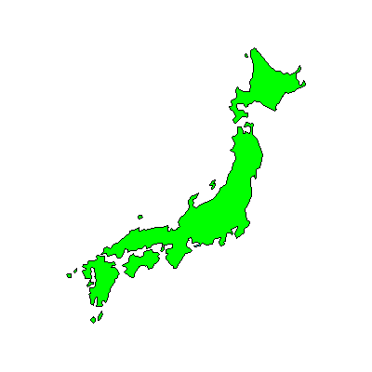
Japan’s Islands Task
Visit http://www.freeworldmaps.net/asia/japan/ to complete the task below
- Give your map a title
- Add the orientation compass points in the top right corner
- Label: Japan’s islands: Hokkaido, Honshu, Shikoku, and Kyushu
- Label: Cities of Tokyo, Kyoto, Osaka, Hiroshima, Sapporo
- Label: Pacific Ocean, Sea of Japan

