CAMPBELLTOWN PERFORMING ARTS HIGH SCHOOL

HSIE Faculty

Medieval Europe
Research Task and In-Class Extended Writing Task
Date Task Issued: Week 4 Term 1 | Date Task is Due: Week 6 Term 1
Task Type: Research Task and In-Class Essay | Weighting of Task: 25%
Head Teacher: Kevin Kelly
Outcomes Assessed: (from the History K-10 NSW Syllabus)
HT4.5  HT4.6  HT4.8 | Identifies the meaning, purpose and context of historical sources  Uses evidence from sources to support historical narratives and explanations  Locates, selects and organises information from sources to develop an historical inquiry
HT4.9  HT4.10 | Uses a range of historical terms and concepts when communicating an understanding of the past Selects and uses appropriate oral, written, visual and digital forms to communicate evidence about the past

*Please note you will be given FOUR periods in class to gather evidence and research.

Task Instructions:

Part A: Source 0.7 Questions – 17 marks

Interpret Source 0.7 and answer the following questions relating to the Source.

Part B: Historical Inquiry - 10 marks

Complete the attached journal to record the details of your research. You must use at least 2 different information sources from your research from ONE of the following topics of Medieval European society:
Architecture | Art | Medieval Manuscripts
Literature | Music | Military and defence
Commerce | Towns and cities | Crime and Punishment

Part C: Extended Response (15 Marks)

Describe the reliability and usefulness of Source A for a historian studying the Crusades.

Use the Part C worksheet below

Parts A, B and C are to be submitted in class by the due date.

See Ms Costello for any required assistance or email cathy.costello@det.nsw.edu.au

Part A: Use Source 0.7 to answer Questions 1-3 in the spaces provided.

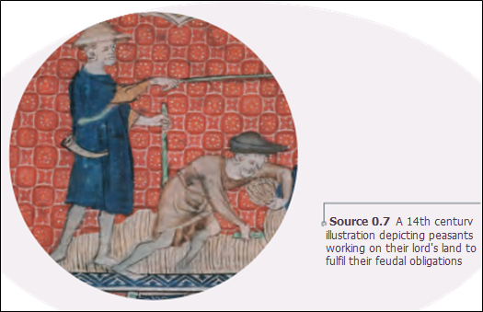
Question 1 – 1 mark

Is this a primary or secondary source?
_______________________________________________________________________________________

Question 2 – 2 marks

Define feudalism.
_______________________________________________________________________________________
_______________________________________________________________________________________
_______________________________________________________________________________________
______________________________________________________________________________________________________________________________________________________________________________
_______________________________________________________________________________________
_______________________________________________________________________________________
Question 3 - 4 marks

What message does Source 0.7 have for the viewer? Discuss you answer directly referring to Source 0.7.
_______________________________________________________________________________________
_______________________________________________________________________________________
_______________________________________________________________________________________
_____________________________________________________________________________________________________________________________________________________________________________________________________________________________________________________________________
_______________________________________________________________________________________

Question 4 – 10 marks (1 Mark for each correctly labelled box).

Complete the diagram below to demonstrate your understanding of the structure of feudal society in Medieval Europe.

PROVIDES
PROVIDES
PROVIDES

Part B: Information Source Interpretation

Source One:

Title: __________________________________________________________________________________
Author: ________________________________________________________________________________
Publishing Details/URL:____________________________________________________________________

INFORMATION LOCATED FROM THE SOURCE
What? When? Where? Who? How? Why? How well?

Source Two:

Title: __________________________________________________________________________________
Author: ________________________________________________________________________________
Publishing Details/URL:____________________________________________________________________

INFORMATION LOCATED FROM THE SOURCE
What? When? Where? Who? How? Why? How well?

Source Three:

Title: __________________________________________________________________________________
Author: ________________________________________________________________________________
Publishing Details: _______________________________________________________________________

INFORMATION LOCATED FROM THE SOURCE
What? When? Where? Who? How? Why? How well?

Part C: HISTORICAL INQUIRY REFLECTION – 15 marks
Review Source A below and information you have gathered about the Crusades to answer the following question.

Describe the reliability and usefulness of Source A for a historian studying the Crusades.

Source A - Motives for the Crusades. 1095AD, Pope Urban II.

An accursed race has violently invaded the lands of the Christians. They have destroyed the churches of God or taken them for their own religion. Jerusalem is now held captive by the enemies of Christ, subject to those who do not know God – the worship of the heathen….. He who makes this holy pilgrimage shall wear the sign of the cross of the Lord on his forehead or on his breast….. If you are killed your sins will be pardoned….let those who have been fighting against their own brothers now fight lawfully against the barbarians….

_______________________________________________________________________________________
_______________________________________________________________________________________
_______________________________________________________________________________________
_______________________________________________________________________________________
______________________________________________________________________________________________________________________________________________________________________________
_______________________________________________________________________________________
_______________________________________________________________________________________
_______________________________________________________________________________________
_______________________________________________________________________________________
______________________________________________________________________________________________________________________________________________________________________________
_______________________________________________________________________________________
_______________________________________________________________________________________
_______________________________________________________________________________________
______________________________________________________________________________________________________________________________________________________________________________
_______________________________________________________________________________________

