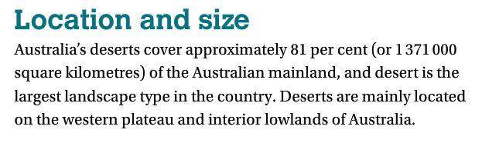
Australian Deserts

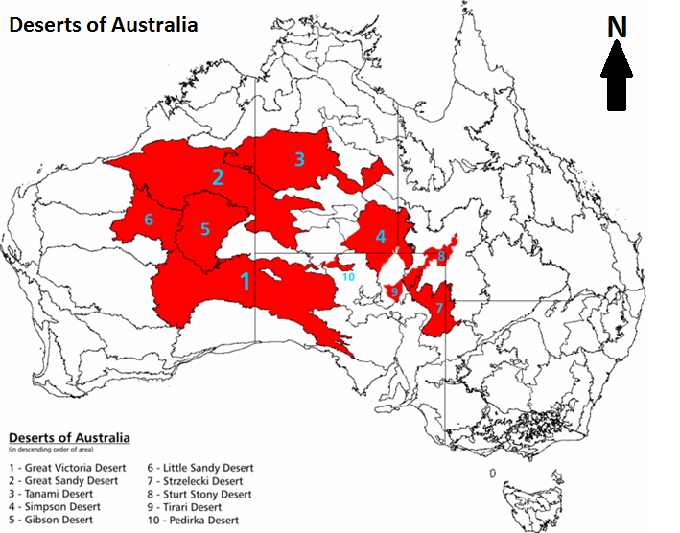
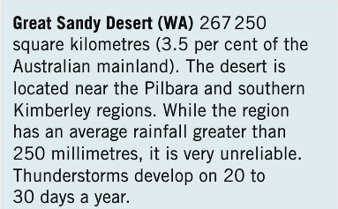
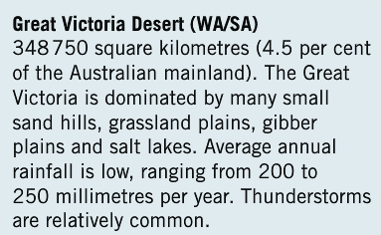
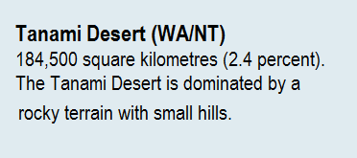
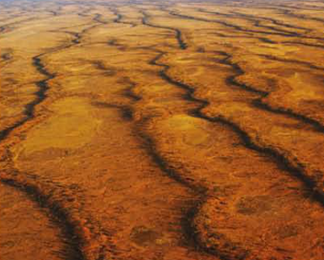
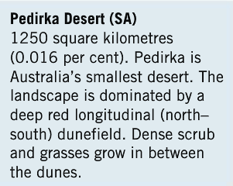
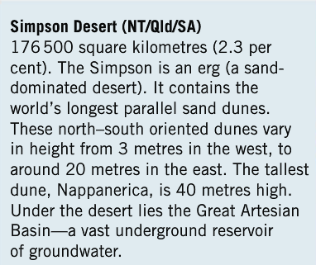

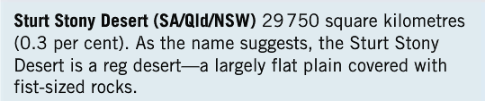
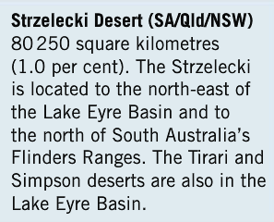
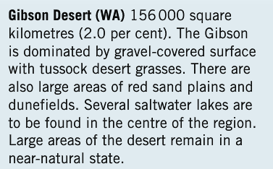
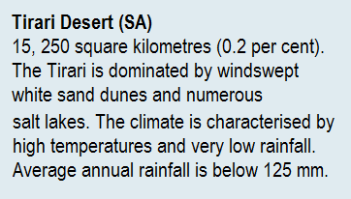

Australian Deserts Answer:
- Approximately what percentage of the Australian mainland is covered by desert? = 81%
- Where are deserts mainly located on the mainland?
= On the western plateau and interior lowlands of Australia
3. Which desert contains the world’s longest parallel sand dunes?
= The Simpson Desert
4. What is an erg? = A sand dominated desert
5. What lies under the Simpson Desert? = The Great Artesian Basin
6. Which desert in SA is Australia’s smallest desert? = The Pedirka Desert
7. Which desert is Australia’s largest? = The Great Victorian Desert
8. Which desert is characterised by rocky terrain with small hills?
= The Tanami Desert
8. Which desert has saltwater lakes near its centre?
= The Gibson Desert
9. Which desert comprises 1 per cent of Australian land area?
= The Strzelecki Desert
10. Which desert is dominated by windswept white sand dunes?
= The Tirari Desert
11. Which reg desert is covered by fist sizes rocks?
= The Sturt Stony Desert

Desertification
Causes of desertification
Q. 1
Since the early 1970s, deserts have been increasing in size. Semi-arid areas on the edges of deserts are getting drier and becoming deserts. This process is called desertification.
There are two main theories about the causes of desertification: it is dues to natural process or it is a result of human behaviour. The diagram below shows the process of human and natural causes of land degradation.
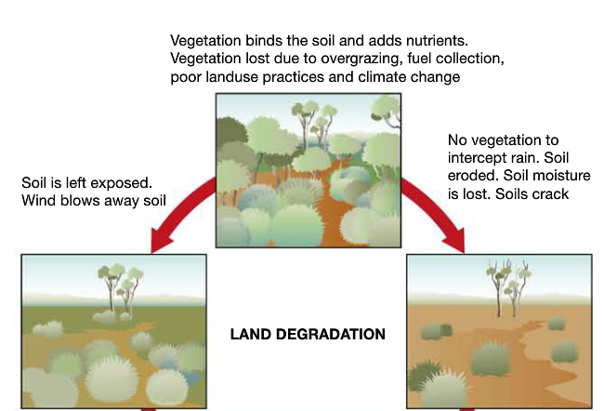
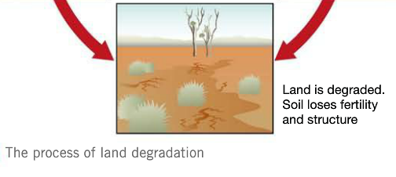

Q. 2
Natural Causes of Desertification
Climate change has reduced the amount of rainfall and shortened the wet season. As a result, vegetation dies, soil is blown away and the land becomes degraded.
Q. 3
Human Causes of Desertification
Deserts and semi-deserts have become degraded because of poorly managed landuse on the edges of deserts. In these areas, too many cattle graze the land, crops are grown on land that is not really suited to agriculture and people cut down trees to use as fuel for cooking and providing warmth.
Some scientists argue that desertification is caused by a combination of both natural and human factors and may also be linked to the process of global warming.

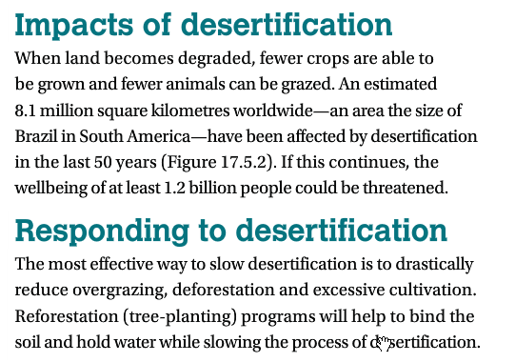

Q. 4

Q. 5

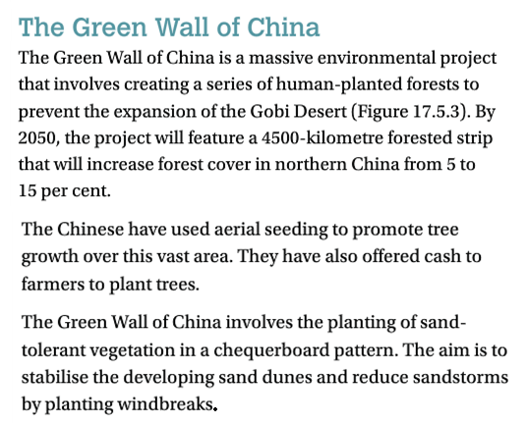
Q. 6

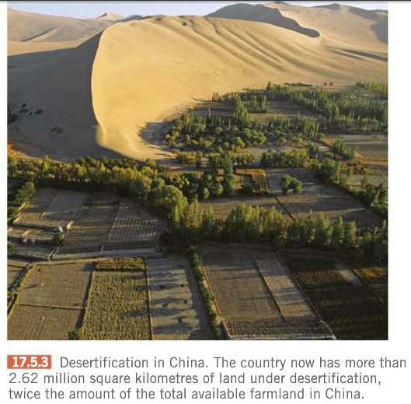

Desertification: Answer the following:
- Define the term desertification
________________________________________________________________________________________________________________________________________________________________________________________________________________________________________________________________
- Outline natural causes of desertification
________________________________________________________________________________________________________________________________________________________________________________________________
- Outline the human causes of desertification
________________________________________________________________________________________________________________________________________________________________________________________________________________________________________________________________
4. State how much land has been affected by desertification in the last 50 years ________________________________________________
5. What can we do to slow desertification? ________________________________________________________________________________________________________________________________________________________________________________________________
6. Describe the various steps have the Chinese taken in the ‘Green Wall of China’ project. ________________________________________________________________________________________________________________________________________________________________________________________________________________________________________________________________________________________________________________________________________________________________________________________________

