Climatic Graphs
Climatic graphs present a graphical depiction of the climate of a place, measured by its average monthly rainfall and temperature. The difference in the appearance of climatic graphs reflects both the topography of a place, and its location within a landmass and in respect to the Equator.
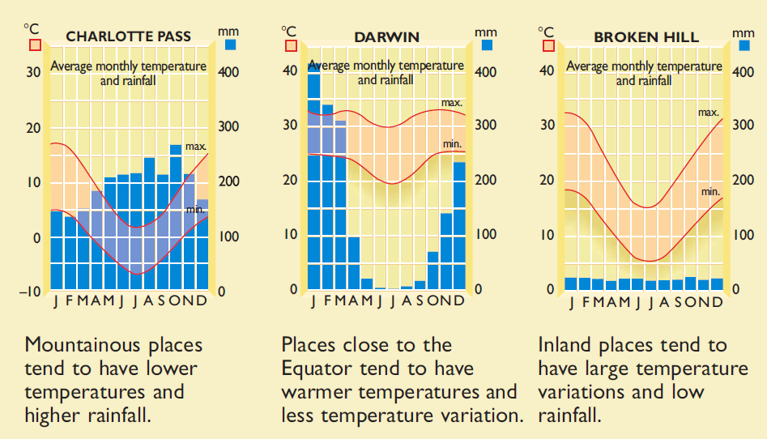

Noting that the bar graphs represent rainfall in millimetres, whilst the line graphs represent temperature in degrees Celsius – answer the following:

- Which of the three locations (Charlotte Pass, Darwin & Broken Hill) had the most rainfall in:
- August: ___________________________
- January: ___________________________
- April: ___________________________
- November: ___________________________

2. Which month has the least rainfall for :
a. Charlotte pass ___________________________
b. Darwin ___________________________
c. Broken Hill ___________________________

3. Which of the three locations (Charlotte Pass, Darwin & Broken Hill) had the highest temperature in:
- August: ___________________________
- January: ___________________________
- April: ___________________________
- November: ___________________________

4. Which month has the lowest temperature for :
a. Charlotte pass ___________________________
b. Darwin ___________________________
c. Broken Hill ___________________________

5. If you were planning a holiday, which month would be the best time to visit:

a. Charlotte pass ___________________________
b. Darwin ___________________________
c. Broken Hill ___________________________

