Dear Class,
Hopefully these worksheets might help you to answer Part C of your assessment task.
Also, please look at the website on the assessment task page under the heading of Crusades. I have added new information there. http://www.costellohsie.info/medieval-europe-asst-task.html

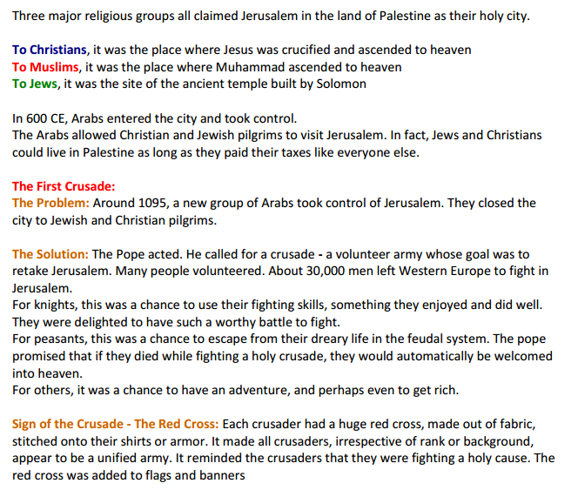
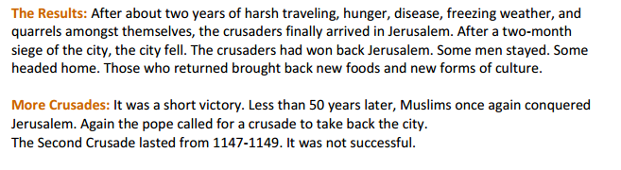
The Crusades

