Australian Curriculum Year 8 Geography sample assessment ׀ Assessment resource

Investigating landscapes and their landforms

© The State of Queensland (Queensland Curriculum and Assessment Authority) and its licensors 2014. All web links correct at time of publication.

Identifying landscapes and their distinctive landform features
Research and identify specific landforms that are evident in each landscape image to complete the tables.
The first table has been completed for you as an example.
Landscape — Tropical rainforest landscape | Landforms evident | Examples
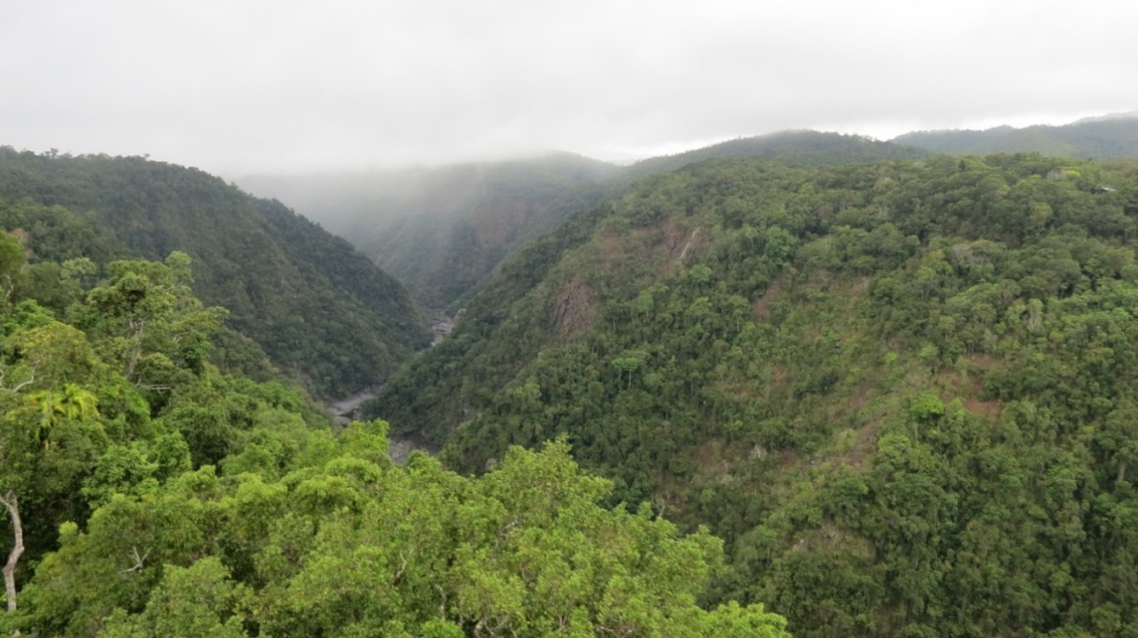 | - Mountains  - Valley  - Wetlands | - Amazon Rainforest, South America
Image source: Daintree Rainforest, Queensland (483858), Robert Linsdell, CC BY 2.0 https://flic.kr/p/fofCKk

Landscape — Coastal landscape | Landforms evident | Examples
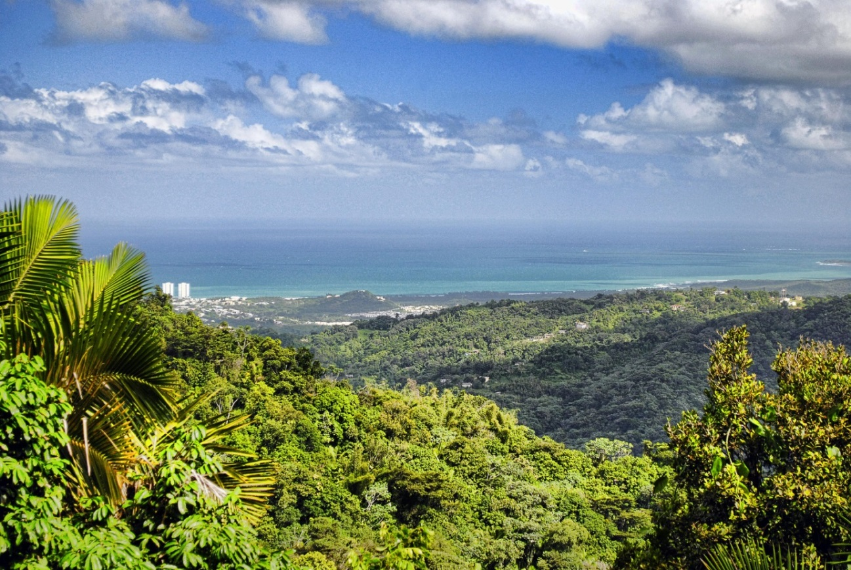
Image source: Puerto Rico Vista, Trish Hartmann,CC BY 2.0. https://flic.kr/p/dCaHuT

Landscape — Desert landscape | Landforms evident | Examples
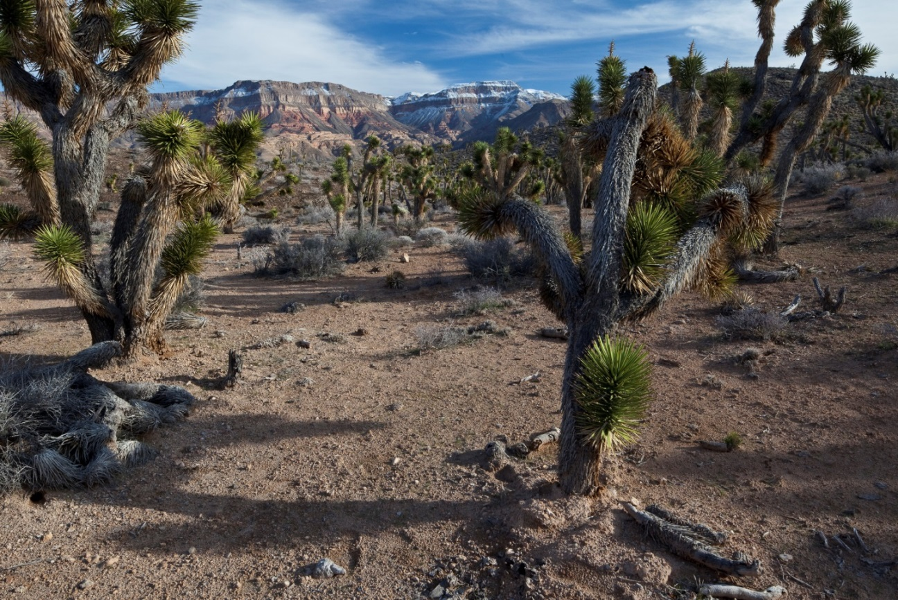
Image source: Paiute Wilderness, Bob Wick, Bureau of Land Management, California, CC BY 2.0. https://flic.kr/p/fm1d86

Landscape — Coastal landscape | Landforms evident | Examples
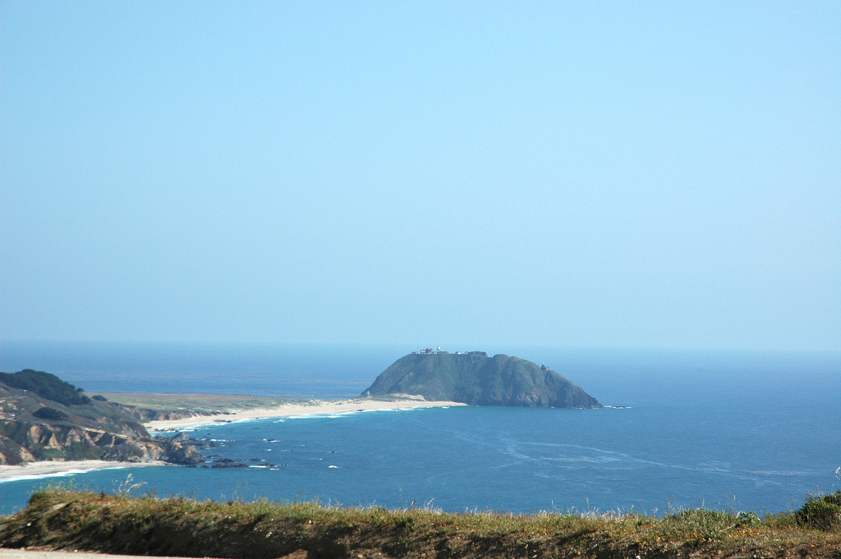
Image source: Island, isthmus, surrounded by the blue Pacific Ocean and the equally blue sky, in southern California coast, USA, Wonderlane, CC BY 2.0. https://flic.kr/p/86TQ9F

Landscape | Landforms evident | Examples
This table has been left blank for you to include a landscape of your own choosing.

Image source:

