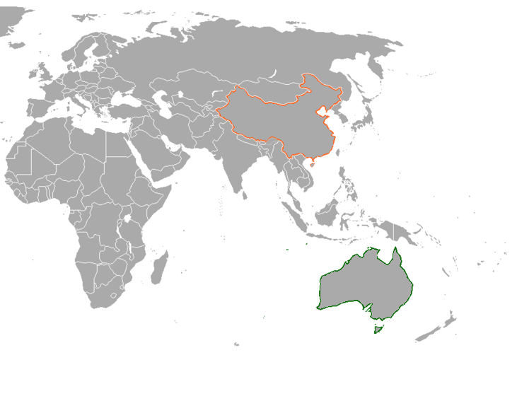
Japan Under The Shoguns – Mapping Activity
1. Give your map a title
2. Add the orientation compass points in the top right corner
3. Label these countries:
a - Australia
b - China
c - Japan
d - India
e - Indonesia
f - Papua New Guinea
g - New Zealand
4. Label these Continents:
a - Africa
b - Europe
5. Label these oceans
A - Pacific Ocean
b - Indian Ocean

