Landscapes and Landforms
LS Student Booklet

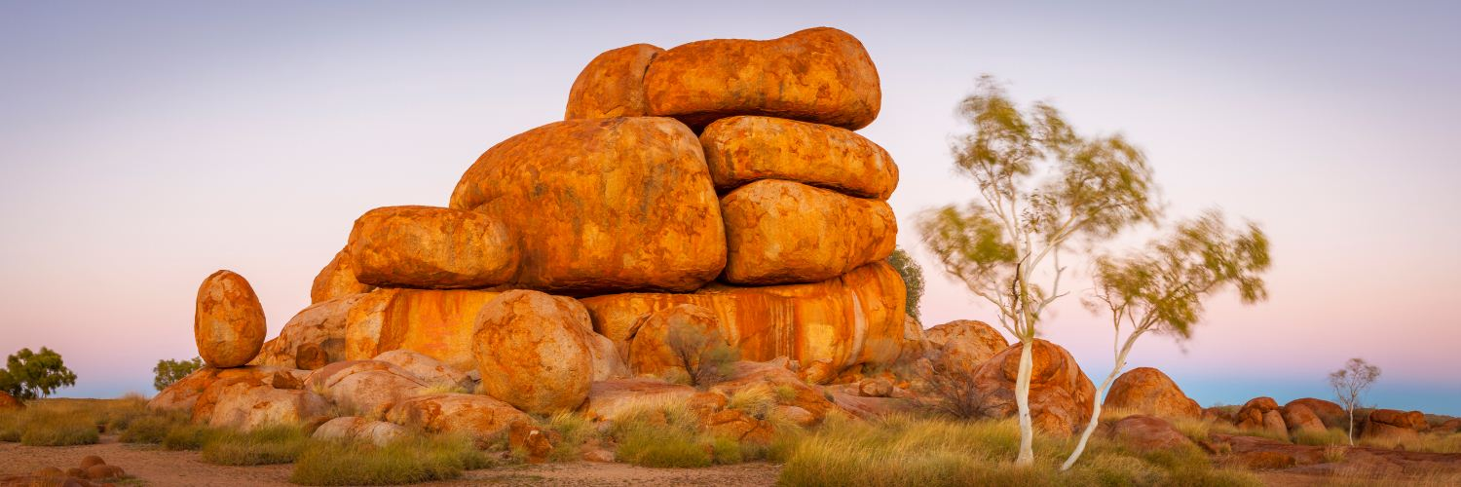
The Devils Marbles- Tennant Creek in the Northern Territory.
The Devils Marbles are located in the traditional country of the Warumungu, Kaytetye, Alyawarra and Warlpiri people. They call the Devils Marbles Karlu Karlu, which literally translates as ‘round boulders'.

This booklet will be used to present findings and representations of data and information about landscapes and their landforms in a collection of work using a range of appropriate communication forms.
You will:
- develop a collection of work in class to demonstrate your knowledge, understanding and skills about landforms and landscapes
- use a range of sources to complete a series of learning projects.

Section | Topic | Evidence of learning
1 | Landscapes and their landform features | - Labelled line drawing (from a photograph) of one landscape and specific landforms
2 | Spatial distribution of landscapes and landforms | - Special purpose map showing the spatial distribution of one type of landscape and one related landform within that landscape
3 | Geomorphic processes that produce landforms | - Labelled diagram showing how the Geomorphic process occurs
4 | Cultural significance of landscapes | - Mind Map exploring cultural significance of landscapes  - Aboriginal Art Symbols
5 | Landscape degradation | - Supported explanation and analysis of a selected land degradation issue
6 | Geomorphological hazards | - How the hazard occurs  - Summary of the hazard’s effects  - Spatial distribution of the hazard

  - Section 1.
  - LS Landscapes and their landform features

Constructing a line drawing from a photo
The ability to construct a line drawing is a valuable geographical skill. It allows us to make a quick summary of information shown in a photographic image.
It is important to note:
- Photo sketches should not seek to reproduce everything. Only the prominent features need to be included and should be labelled
- It is useful to divide your drawing into three areas – foreground, middle ground and background. It is often easiest to begin with the background, followed by the middle ground and then the foreground.
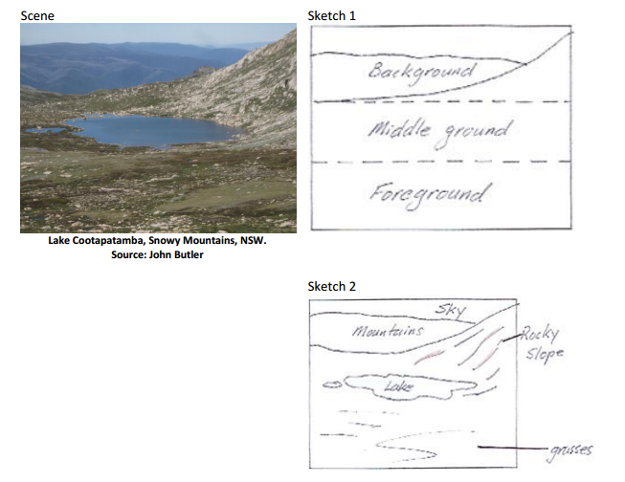

Line Drawing
Choose one image of a landscape from the worksheet Resource 1 Identifying landscapes and landforms :
- create a line drawing or sketch of this landscape in the space below
- label each of the different landforms, and other features, in your drawing.

  - Section 2. LS Distribution of landscapes and landforms
- On the map of the world, shade in the spatial distribution of:
  - one type of landscape, e.g. desert, coastal.
  - one type of landform found in that landscape, e.g. grassland plain, mountain, wetland, headland
- Include all the appropriate cartographic conventions: ie. BOLTS (Border, Orientation, Legend, Title, Scale)

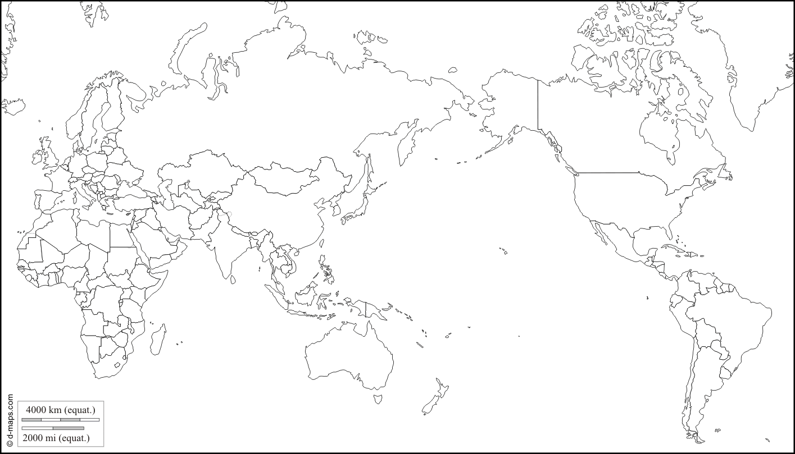

  - Section 3.
  - LS Geomorphic processes that produce landforms
The Formation of Mountains
Label the types of Mountains and their features using the words in the text box
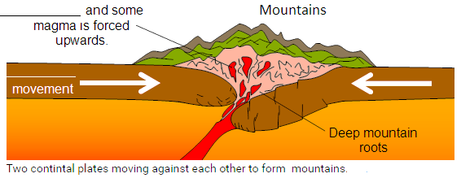
______________________ Mountain

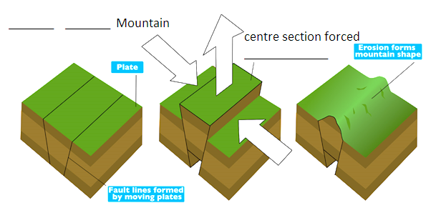
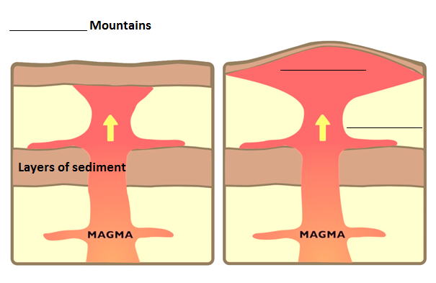
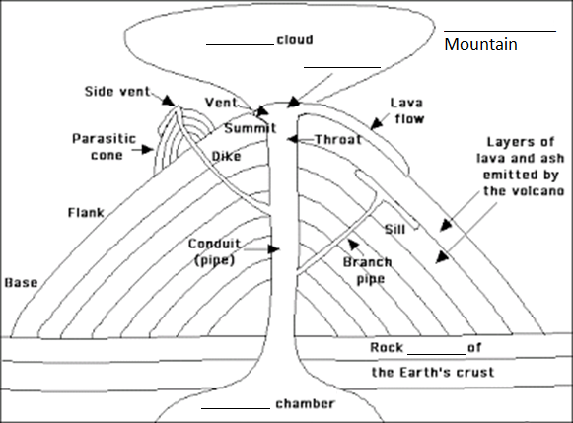
Fold Fault Block Volcanic Dome ash sediment magma plate upwards pressure layers bulge crater

  - Section 4. LS Cultural significance of landscapes

View the video clips:
Balgo, Maps of the Country, Kiwirrkurra
http://aso.gov.au/titles/documentaries/painting-country
Dreamings through Indigenous art
www.australiansatwork.com.au/dreamings/dreamings_ar7-8.php
How does Aboriginal art create meaning?
https://www.youtube.com/watch?v=mQi1NMh9CvA
What are songlines?
https://www.youtube.com/watch?v=kVOG-RKTFIo
What do circles represent in Aboriginal art?
https://www.youtube.com/watch?v=qyUxxgwHK8Q

While viewing, think about:
- who owns the Dreaming stories associated with Country
- the ways these stories are passed on between generations
- how art is used to represent the patterns of the landscape and features of landforms
- how interconnections are made between places and people and their culture in paintings
- how symbols are used to represent ideas in paintings.

Your notes:

Use your notes to create a Mind Map of the cultural significance of landscapes for ATSI peoples

Cultural Significance of Landscapes

Symbols used in Aboriginal Art
Aboriginal Art uses symbols or iconography. These symbols were used as a means of communicating about their rituals, food, customs and knowledge and to depict the landscape.
Complete the labels of the symbols
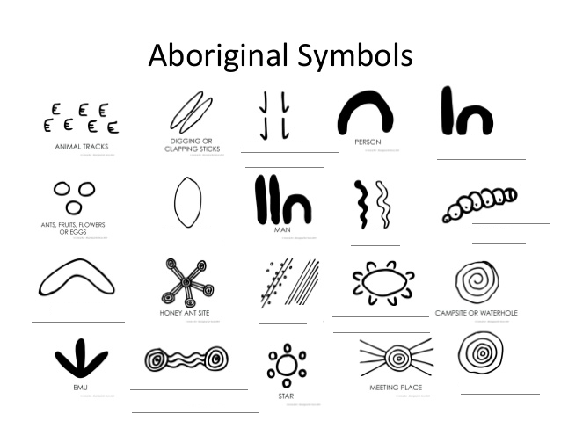

woman boomerang waterholes connected by running water rain snakes kangaroo tracks people sitting campsite coolamon witchety grub

Create your own symbols in the spaces below
Day

Night

Summer

Winter

Food

Drink

Near

Far

Section 5 – LS Landscape Degradation
World Population Mapping
Use the figures from the Popultation Table to create a line graph
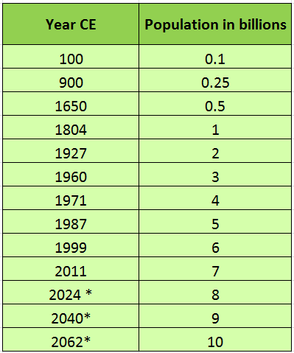
Population Table

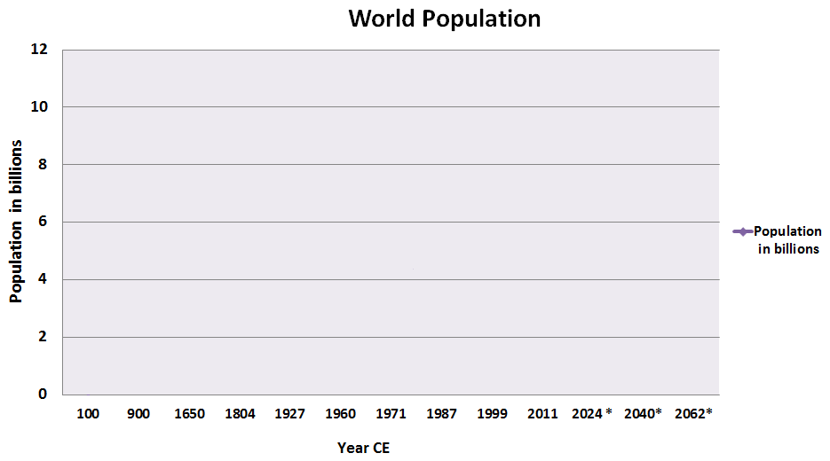

Coastal Degradation
Watch: Coogee Beach Sydney Australia Ecosystem
https://www.youtube.com/watch?v=SC46_iBFCx0
Explore: Narrabeen Dunes Restoration
www.toolijooa.com.au/narrabeen_dunes.html
- Identify some of the impact of human actions at Coogee Beach

2. Suggest management strategies that can be taken to protect the beach

  - Section 6 – LS Geomorphological hazards
Volcanoes

How do volcanic eruptions occur?

Provide a diagram to show how it occurs

Discuss some of the impacts of a volcanic eruption

How can the impact be minimised?

4. Show the distribution of Volcanoes on the map below. (Ensure to use BOLTS)

