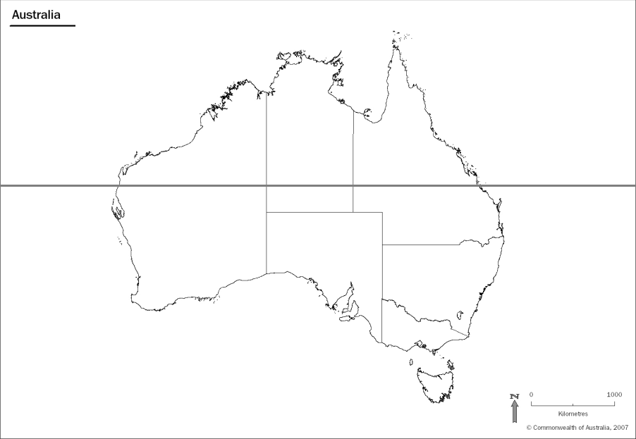

Label the following on the map:

Tropic of Capricorn, Great Australian Bight, Pacific Ocean, Indian Ocean, Torres strait, Coral Sea, Tasman Sea, Tasmania, Victoria, South Australia, Western Australia, Northern Territory, Queensland, New South Wales, Australian Capital Territory, equator.