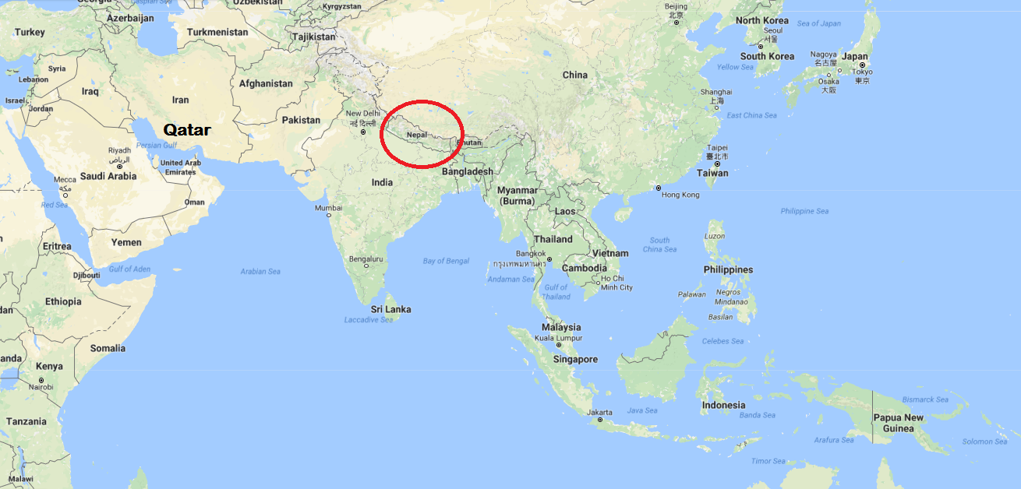

Revealed: Qatar's World Cup 'slaves'
World Cup construction 'will leave 4,000 migrant workers dead'
Analysis: Qatar 2022 puts Fifa's reputation on the line
By Pete Pattisson in Kathmandu and Doha
Thursday 26 September 2013
Dozens of Nepalese migrant labourers have died in Qatar in recent weeks and thousands more are enduring appalling labour abuses, a Guardian investigation has found, raising serious questions about Qatar's preparations to host the 2022 World Cup.
This summer, Nepalese workers died at a rate of almost one a day in Qatar, many of them young men who had sudden heart attacks. The investigation found evidence to suggest that thousands of Nepalese, who make up the single largest group of labourers in Qatar, face exploitation and abuses that amount to modern-day slavery, as defined by the International Labour Organisation, during a building binge paving the way for 2022.
According to documents obtained from the Nepalese embassy in Doha, at least 44 workers died between 4 June and 8 August. More than half died of heart attacks, heart failure or workplace accidents.
The investigation also reveals:
• Evidence of forced labour on a huge World Cup infrastructure project.
• Some Nepalese men have alleged that they have not been paid for months and have had their salaries retained to stop them running away.
• Some workers on other sites say employers routinely confiscate passports and refuse to issue ID cards, in effect reducing them to the status of illegal aliens.
• Some labourers say they have been denied access to free drinking water in the desert heat.
• About 30 Nepalese sought refuge at their embassy in Doha to escape the brutal conditions of their employment.

The allegations suggest a chain of exploitation leading from poor Nepalese villages to Qatari leaders. The overall picture is of one of the richest nations exploiting one of the poorest to get ready for the world's most popular sporting tournament.
"We'd like to leave, but the company won't let us," said one Nepalese migrant employed at Lusail City development. The Guardian's investigation also found men throughout the wider Qatari construction industry sleeping 12 to a room in places and getting sick through repulsive conditions in filthy hostels. Some say they have been forced to work without pay and left begging for food.
"We were working on an empty stomach for 24 hours; 12 hours' work and then no food all night," said Ram Kumar Mahara, 27. "When I complained, my manager assaulted me, kicked me out of the labour camp I lived in and refused to pay me anything. I had to beg for food from other workers."
Almost all migrant workers have huge debts from Nepal, accrued in order to pay recruitment agents for their jobs. The obligation to repay these debts, combined with the non-payment of wages, confiscation of documents and inability of workers to leave their place of work, constitute forced labour, a form of modern-day slavery estimated to affect up to 21 million people across the globe. So entrenched is this exploitation that the Nepalese ambassador to Qatar, Maya Kumari Sharma, recently described the emirate as an "open jail".
"The evidence uncovered by the Guardian is clear proof of the use of systematic forced labour in Qatar," said Aidan McQuade, director of Anti-Slavery International, which was founded in 1839. "In fact, these working conditions and the astonishing number of deaths of vulnerable workers go beyond forced labour to the slavery of old where human beings were treated as objects. There is no longer a risk that the World Cup might be built on forced labour. It is already happening."
Qatar has the highest ratio of migrant workers to domestic population in the world: more than 90% of the workforce are immigrants and the country is expected to recruit up to 1.5 million more labourers to build the stadiums, roads, ports and hotels needed for the tournament. Nepalese account for about 40% of migrant labourers in Qatar. More than 100,000 Nepalese left for the emirate last year.
The murky system of recruitment brokers in Asia and labour contractors in Qatar leaves them vulnerable to exploitation. The supreme committee has insisted that decent labour standards will be set for all World Cup contracts, but underneath it a complex web of project managers, construction firms and labour suppliers, employment contractors and recruitment agents operate.
https://www.theguardian.com/world/2013/sep/25/revealed-qatars-world-cup-slaves
Table: Comparison of GDP of Qatar with Nepal
 | 1990 | 1995 | 2000 | 2005 | 2010 | 2015
Qatar GDP  Billion $US | 7 | 8.1 | 17.76 | 44.5 | 125 | 164.5
Nepal GDP  Billion $US | 3 | 4.4 | 5.4 | 8.1 | 16 | 21.3
Qatar GDP  per capita  $US | 15,450.00 | 15,850.00 | 29,980.00 | 51,480.00 | 70,300.00 | 66,340.00
Nepal GDP  per capita  $US | 193.00 | 205.00 | 231.00 | 317.00 | 592.00 | 743.00
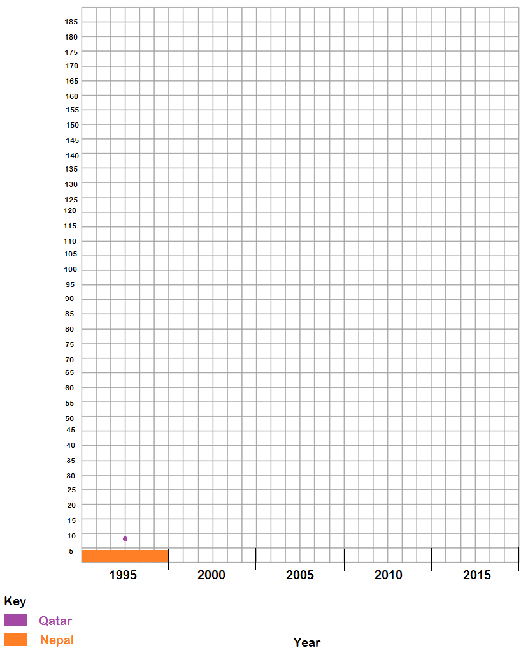
GDP in Billion US Dollars

