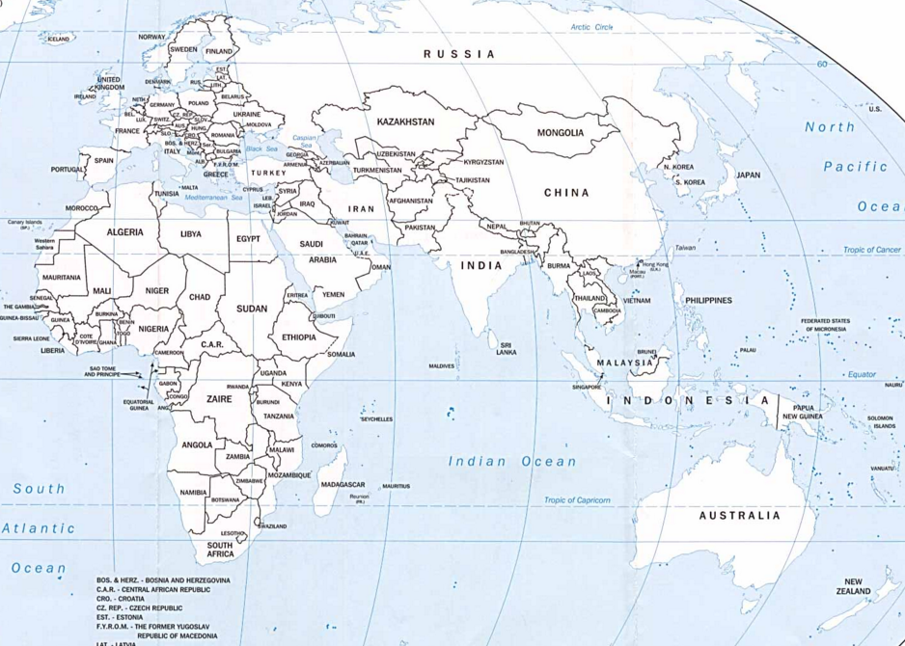

**The human journey ‘out of Africa’**