The Agricultural Revolution

The shift from hunter __________________ to agriculture is probably the most important ecological event in the history of humanity. The __________________ revolution was a global event because it happened in parallel developments in many parts of the ___________, although at slightly different times. It is viewed as the beginning of__________________.
Core regions of the development of agriculture were in the Fertile ________________ in the Middle East (circa* 10,000 BCE), ____________ (circa 9,000 BCE), New ________________ (circa 8,000 – 6,000 BCE), and South and Central ________________ (circa 4,000 BCE). Agriculture revolutionised the way people interacted with other_____________, which revolutionised the way people interacted with each other as well. It made civilisation possible as people started living in ______________ and then eventually in complex city ___________.
As agriculture became more and more widespread, people began to accumulate ____________ of food, meaning that people __________ more than they consumed. This resulted in the first commerce or ___________ as people could then trade or _________ their surplus crops with their neighbours for the items they needed.
We cannot be certain why and how some groups of Palaeolithic _______________ gatherer peoples began adopting new ways of producing ____________ and other necessities of life by ___________________ plants and domesticating ____________ because there are no written records of this transition. It is thought perhaps ______________ changes associated with the retreat of the glaciers at the end of the last _____________ (circa 12,000 B.C.), may have played an important role.
The emergence of agriculture also had a major environmental __________ on the earth. The most important has been __________________ in order to make space for _________ and livestock. There is also strong evidence that _________ clearing for agriculture, the farming of animals and the development of rice _____________ released significant amounts of _______________________ gasses (methane and CO2).
*circa is a Latin word meaning around or approximately
China gathering Guinea crops swap food Ice Age world America hunter Crescent paddies towns trade animals climatic agricultural civilisation cultivating species states surpluses deforestation grew impact greenhouse land states cultivating

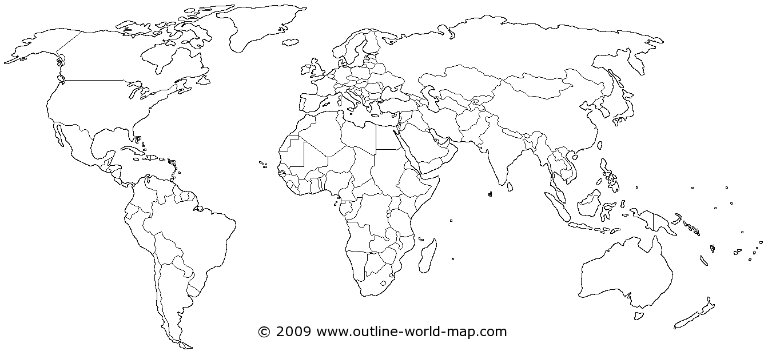
THE FIRST AREAS OF AGRICULTURAL CULTIVATION

