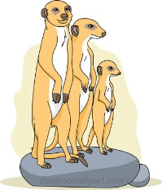
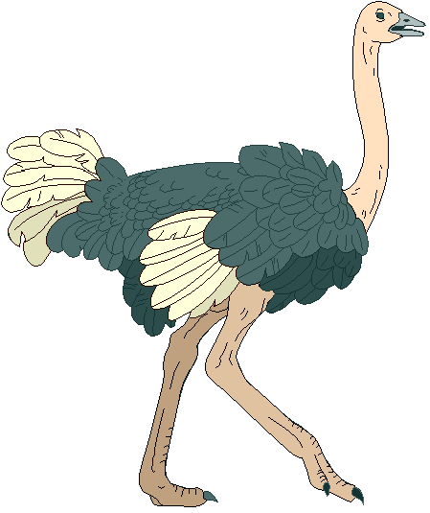
The San of the Kalahari
The Kalahari Desert, in the southern part of the _______________ continent, has existed for approximately sixty ______________ years. The desert covers approximately 900,000 square _______________ and covers parts of the African countries of Botswana, ____________ and South Africa.
The Kalahari gets very hot; it can reach temperatures of 40 _________ celsius in the summer. In winter the desert has a dry, cold climate where the temperature can reach 0 degrees ________________. The vegetation consists mostly of grasses, scattered trees and ______________ including Acacia.
The San people's successful ___________________ to the arid Kalahari has earned them the title of ultimate survivors. The San have lived in the Kalahari for around twenty thousand _________ and are considered to be one of the oldest _______________ in the world. A small group of these people still follow the traditional ________________ lifestyle as hunter gatherers.
The San have survived invasions, first, from other African groups such as the Zulu and __________ and, later, from _____________________ colonists. The arrival of white settlers in the 1600s brought dispossession of land, _______________________ and slaughter of the San.
Traditionally, their hunter gather diet consisted of 70 - 80% of plant food, including _____________, nuts, roots and melons gathered primarily by the _____________. The remaining 20 - 30% was _________ hunted by the men using poisoned ____________ and spears on hunts that could last several days. They made their own ___________________ homes from wood that they gathered.
The San are not ___________________ and every part of the animal is used. The _________ are used for blankets and the __________ are used for arrows and spears. In the Kalahari water is hard to come by. The San collect moisture by scraping and squeezing the water held in __________ and tubers. They also ______ holes in the sand to find water. They also carry water in an _______________ eggshell.
adaptation shrubs temporary million Bantu women European African celcius Namibia arrows years nomadic berries enslavement cultures meat ostrich dig roots kilometres bones degrees skins wasteful

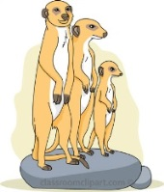
Modern Challenges for the San
The San hunting and gathering economy and ___________________ structure had remained virtually unchanged for tens of thousands of years until recently. European colonialism destroyed the San nomadic way of life, they were no longer allowed to _______________ freely and trophy hunters destroyed the vast herds of _____________ that formed their food supply.

The San have been under great pressure to abandon their nomadic lifestyle. Beginning in the 1950's, many San have converted from a nomadic to an agricultural ______________ lifestyle. For example, today in ______________ – the country with the largest San population – out of a population of 50,000 San, only about 3,000 follow the ________________ way of life. Land that the San used to hunt on is increasingly being used for ______________ cattle. ______________ are put up to protect the cattle which means that the _______________ the San depend upon for their hunting are changing their migrating patterns.

The last of the hunter gatherers were forcibly evicted from the Central Kalahari Game Reserve in 2002, by the Botswana government to make way for ____________________ mines. A court case is currently in existence to help the San __________ back their land.

Governments have forced the San to relocate to ____________________ locations usually with the intention of 'civilizing' them and providing schooling, running _____________ and other modern amenities. Unfortunately rounding up hunter gatherers and forcing them to live in settlements has been tried in many countries and has not been very __________________.

Sadly, few modern San are able to continue as nomadic ___________________________, and most live at the very ______________ of the social scale in unacceptable conditions of poverty, leading to alcoholism, disease and __________________.
farming despair roam hunter gatherers claim Botswana
wildlife diamonds water social traditional successful game bottom evicted grazing permanent

