​​
Think, Pair, Share Activity
- What do we use water for? List as many uses as you can think of.

2. What percent of the world's surface is water?
Your Best Guesstimate | Notes from video
3. What percent of the world's water is salt water?
Your Best Guesstimate | Notes from video
4. What percent of the world's water is fresh water?
Your Best Guesstimate | Notes from video
5. What percent of the world's fresh water is surface water?
Your Best Guesstimate | Notes from video

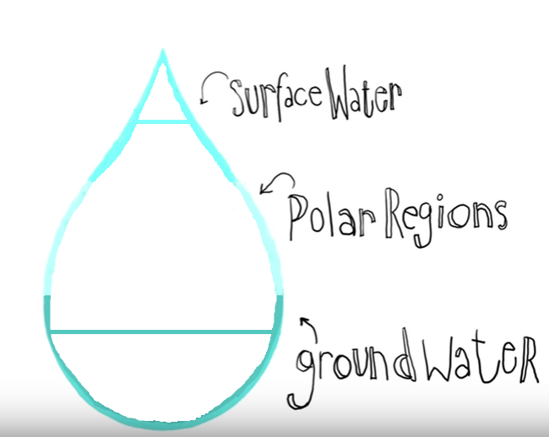
6. Complete the percentages for fresh water

7. Label the breakdown of fresh water use in the pie graph below.
[Domestic/Household, Industry, Agriculture]
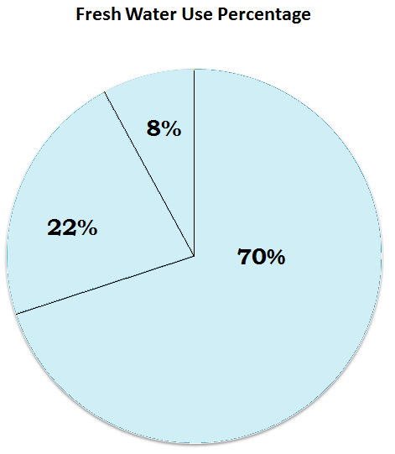

8. How might the limited access to fresh water be a global issue? Why?
__________________________________________________________________________________________________________________________________________________________________________________________________________________________________________________________________________________________________________________________________________________________________________________________________________________________________________________________________________________________________________________________________________________________________________________________________________________________________________________________________________________
______________________________________________________________________________________________

