World Population Mapping LS Section 5
Use the figures from the Popultation Table to create a line graph
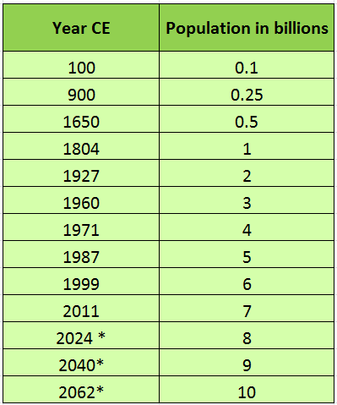
Population Table

