Name:

The Social and Cultural World

Concepts
Society and Culture integrates concepts and applies research methods to the subject matter.
The concepts are tools to organise and to further understand the subject matter. They spiral through the course and are classified as fundamental, additional and related.
The fundamental course concepts are:
- persons
- society
- culture
- environment
- time

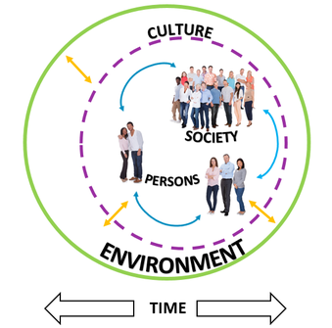
THE FIVE KEY CONCEPTS
Persons
Every person is a unique individual who develops in a social and environmental setting in which he or she is influenced by, and interacts with, other persons and groups. Communication, the sharing of values and beliefs, and cooperation are major interactions. The identity achieved by each individual is the result of interactions at the micro, meso and macro levels of society. Examples include: Socialisation. Self and Identity, Human Rights and Obligations, Individual growth and development, Communication, Personality, Life Style, Rights of passage, Alienation.

Society
Society is made up of people, groups, networks, institutions, organisations and systems. These aspects of society may include local, national, regional and international patterns of relationships and organisation. People belong to informal and formal groups, and within and between these groups there are patterns of interactions that contribute to unique cultures. Examples include: Groups and institutions, Class and Status, Authority/Influence and Power, Conflict and Co-operation, Kinship, Social Networks, Peer Groups, Class, Race & Ethnicity, Community, Roles. Discrimination, Socialisation.
Culture
Culture refers to the shared knowledge, attitudes and behaviours that give each society its coherence, identity and distinctive way of life. Culture is demonstrated by the beliefs, customs, values, norms, rules, laws, governance, arts, technologies and artefacts that people generate and use as they interpret meaning from their world and solve present and future problems. Culture is dynamic and undergoes change, and is therefore not static. Examples include: Language, Myths/Rituals and Beliefs, Knowledge, Technology, Cultural Diversity, Customs/Norms/Values, Art and Artifacts, Prejudice and Stereotypes, Science and Civilisation.
Environment
Every society is located in a particular physical setting and interacts with its environment. The attitudes and values that people have in regard to their environment greatly affect interactions between persons, society, culture and the environment. Unique culture is generated from the interactions with the immediate environment. Different locations and their environments – including urban, rural, coastal, inland and isolated – present societies and their cultures with both opportunities and constraints. Examples include: Location, surroundings, Landforms/Vegetation/Climate, Landuse, Interdependence, Ecosystems.

Time
Every person, society, culture and environment is located in a period of time and is changing with time. Time can be examined as past, present and future. Our perceptions of time are drawn from past events and these influence our ideas about the present. These perceptions need not, however, determine possible ideas of a future. The concept of time is best studied in context – last century, this century, and pre- and post-events – or as a particular decade. Time is studied in relation to continuity and change. Examples include: Past and Future, Present, Continuity, Change and Conflict. Cultural Heritage, Social Mobility, Innovation, Adaptability, Science, Technology, Tradition.

ACTIVITY
Instructions: Complete the activity below based on the information provided and your own knowledge and experience.
CONCEPT | DEFINITION | EXAMPLES FROM BOOKLET | OWN EXAMPLE

Persons
Society
CONCEPT | DEFINITION | EXAMPLES FROM BOOKLET | OWN EXAMPLE
Culture
Environment
Time

The additional and related course concepts are:
- power
- authority
- gender
- identity
- technologies
- globalisation
The additional course concepts help us to understand and analyse the interactions between the fundamental course concepts. These additional course concepts are important when analysing and understanding the interactions of society at the micro, meso and macro levels.
Power
Power is the ability or capacity to influence or persuade others to a point of view or action to which they may not always agree. Exercising power is important in initiating or preventing change.

Authority
Authority is linked to power and the right to make decisions and to determine, adjudicate or settle issues and disputes in society. Authority is best understood as the legitimate use of power. The use of authority is important in the process of decision-making and in initiating change and maintaining continuity.

Gender
Gender refers to the socially constructed differences between females and males. Social life – including family life, roles, work, behaviour and other activities – is organised around the dimensions of this difference. Gender also refers to the cultural ideals, identities and stereotypes of masculinity and femininity and the sexual division of labour in institutions and organisations. Gender reflects the value a society places on these social constructs, which are particular and unique to a society.

Identity
Identity refers to the sense of self and can be viewed from a personal, social and cultural level. Identity is formed over a period of time and is the result of interactions at the micro, meso and macro levels of society. An identity has dimensions or layers that create a sense of inclusion in a group or culture. Contributing factors to one’s identity may be gender, sexuality, family, class, ethnicity, beliefs, social status, group membership and national pride.

Technologies
The term ‘technologies’ refers to all the tools that we use to assist our interactions in society. Technologies can lead to innovation and can initiate change to micro, meso and macro operations in society. The value placed on technologies at any level of society influences the rate of change to society and culture. Technologies are constantly changing and adapting and their impact varies over time. Communication-based technologies facilitate the interaction between the micro, meso and macro levels of society.

Globalisation
Globalisation is the process of integration and sharing of goods, capital, labour, services, knowledge, leisure, sport, ideas and culture between countries. Globalisation is evidenced in the emergence of global patterns of consumption and consumerism; the growth of transnational corporations; global sport; the spread of world tourism; and the growth of global military and economic systems. Globalisation is assisted by technologies and media integration, resulting in an increasing consciousness of the world as a single place.

Watch: How to understand power:
https://ed.ted.com/lessons/how-to-understand-power-eric-liu

Social and cultural literacy
Society and Culture is designed to facilitate the development of a student’s social and cultural literacy. Achieving social and cultural literacy is a developmental process that requires the student to synthesise personal experience and public knowledge at the micro, meso and macro levels of society. Social and cultural literacy refers to the idea that people should possess a body of knowledge, understanding and skills that allows them to share, communicate effectively, and respect themselves and others. The process of gaining social and cultural literacy is reflected in the diagram below.
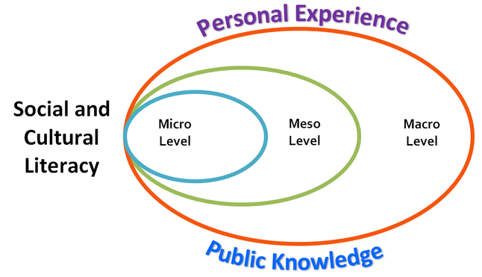

Social and Cultural Literacy
Personal experience refers to the knowledge gained from reflecting on individual experiences.
Public knowledge refers to general knowledge and the knowledge available to everyone. The term also refers to all the knowledge found in the public domain that is the work or research of other people.
Micro-level interactions are personal and occur between individuals and their family, peers and individuals in the community.
Meso-level interactions occur between the micro and the macro levels of society. Meso-level structures are groups in the community, village, school, workplace, local interest club, branch, organisation and state. The meso level is also known as the middle level.
Macro-level interactions are impersonal and relate to large institutions, the media, law and
government and are evident at a national and international level.

Interactions exist between micro and meso, micro and macro,and meso and macro levels.
Interactions should be viewed as two-way.

ACTIVITY
Instructions: Complete the activity below based on the information provided and your own knowledge and experience.
CONCEPT | DEFINITION | EXAMPLES
Power
Authority
Gender
CONCEPT | DEFINITION | EXAMPLES
Identity
Technologies
Gender

Answer:
1. Who holds power in your family? _________________________________________________
2. How is that power used ? _______________________________________________________
____________________________________________________________________________________________________________________________________________________________
3. Who has authority in your family? ________________________________________________
4. How is that authority used? _________________________________________________________________________________________________________________________________________________________________________________________________________________________________________
5. Who holds power in your everyday experience of school? _____________________________
_____________________________________________________________________________
6. How is that power used? _______________________________________________________
____________________________________________________________________________________________________________________________________________________________
7. Who has authority in your school? ________________________________________________
______________________________________________________________________________
8. How is that authority applied? ____________________________________________________
________________________________________________________________________________________________________________________________________________________________________________________________________________________________________________________________________________________________________________________
9.List 3 male gender stereotypes and 3 female gender stereotypes
______________________________________________________________________________________________________________________________________________________________________________________________________________________________________________________________________________________________________________________________________________________________________________________________________
10. Will these stereotypes change over time? If so, how and why? _________________________
______________________________________________________________________________
______________________________________________________________________________
______________________________________________________________________________
11. Research: Provide an example of 2 types of technology that was essential in each of the following periods of history and explain why each was so important in those times:

Medieval times: _________________________________________________________________
______________________________________________________________________________
________________________________________________________________________________________________________________________________________________________________________________________________________________________________________________________________________________________________________________________________________________________________________________________________________________________________________________________________________________________________________________________________________________________________________________________________________________________________________________

The Industrial Revolution: _________________________________________________________
____________________________________________________________________________________________________________________________________________________________________________________________________________________________________________________________________________________________________________________________________________________________________________________________________________________________________________________________________________________________________________________________________________________________________________________________________________________________________________________________________________________________________________________________________________________________________________________________________________

The Information Revolution: __________________________________________________________________________________________________________________________________________________________________________________________________________________________________________________________________________________________________________________________________________________________________________________________________________________________________________________________________________________________________________________________________________________________________________________________________________________________________________________________________________________________________________________________________________________________________________________________________________________________________________________________________________________________

12. Identify 5 examples of globalisation in today’s world _________________________________
________________________________________________________________________________________________________________________________________________________________________________________________________________________________________________________________________________________________________________________
13. Imagine you live in the future and are digging the ruins of the city of Sydney. Identify 3 artefacts you might uncover that would be evidence of Sydney having been a globalised city. Explain. _____________________________________________________________________________________________________________________________________________________________________________________________________________________________________________________________________________________________________________________________________________________________________________________________________________________________________________________________________________________________________________________________________________________________________________________________________________________________________________________________________________________________________________________________

Use the ALARM Structure outlined below to respond:

14. ‘Gender is power’- Discuss.
___________________________________________________________________________________________________________________________________________________________________________________________________________________________________________________________________________________________________________________________________________________________________________________________________________________________________________________________________________________________________________________________________________________________________________________________________________________________________________________________________________________________________________________________________________________________________________________________________________________________________________________________________________________________________________________________________________________________________________________________________________________________________________________________________________________________________________________________________________________________________________________________________________________________________________________________________________________________________________________________________________________________________________________________________________________________________________________________________________________________________________________________________________________________________________________________________________________________________________________________________________________________________________________________________________________________________________________________________________________________________________________________________________________________________________________________________________________________________________________________________________________________________________________________________________________________________________________________________________________________________________________________________________________________________________________________________________________________________________________________________________________________________________________________________________________________________________________________________________________________________________________________________________________________________________________________________________________________________________________________________________________________________________________________________________________________________________________________________________________________________________________________________________________________________________________________________________________________________________________________________________________________________________________________________________________________________________________________________________________________________________________________________________________________________________________________________________________________________________________________________________________________________________________________________________________________________________________________________________________________________________________________________________________________________________________________________________________________________________________________________________________________________________________________________

TO PEEL AND ALARM
ALARM – A Learning and Responding Matrix
https://www.virtuallibrary.info/alarm.html
Why ALARM?

ALARM was developed by ESL Teacher Max Woods. It aimed to assist students to improve their writing skills by making each body paragraph specific. This, however, was not the motivation behind its development.
ALARM seeks to help students learn how to learn by making the learning process EXPLICIT. It is important to understand how to learn if we are to take on board more than just the content to be learned. Understanding how to learn, rather than just the content, is the key to becoming lifelong learners.
Another purpose of ALARM is to promote deep understanding, rather than superficial knowledge which is learned by rote. This is achieved partly by requiring us to employ higher order thinking skills, such as analysis and evaluation, but primarily by asking provocative questions, which promote inquiry and reflection. ALARM fundamentally challenges the role of the teacher - demanding that the teacher primarily be the lead enquirer, rather than providing students with the answers immediately.
How does ALARM work?
ALARM:
- provides a step by step guide to the process of learning and then responding to a question
- makes explicit the ordering of concepts from simple to complex
- allows students to tap into higher order concepts throughout the teaching process
- aids students to identify gaps in their knowledge
- allows students to communicate with a common terminology across the curriculum
- provides templates which can be adapted to suit content area, complexity of information, level of depth required

TOPIC SENTENCE | POINT | EVIDENCE | EXPLAIN | LINK TO QUESTION
Name and Define  (Identify the points/  argument) | Describe  (Outline the details of the points/  argument) | Explain  (Express the reason for this point/  argument) | Evidence (Provide evidence to support your point/  argument) | Analyse (Express how/why the evidence supports your point/  argument) | Evaluate  (Express an opinion/  judgement on the significance  /impact of your point/  argument)

Sample Body Paragraph.
‘Egypt is the gift of the Nile.’ (a quote from the historian Herodotus). Assess this statement.
The River Nile is incredibly important to Egypt. The river runs the entire length of Egypt with fertile land on either side. Egypt is located in a desert environment and it is this river which allows it to flourish. The important historian Herodotus stated that is was a ‘gift’ to the Egyptians. It is this water that provided transport, water for drinking and crops for the Egyptians. Therefore without the Nile River, Egypt would have been a desert area which did not allow for habitation, for food sources and the development of society.
Costello, C. (2015). ALARM- A learning and responding matrix. Virtual Library. Retrieved from https://www.virtuallibrary.info/alarm.html

Secondary research
Watch the following clips & read the newspaper article.
Answer the questions below for each clip & the newspaper article.

Clip 1:
Where the hell is Matt? 2012

https://www.youtube.com/watch?v=Pwe-pA6TaZk

Clip 2:
The women behind the Napoleon Perdis beauty empire
https://au.tv.yahoo.com/the-morning-show/video/watch/29174447/the-women-behind-the-napoleon-perdis-beauty-empire/#page1

Clip 3:
Changing the world, One word at a time! The Queen Latifah Show.
https://www.youtube.com/watch?v=YshUDa10JYY

Clip 4:
Married to the Moonies
https://vimeo.com/43248078

Newspaper article 1:
Vast majority of faiths inspired by Spaghetti and Maradona
http://www.dailytelegraph.com.au/news/vast-show-of-faiths-inspired-by-spaghetti-and-maradona/news-story/2cc64b311efd9a4558ad7d60878d3b28

Vast show of faiths inspired by spaghetti and Maradona
Marea Donnelly, History Writer, The Daily Telegraph
December 22, 2015 12:00am

About 73,000 Australians identified as Jedis in the 2001 census
To believers of established faiths, a denomination convinced that humans evolved from pirates, while heaven promises a beer volcano, is at best parody and at worst something far more sinister.But after an Australian member last month won the right to wear a spaghetti strainer headdress in a driver’s licence photo, members of the Church Of The Flying Spaghetti Monster now hope to win the legal right to celebrate marriages in New Zealand by next month. The group is the most recent of dozens of unusual faiths adopted and promoted around the world. Their beliefs span telepathic communication with extraterrestrials to worship of British royal consort Prince Philip and Argentinian soccer legend Diego Maradona.
Church Of The Flying Spaghetti Monster
Identifying as Pastafarians, the group evolved in 2005 in protest against teaching evolution and “intelligent design”, or belief in a universal creator, in Kansas schools. Despite an apparently irreverent faith promoting “a lighthearted view of religion”, the church gained followers in Germany and Poland, where a Warsaw court paved the way for official recognition. US physics graduate Bobby Henderson, then 24, inspired the movement in a letter to the Kansas State Board of Education about teaching intelligent design in biology classes. Henderson argued his belief that “a Flying Spaghetti Monster” created the universe and intelligent design were equally valid.
Cosmic People of Light Powers
Founded in 1997 by Ivo Benda, an information systems engineer with the Czech Skoda car company, two years after cowherd Miloslav Drskova “changed his world” by introducing him to communications with extraterrestrials on the planet Pleiades. Influenced by Czech “spiritual scientist” and ufologist Eduard Meier, Benda believes extraterrestrial civilisations have spaceships orbiting Earth to watch and help the good, who will be transported into another dimension. Claiming 12,000 followers, in 2001 Benda contacted Czech president Vaclav Havel and Slovak president Rudolf Schuster to request a meeting between extraterrestrial civilisations and heads of state.
Church of All Worlds
A revival of ancient polytheistic European and Middle Eastern worship began in Britain before World War II, but blossomed with devotion to nature and psychology from the late 1950s. The Church of All Worlds, founded in 1962 by Oberon Zell-Ravenheart and his wife Morning Glory Zell-Ravenheart, is one of America’s oldest neo-pagan deities. Partly based on Robert Heinlein’s 1961 science fiction novel, Stranger In A Strange Land, followers recognise Gaea as the Earth Mother Goddess and the Father God, as well as Faerie realms from Greek pantheons.
The Prince Philip Movement
The faith adopted by Kastom people on Vanuatu’s Tanna island in the 1950s was reinforced when Queen Elizabeth and Prince Philip visited in 1974. Yaohnanens believed Philip was an ancient divine being, the son of a mountain spirit who travelled to a distant land where he married a powerful lady, only to eventually return. Philip was sometimes considered a brother to John Frum of another Tanna cargo cult. Philip then sent a portrait to villagers, who responded with a traditional pig-killing club, or nal-nal. In compliance with their request, Philip sent a photograph of himself posing with the club.
Maradonian Church
Maradonians count the years since football legend Maradona’s birth in 1960. Devotees Hernan Amez, Alejandro Veron and Hector Campomar opened their church in 2001 in Rosario, 300km from Buenos Aires, using Maradona’s jersey number 10, or diez in Spanish, and dios, Spanish for God, as a symbol. With 200,000 followers, they celebrate the nativity on Maradona’s birthdate, October 30, and use an Anno Diego calendar, dating from 1960. Easter is celebrated on June 22 to honour Maradona leading Argentina to victory against England in the 1986 FIFA World Cup.
ANSWER:
- List the concepts related to the clips/newspaper article.

- Explain how the concepts are related to the clips/newspaper article.

- Describe how the clip assists with your understanding of the course using the ALARM structure.

Identify / Define

Describe

ACTIVITY
Using the ALARM structure, explain the significance of TWO CLIPS (CLIP 1, CLIP 2, CLIP 3) to Society and Culture.

Name and Define | Describe | Explain | Evidence | Analyse | Evaluate
Identify the points / argument | Outline the details of the points / argument | Express the reason for this point / argument | Provide evidence to support your point / argument | Express how/why the evidence supports your point / argument | Express an opinion / judgement on the significance / impact of your point/argument

________________________________________________________________________________________________________________________________________________________________________________________________________________________________________________________________________________________________________________________________________________________________________________________________________________________________________________________________________________________________________________________________________________________________________________________________________________________________________________________________________________________________________________________________________________________________________________________________________________________________________________________________________________________________________________________________________________________________________________________________________________________________________________________________________________________________________________________________________________________________________________________________________________________________________________________________________________________________________________________________________________________________________________________________________________________________________________________________________________________________________________________________________________________________________________________________________________________________________________________________________________________________________________________________________________________________________________________________________________________________________________________________________________________________________________________________________________
____________________________________________________________________________________________________________________________________________________________________________________________________________________________________________________________________________________________________________________________________________________________________________________________________________________________________________________________________________________________________________________________________________________________________________________________________________________________________________________________________________________________________________________________________________________________________________________________________________________________________________________________________________________________________________________________________________________________________________________________________________________________________________________________________________________________________________________________________________________________________________________________________________________________________________________________________________________________________________________________________________________________________________________________________________________________________________________________________________________________________________________________________________________________________________________________________________________________________________________________________________________________________________________________________________________________________________________________________________________________________________________________________________________________________________________________________________________________________________________________________________________________________________________________________________________________________________________________________________________________________________________________________________________________________________________________________________________________________________________________________________________________________________________________________________________________________________________________________________________________________________________________________________________________________________________________________________________________________________________________________________________________________________________________________________________________
______________________________________________________________________________________________________________________________________________________________________________________________________________________________________________________________________________________________________________________________________________________________________________________________________________________________________________________________________________________________________________________________________________________________________________________________________________________________________________________________________________________________________________________________
________________________________________________________________________________________________________________________________________________________________________________________________________________________________________________________________________________________________________________________
AN OVERVIEW IF THE MULTICULTURAL AND HYBRID NATURE OF SOCIETIES AND CULTURE
- Multicultural: relating to or containing several cultural or ethnic groups within a society.
- Homogenous Society: Single or one identity
- Hybrid Society: A range of social and cultural influences and components

Multiculturalism...

Definition
Multiculturalism is a term which recognises and celebrates the cultural diversity of Australia’s population.
Cultural and linguistic diversity has always been a feature of Aboriginal and Torres Strait Islander societies. In the past 200 years this diversity has been augmented with the settlement of over six million migrants. The 2001 Census determined that 43% of Australians were either born overseas or had at least one parent born overseas. This diversity has had a marked influence on all aspects of our society.
Multiculturalism is the third phase in the evolution of Australia’s public policies on cultural diversity and migration. In place since 1973, this policy respects and values the right of all Australians to express and share their individual cultural heritage within a cohesive and harmonious society, and within an overriding commitment to the basic structures and values of Australian democracy.

Government strategies, policies and programs have been implemented to promote social harmony among different cultural groups, optimise the benefits of cultural diversity for all Australians and make our administrative and economic infrastructure responsive to the rights, needs and responsibilities of different cultural groups. These have focussed on access and equity to public services, equal opportunity in employment, creation of the Special Broadcasting Service (SBS) and productive diversity. Productive diversity promotes utilising Australia’s language and cultural diversity for the economic and social benefits of all Australians.

What makes it hot?
Multiculturalism is a hot word as the idea of a culturally diverse society is not supported by all Australians.
Some people fear that a society inclusive of many cultures will lead to a breakdown in the social cohesion of the Australian community. Others view multiculturalism as a type of reverse racism which discriminates against "mainstream Australians" and benefits "minority groups".

Coexistence of people from diverse cultures is feasible when there is common agreement about basic principles such as respect for the rights and property of others, a commitment to democratic ideals and the rule of law. Many people recognise the reality of Australia as a multicultural society, are proud of the harmonious co-existence of diverse cultures and value the benefits arising from this.

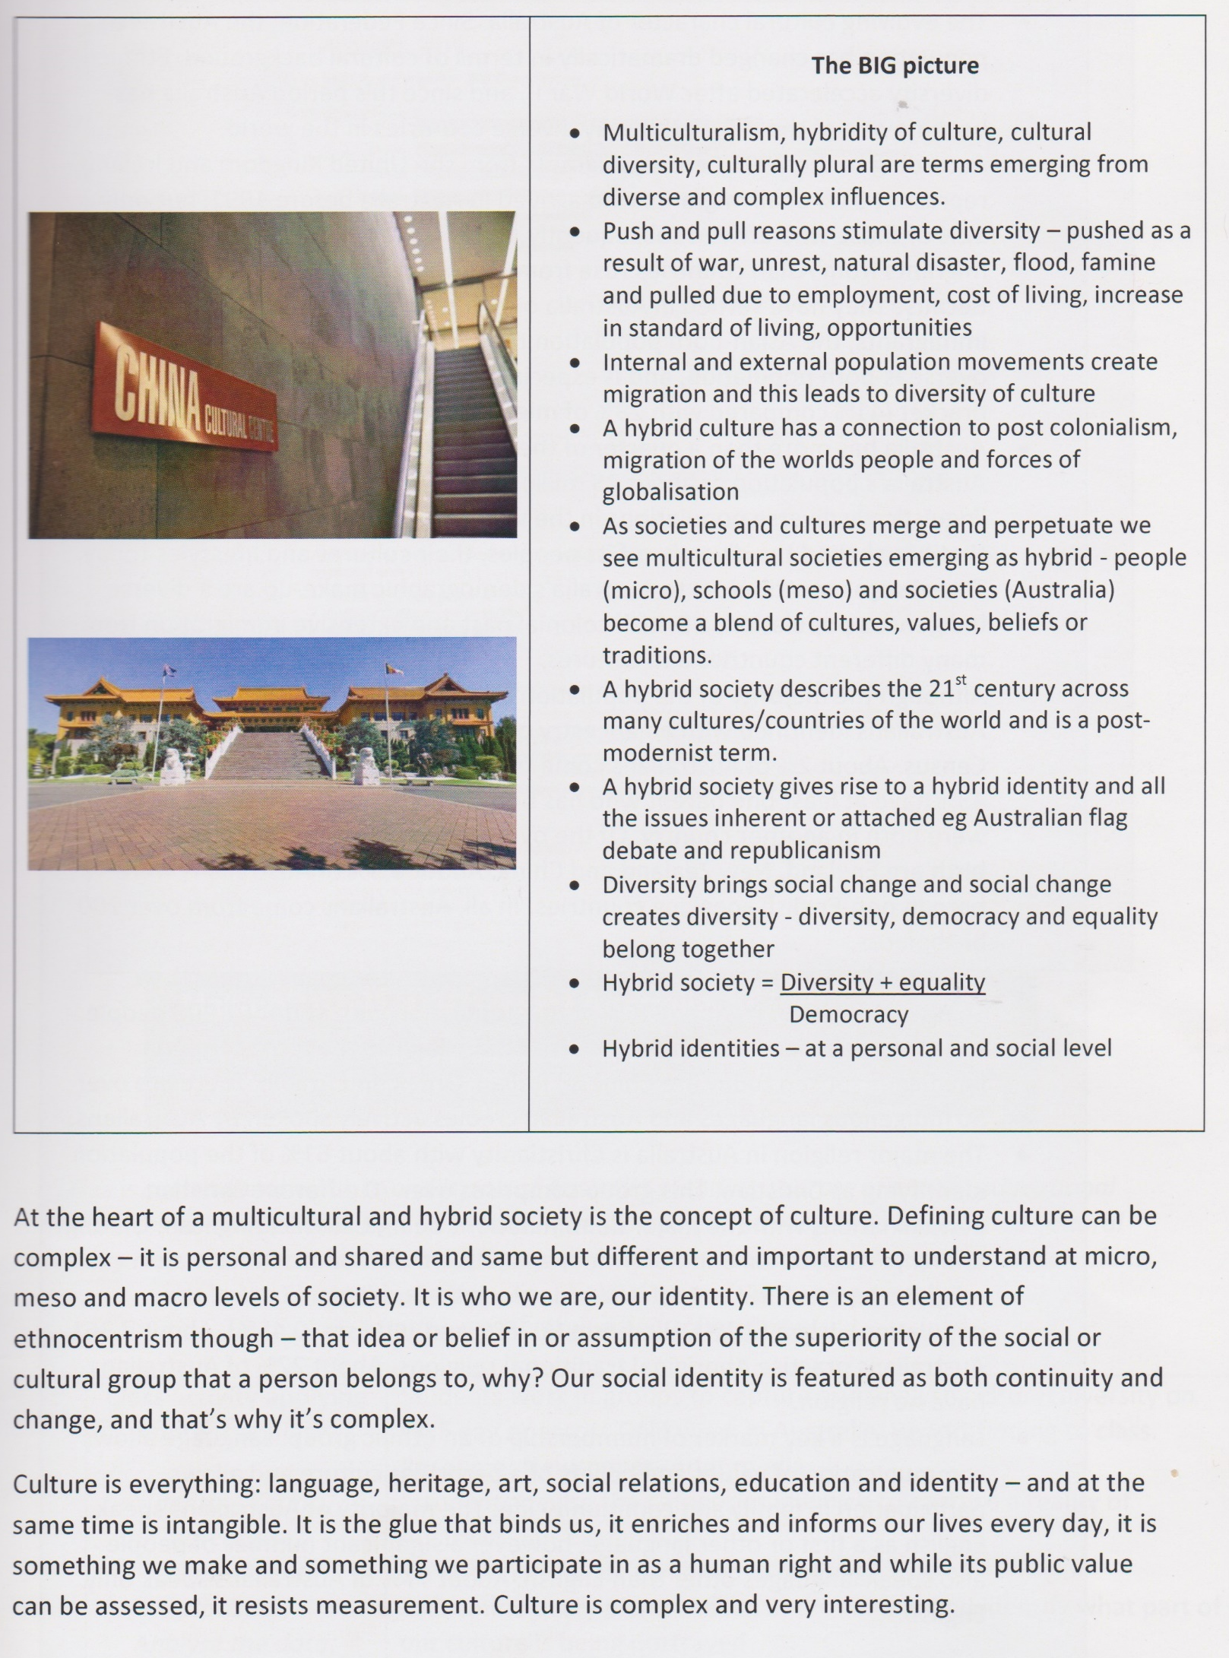
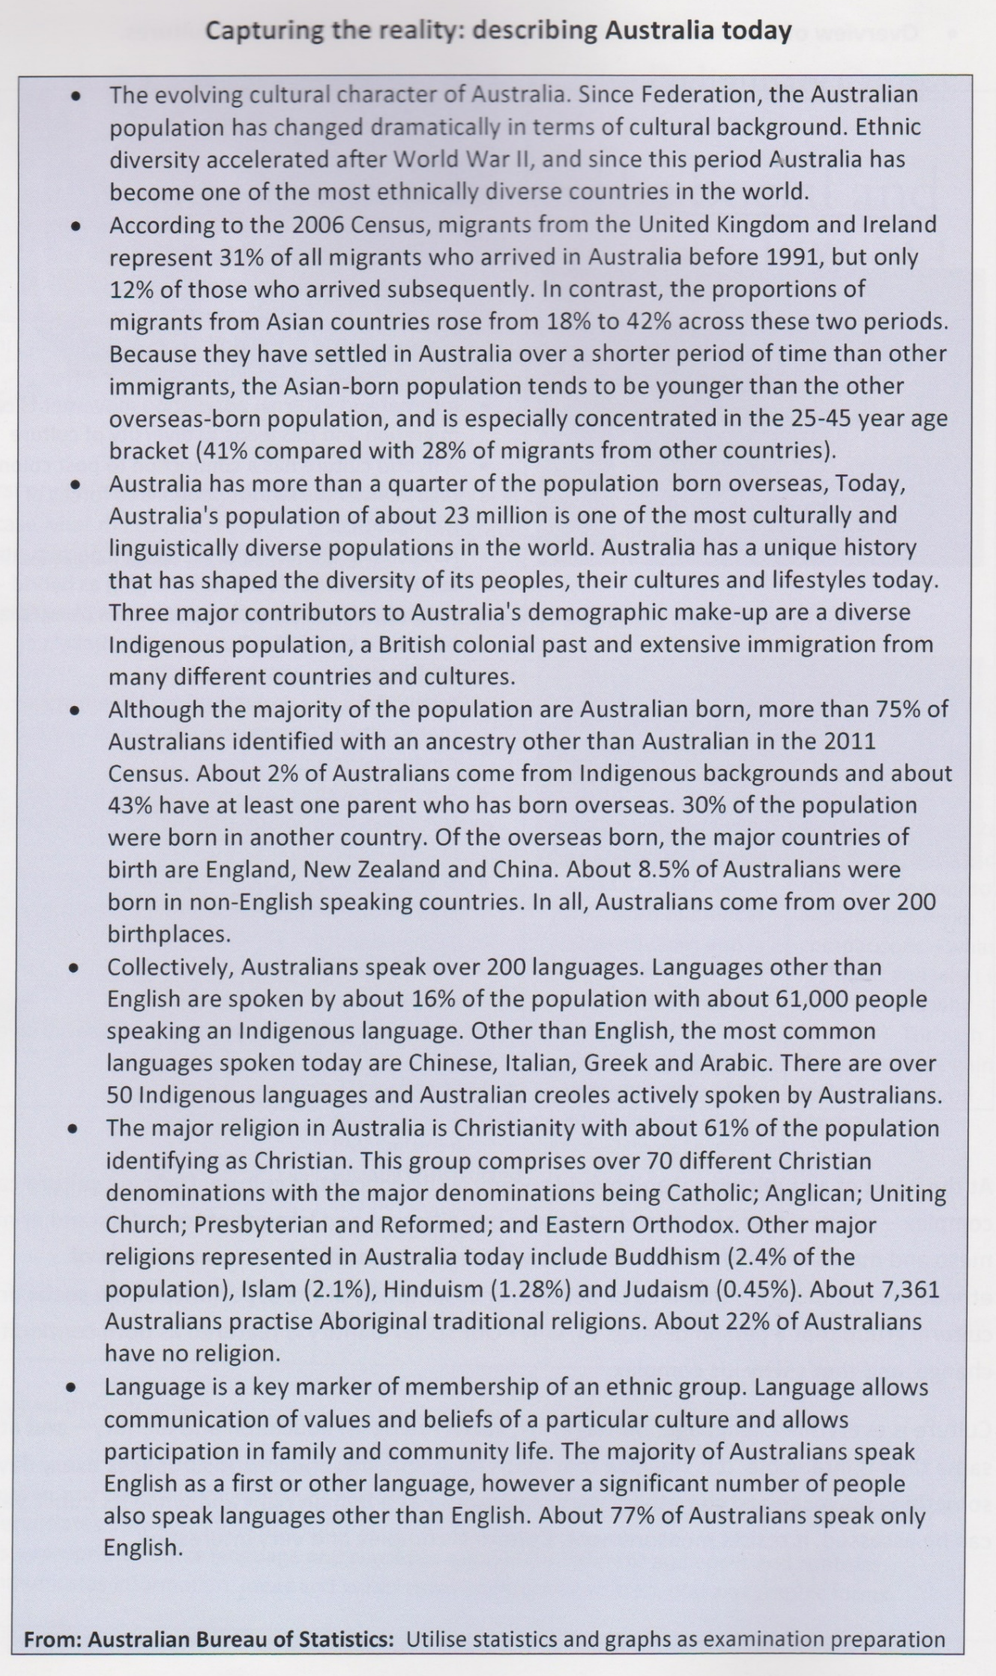
Indonesia: A Hybrid Society
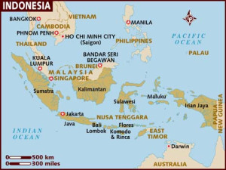
Read the following information and answer the questions in your exercise book.
Indonesia has a population of approximately 210 million people, from 300 different ethnic groups who speak more than 400 distinct languages and dialects. The Javanese are the largest ethnic group, comprising 41% of the population, and more than 85% of the population are Muslim, 10% Christian and 3% Hindu or Buddhist.
This diversity makes Indonesia a hybrid society. Rather than having a single or homogenous identity it is comprised of a range of social and cultural influences and components. As you know from Australia, a family from a Chinese or Indian background will have a very different customs and values compared to a family from an English or Greek background, although there will be some central Australian values and behaviours that will be common to all.
Since gaining independence in 1945 the Indonesian government has followed a philosophy known as the Pancasila – meaning “five principles” in the Sanskrit language. This philosophy is designed to unite the various ethnic groups and maintain national stability.
Top of Form

A plural society
Bali is renowned for its identity as a Hindu-Buddhist island in the Indonesian archipelago, the world’s most populous Muslim nation. Yet Bali in fact has a substantial Muslim minority. Muslims residing in rural areas are usually descendants of long-standing populations, with origins in Java, Madura, South Sulawesi (Bugis), Lombok (Sasak), or elsewhere in the Indonesian-Malaysian region. These Muslims — who have long histories in Bali — are known as Bali Slam, or Bali Muslims, and have assimilated to Balinese identity. They are culturally Balinese. A few live in predominantly Muslim villages, but most live in mixed Hindu-Muslim communities.
As the last published census of 2000 revealed, meanwhile, the number of Muslims in Bali has grown quite dramatically in a short time. In that year, 9.7 per cent of the island’s population was Muslim, up from six per cent less than a decade earlier.
With a population of 3,890,757 in the 2010 census and 4,225,000 as of January 2014, the island is home to most of Indonesia’s Hindu Minority. According to the 2010 Census 83.5% of Bali’s population adhered to Balinese Hinduism, followed by 13.4% Muslim, Christianity at 2.5% and Buddhism 0.5%.
Most of the new arrivals are migrants from neighbouring islands who come in search of jobs. The increase may be associated in part with the growing tourism industry and its labour needs, but their numbers also escalated during the Asian financial crisis of the late 1990s, when Bali fared better than most areas of Indonesia. Bali is attractive, moreover, because it is considered one of the safest parts of Indonesia by Indonesians too. The new arrivals have settled mainly in the urban areas of southern Bali, where they serve as a cheap labour force. Accordingly, the percentage of Muslims in these areas, an estimated 17 per cent, is higher than average.
- Define ‘Multicultural’.
- What is a hybrid society? How is it different from a homogenous society?
- Explain how Australia adheres to being a multicultural society AND a hybrid society.
- Explain how Indonesia adheres to being a multicultural society AND a hybrid society.
MICRO, MESO AND MACRO LEVELS IN SOCIETY
See also Page 4 above

CONCEPT | DEFINITION | EXAMPLES
MICRO LEVEL
MESO LEVEL
MACRO LEVEL

SOCIAL AND CULTURAL PHENOMENA | Provide examples
 | MICRO LEVEL | MESO LEVEL | MACRO LEVEL
Having breakfast at home
Catching the bus to school
Updating your facebook status as ‘Looking for work’
Talking to your neighbour about working in her business
Viewing public Facebook profiles

DOCUMENTARY: MICHAEL PALIN’S SAHARA
PROGRAM 3: THE WODAABE PEOPLE
https://www.youtube.com/watch?v=goZJSkIFes8

- What are your first impressions of the Wodaabe?

- According to the French woman, what are the interactions like between the men and women?

- Describe what the men are doing. Why are they doing it?

- According to the narrator, how do the women look?

- How is the husband/man chosen?

- What is the most important status symbol?

- How does this link to the Micro Level in society?

Once upon a time in Punchbowl.
- LIST and EXPLAIN how this documentary relates to 5 key concepts
- Outline the struggles faced by the Lebanese community and the impact that this had for their community and for the rest of Australia.
- Using the ALARM structure, explain how this documentary relates to the following concepts:
  - Multiculturalism
  - Social expectations
  - Micro and Meso levels of society.
Name and Define | Describe | Explain | Evidence | Analyse | Evaluate
Identify the points / argument | Outline the details of the points / argument | Express the reason for this point / argument | Provide evidence to support your point / argument | Express how / why the evidence supports your point / argument | Express an opinion / judgement on the significance / impact of your point / argument

__________________________________________________________________________________________________________________________________________________________________________________________________________________________________________________________________________________________________________________________________________________________________________________________________________________________________________________________________________________________________________________________________________________________________________________________________________________________________________________________________________________________________________________________________________________________________________________________________________________________________________________________________________________________________________________________________________________________________________________________________________________________________________________________________________________________________________________________________________________________________________________________________________________________________________________________________________________________________________________________________________________________________________________________________________________________________________________________________________________________________________________________________________
____________________________________________________________________________________________________________________________________________________________________________________________________________________________________________________________________________________________________________________________________________________________________________________________________________________________________________________________________________________
__________________________________________________________________________________________________________________________________________________________________________________________________________________________________________________________________________________________________________________________________________________________________________________________________________________________________________________________________________________________________________________________________________________________________________________________________________________________________________________________________________________________________________________________________________________________________________________________________________________________________________________________________________________________________________________________________________________________________________________________________________________________________________________________________________________________________________________________________________________________________________________________________________________________________________________________________________________________________________________________________________________________________________________________________________________________________________________________________________________________________________________________________________
____________________________________________________________________________________________________________________________________________________________________________________________________________________________________________________________________________________________________________________________________________________________________________________________________________________________________________________________________________________
____________________________________________________________________________________________________________________________________________________________
____________________________________________________________________________________________________________________________________________________________________________________________________________________________________________________________________________________________________________________________________________________________________________________________________________________________________________________________________________________

SOCIETY AS A CONSTRUCT THAT DEVELOPS OVER TIME
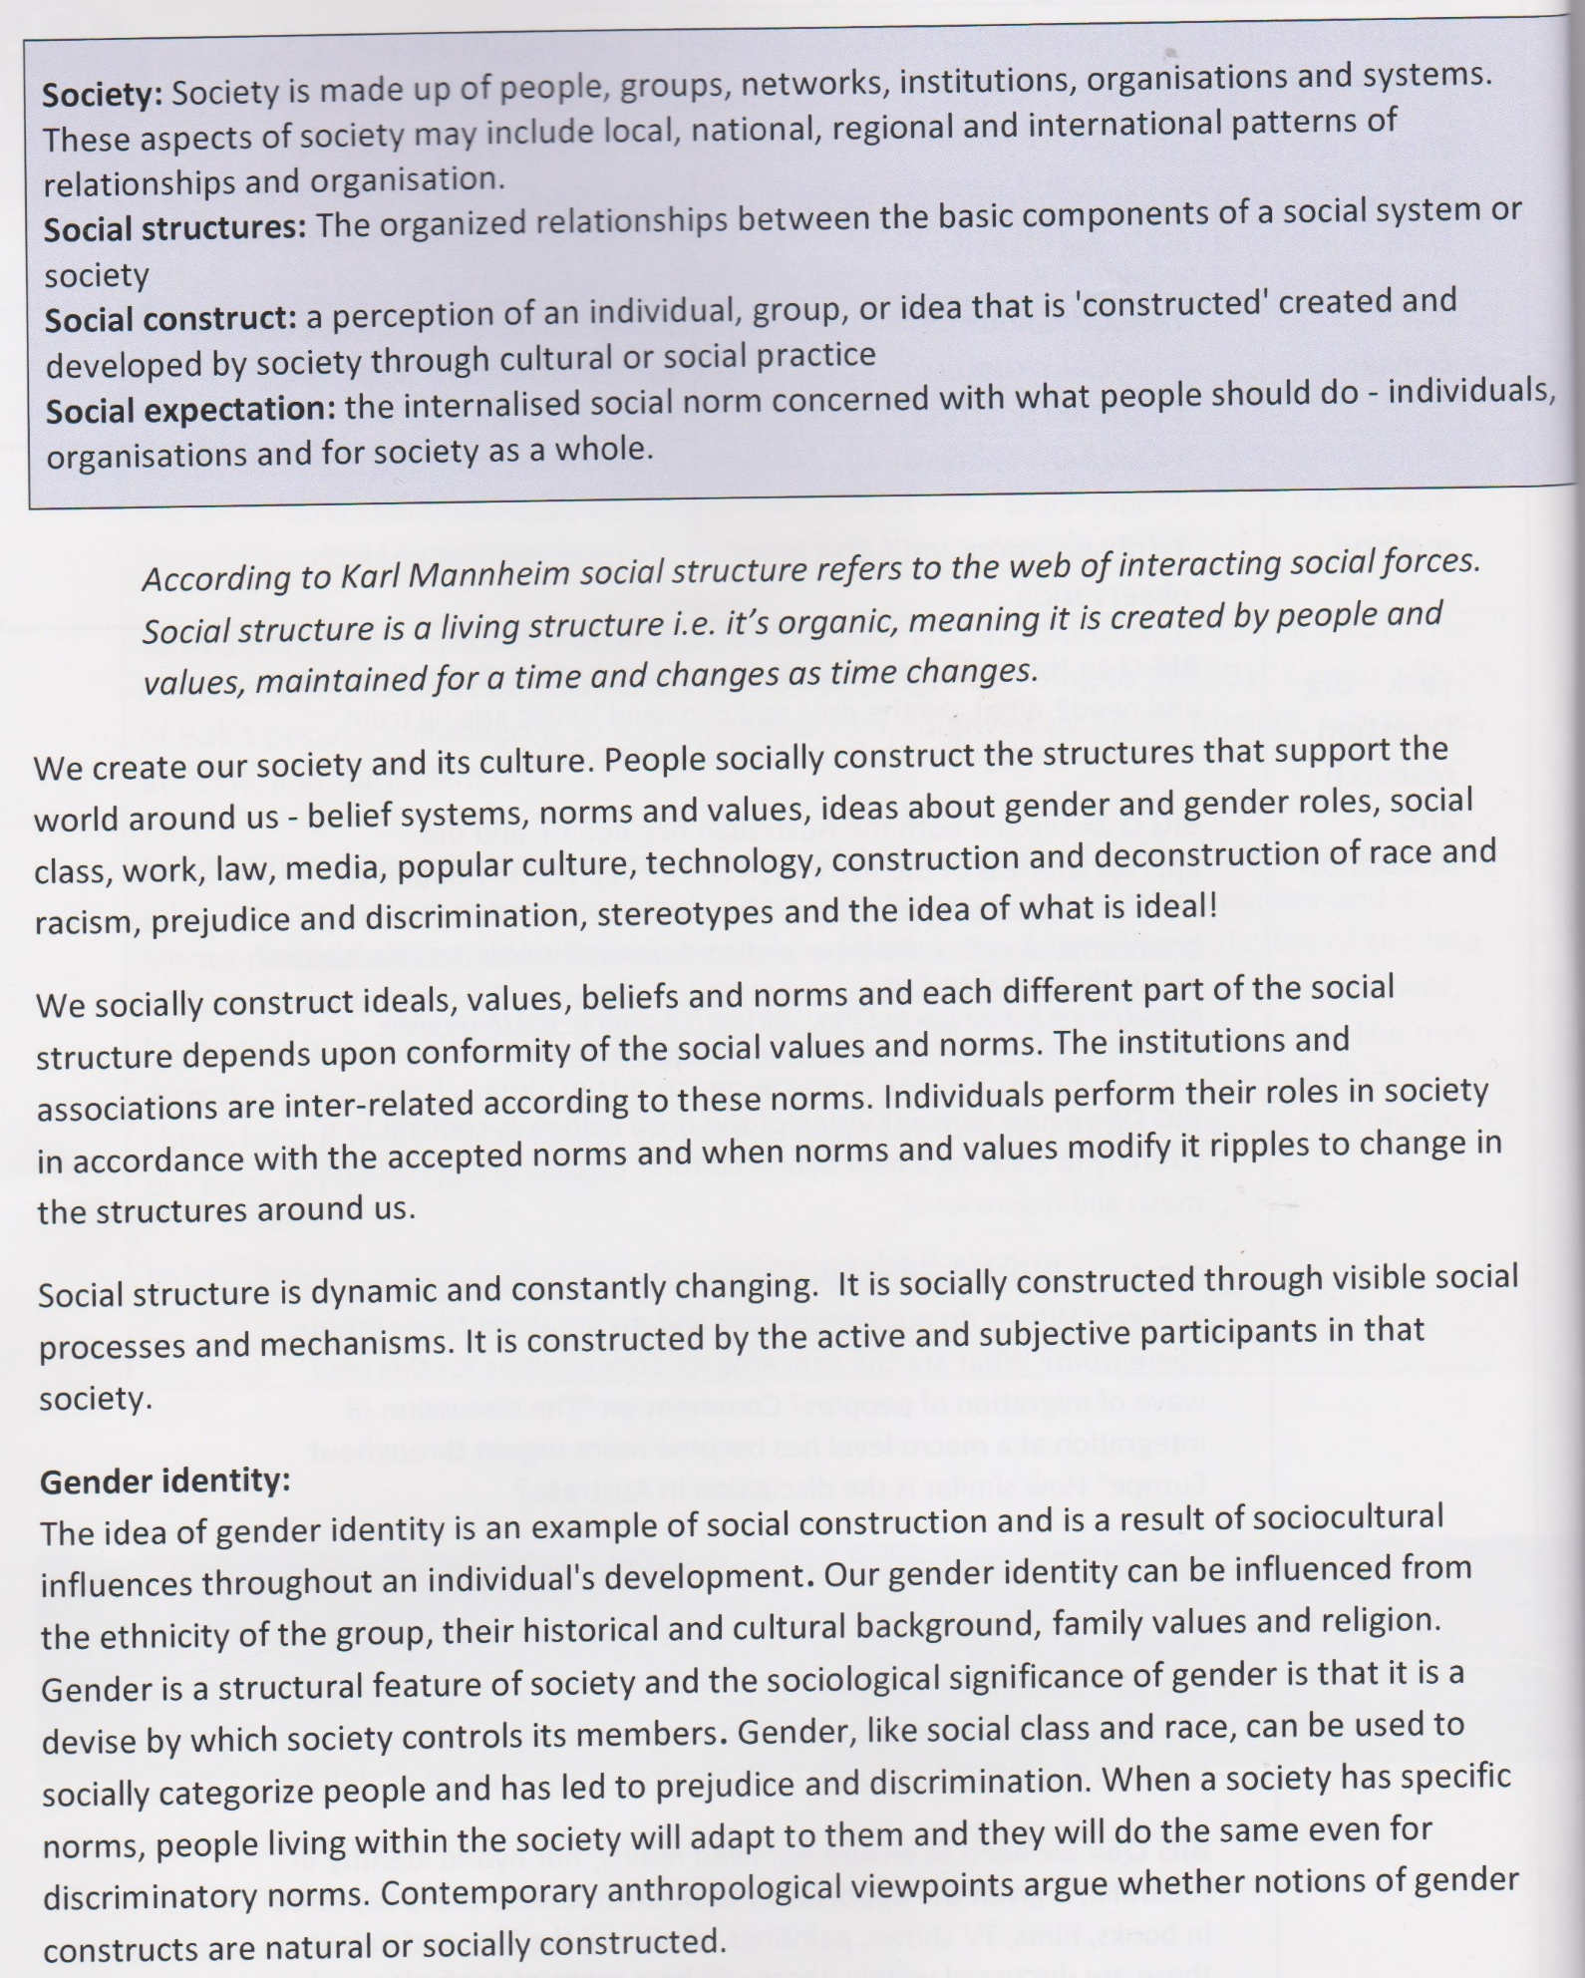

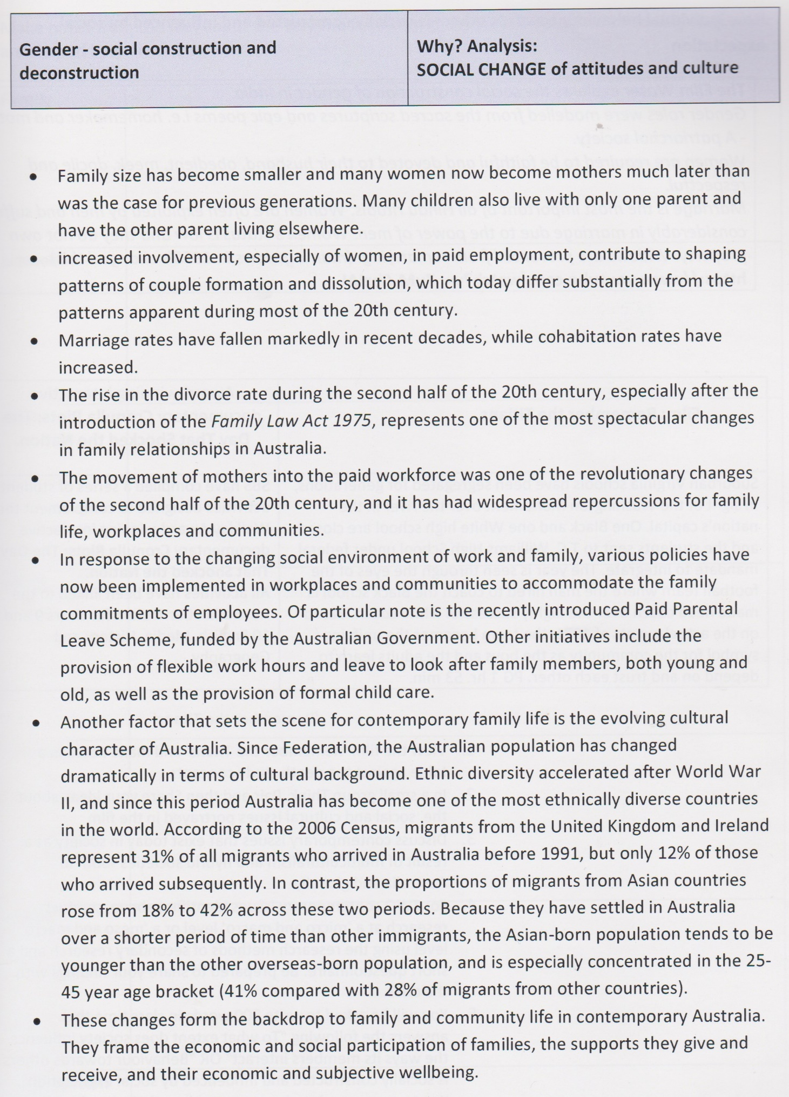
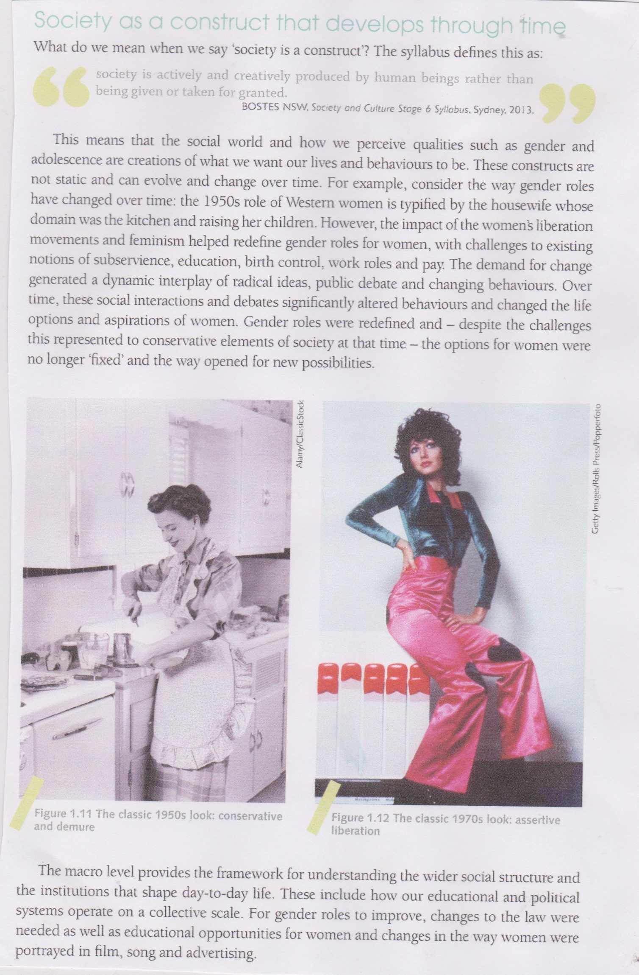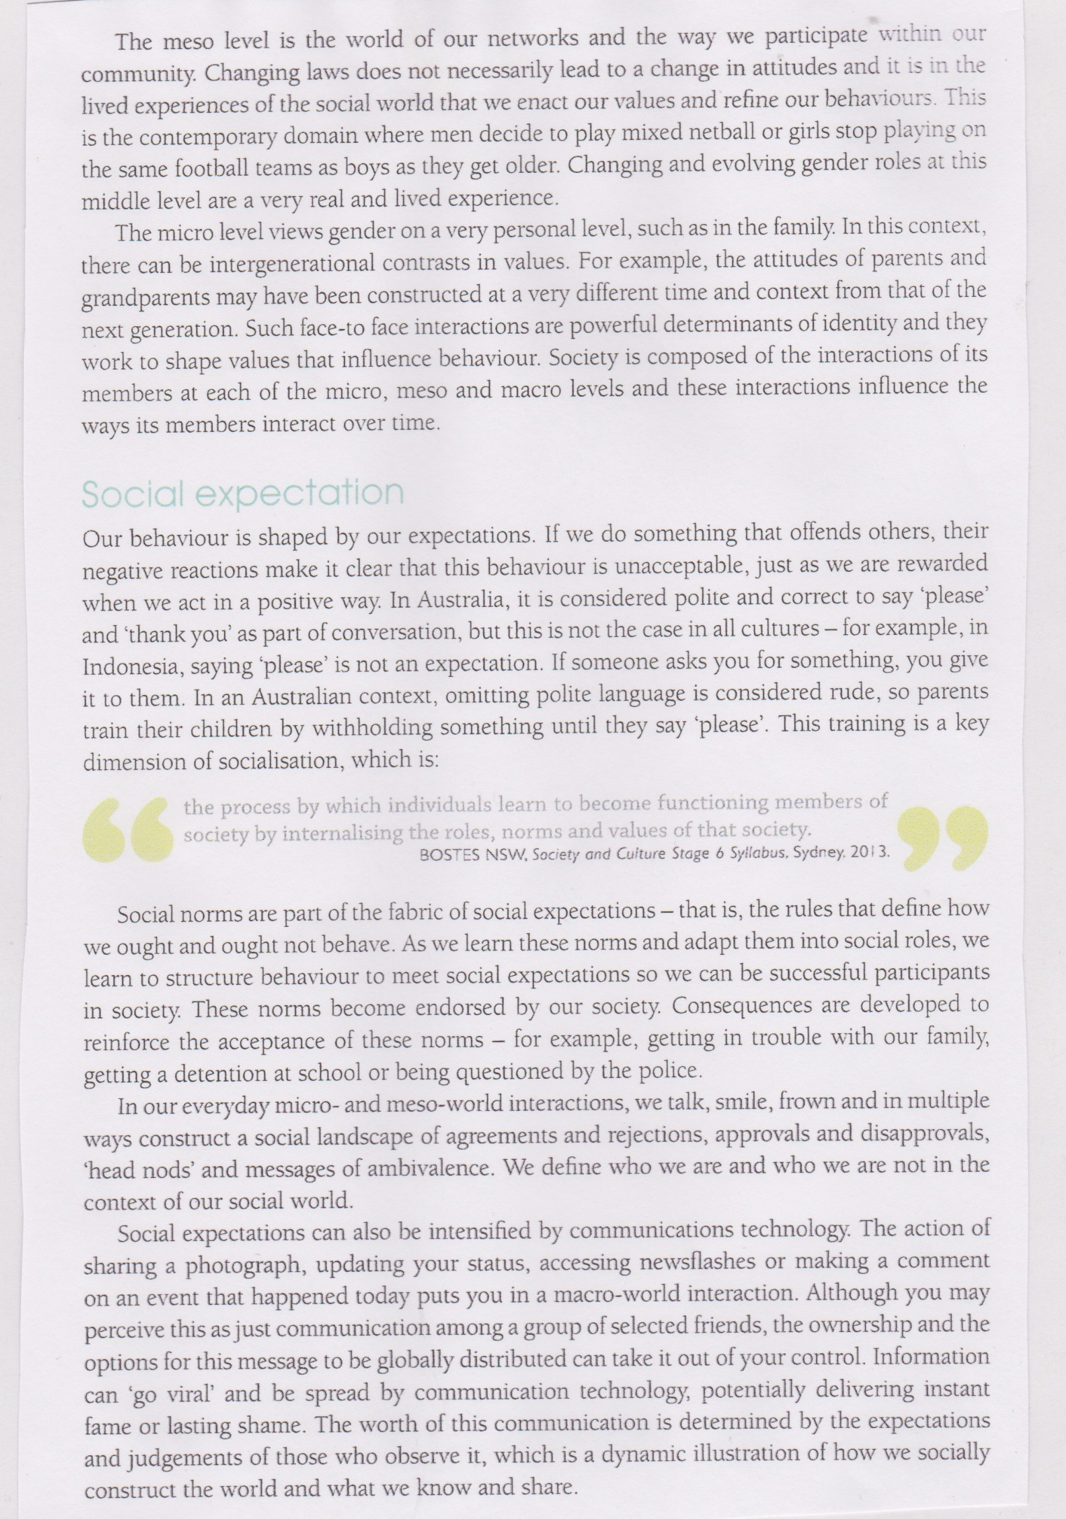
QUESTIONS
- Explain the concept ‘society is a social construct’.
- Define ‘social expectation’.
- Outline the social expectation of women and explain how they have changed since World War 2.
- Define ‘social norms’ and provide 5 examples.
- Explain how the concepts below relate to social expectations:
- Macro Level
- Micro Level
- Meso Level
- Explain how Social Expectations can be linked to communication technology.

GROUPS AND INSTITUTIONS OF SOCIETY
(HOW THEY SHAPE AND ARE SHAPED BY INDIVIDUALS)
In order to understand the social structure that makes up our social and cultural world, it is important to understand the roles of family, school, peers, work, government, media and the legal system. Read the following information and complete the table below.
GROUP/  INSTITUTION | Outline the role, influence and significance of each group/institution
FAMILY
SCHOOL
PEERS
WORK
GOVERNMENT
MEDIA
LEGAL SYSTEM
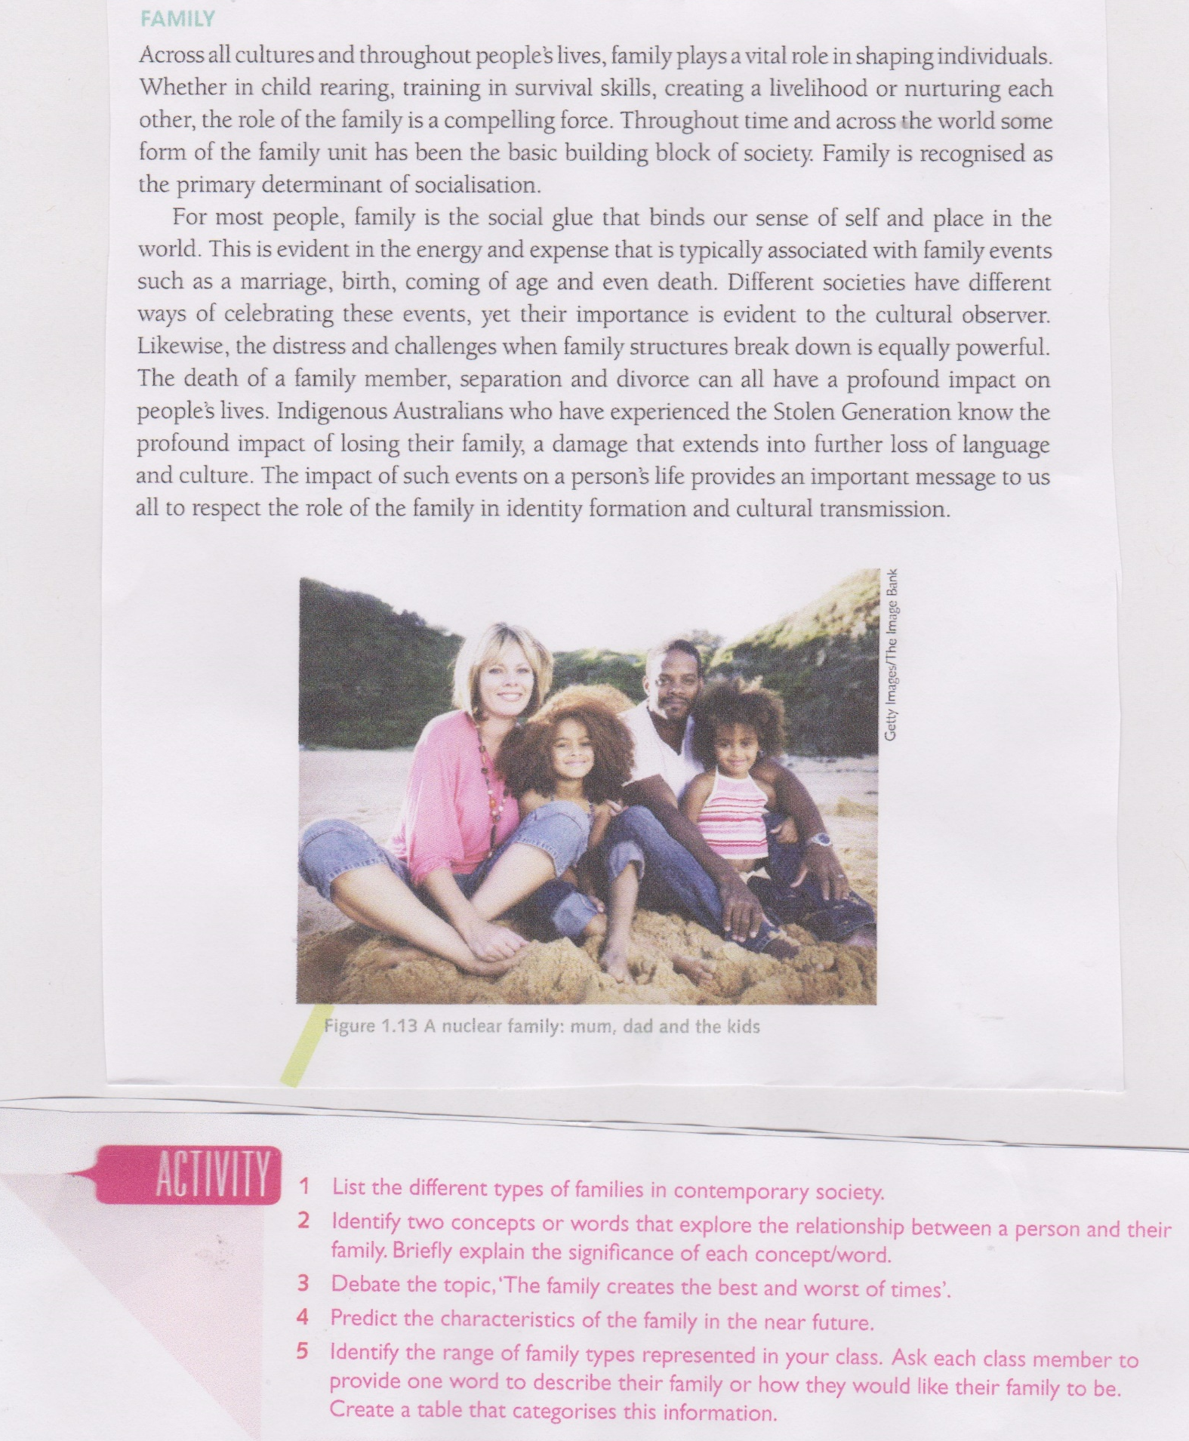

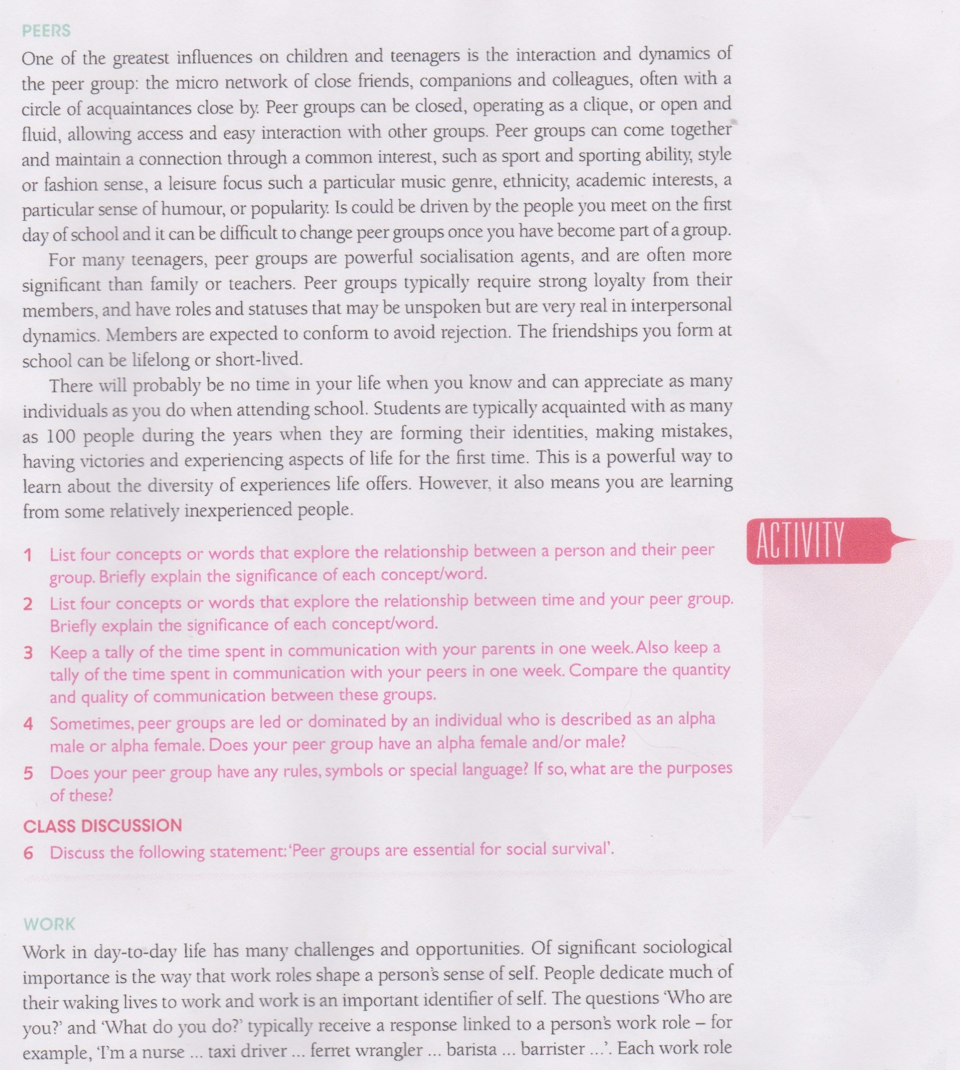
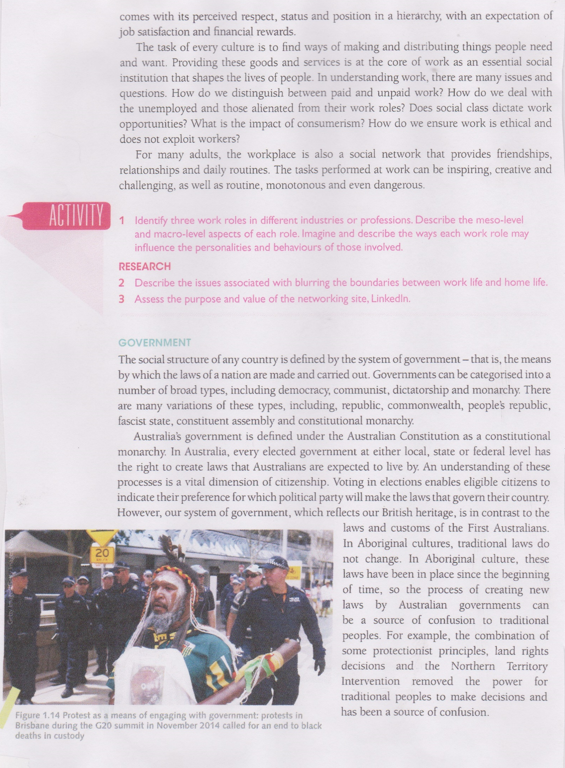
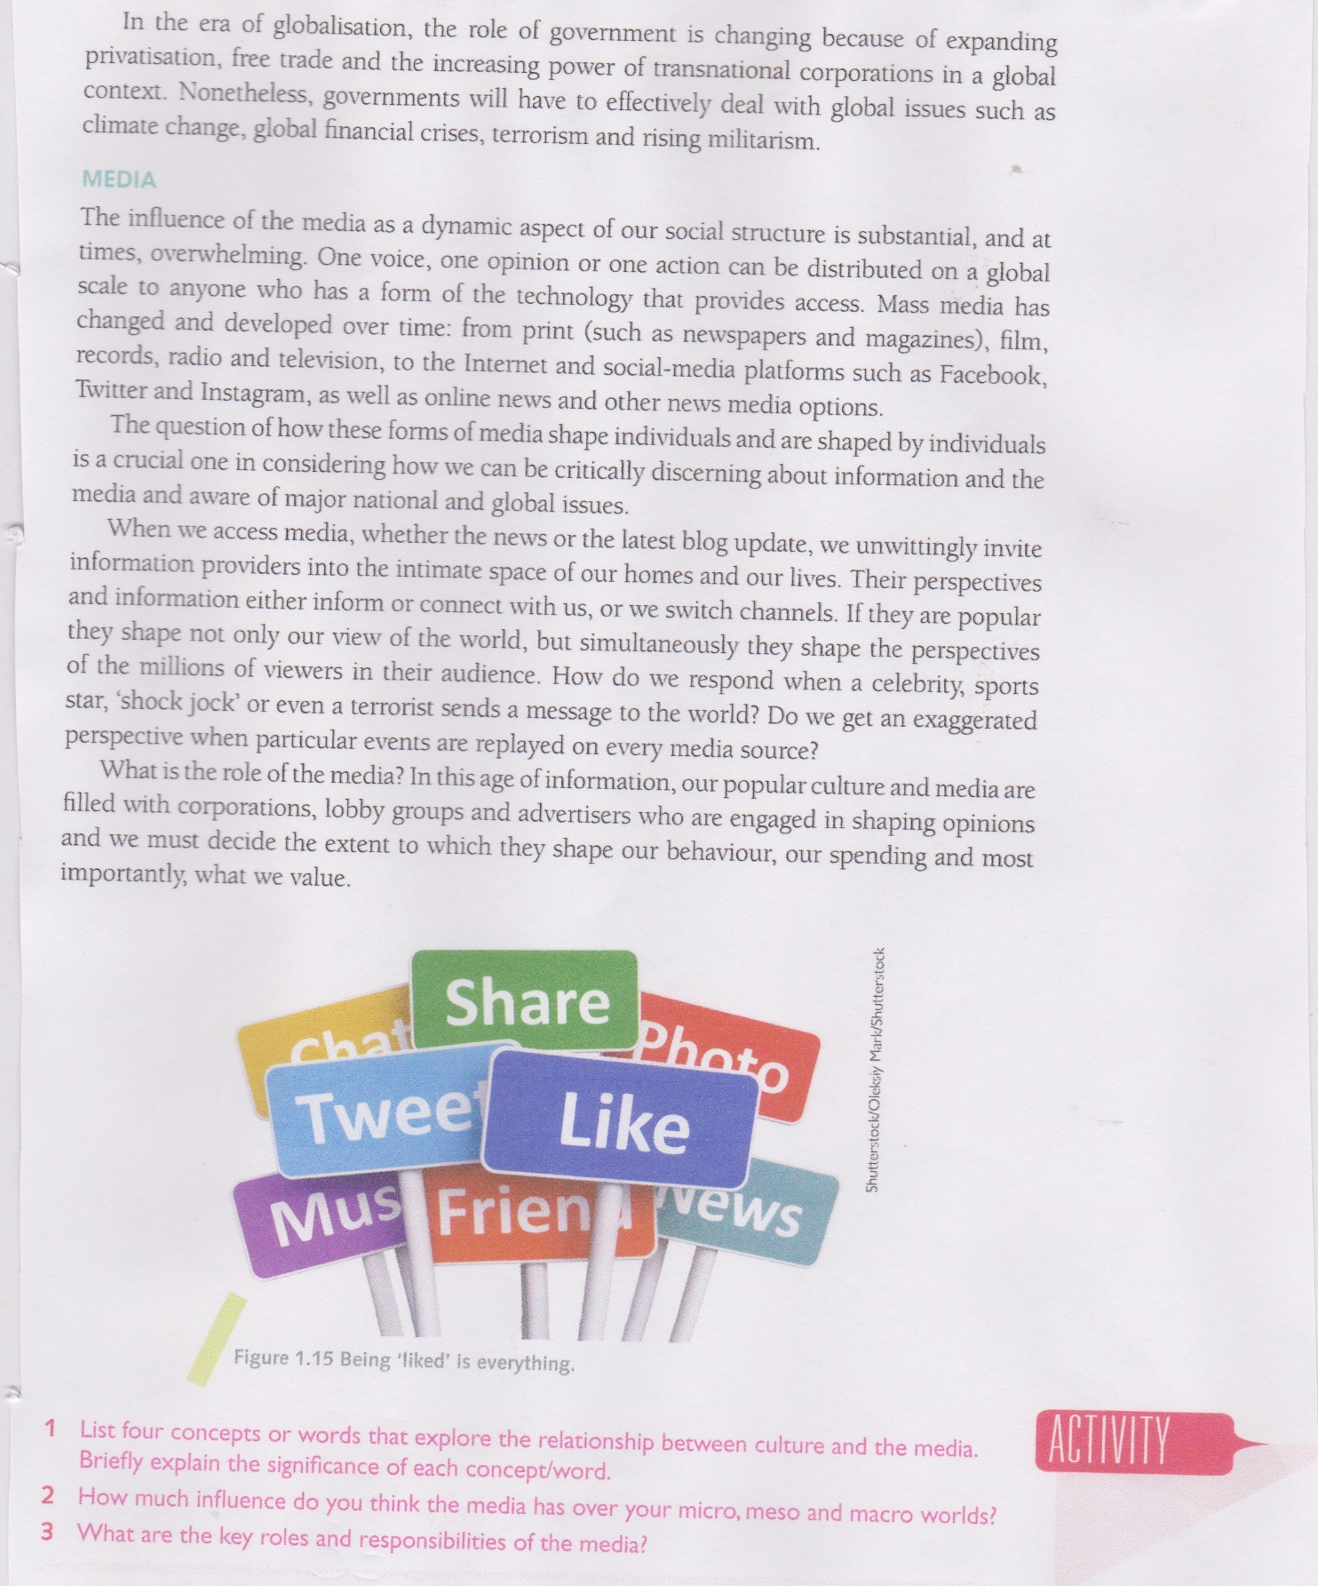
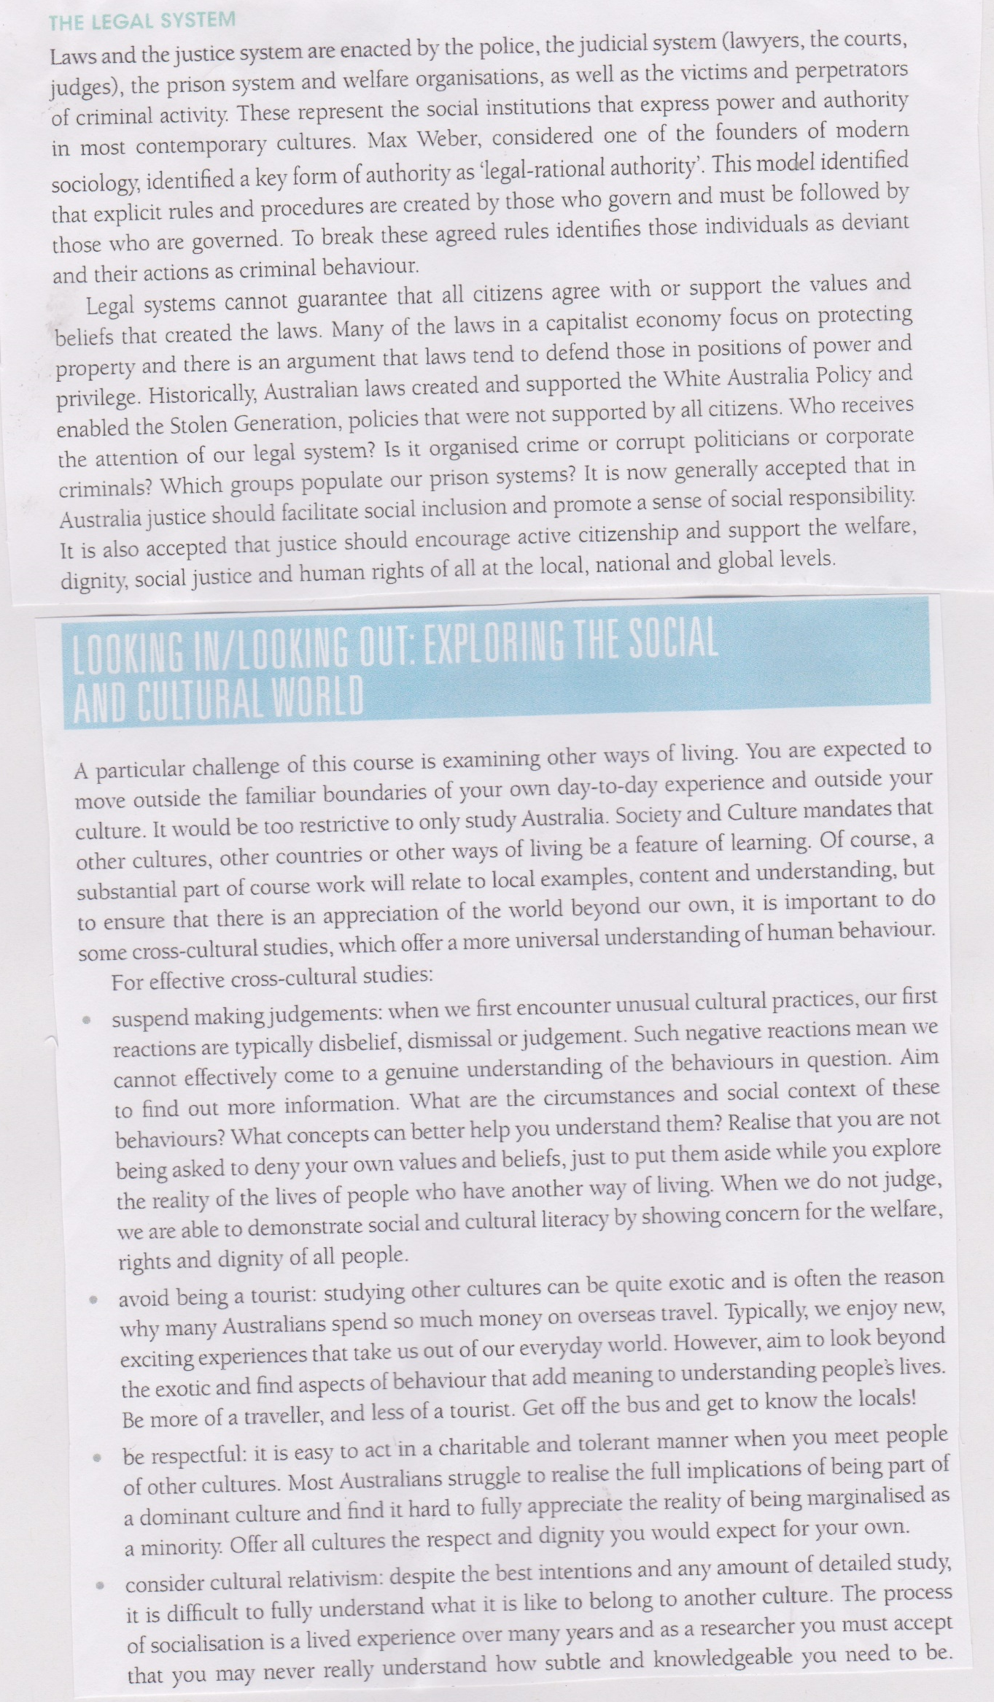

THE AMISH
Make notes based on the following information
History of the Amish
Religion
Ordnung
Family
Gender Roles (two sections)
Roles and Status
Adolescence and Rumschpringes
Conflict, co-operation and decision making
Communication
Power, Authority and influence
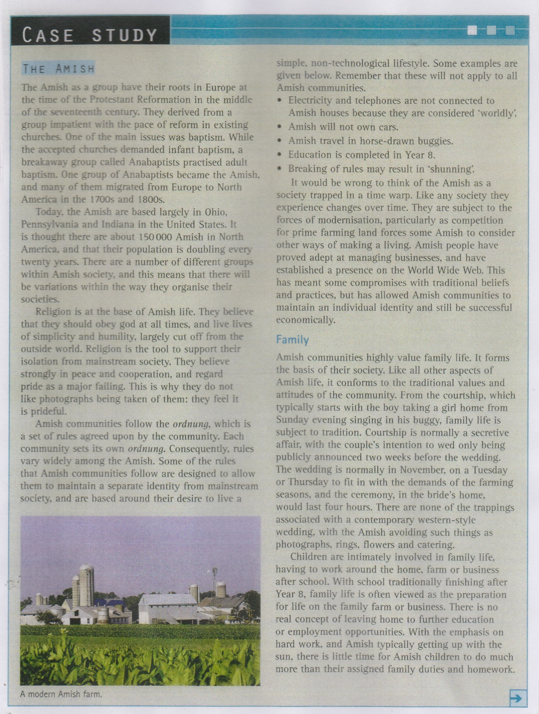
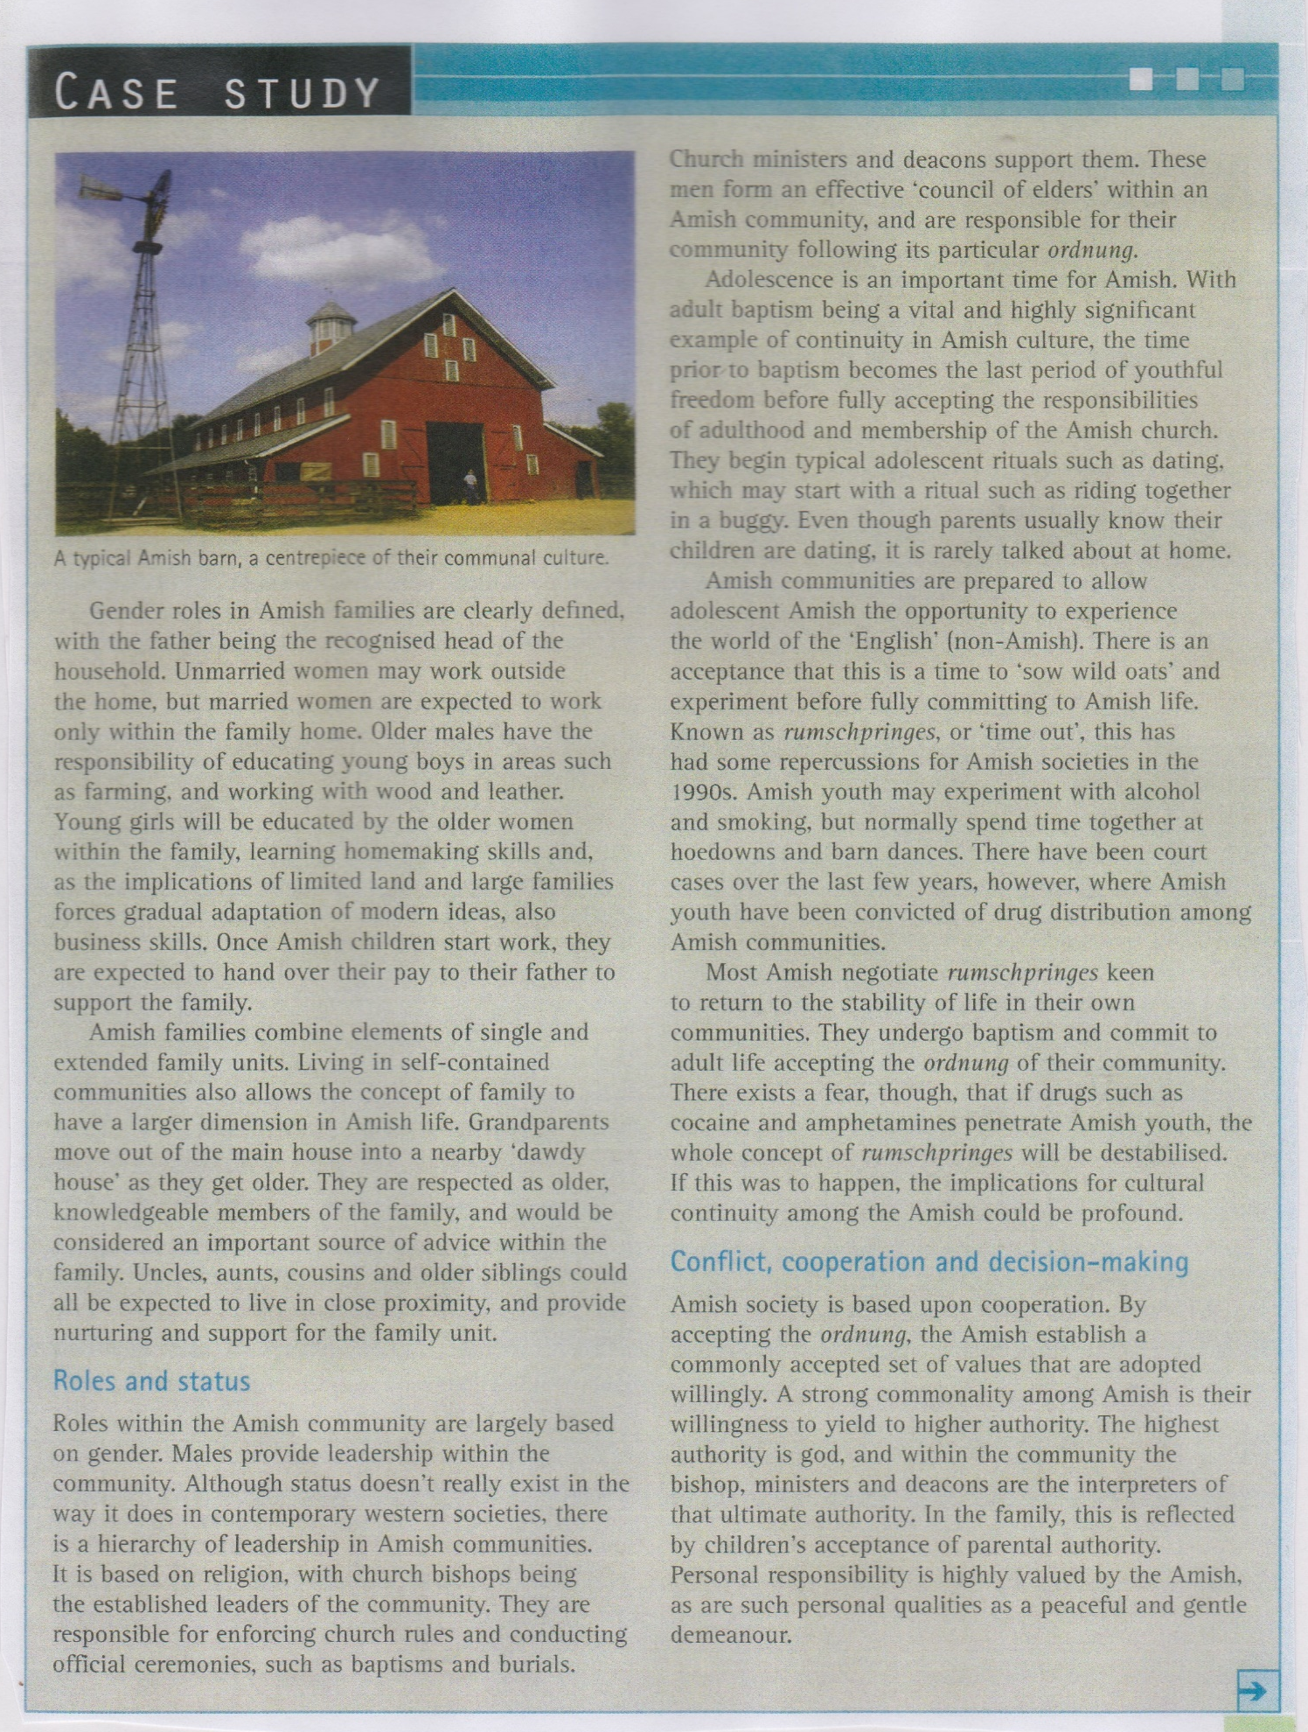
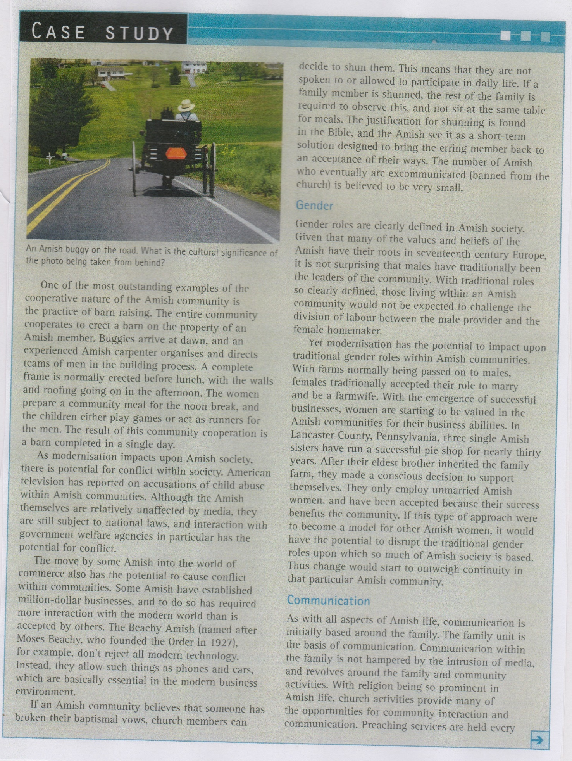
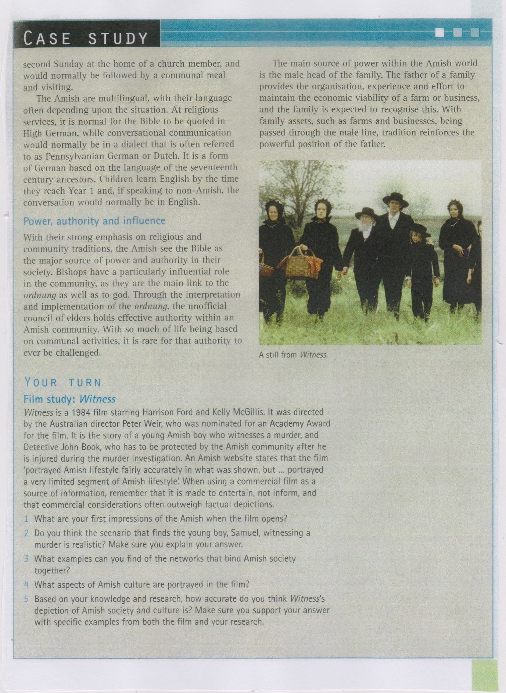
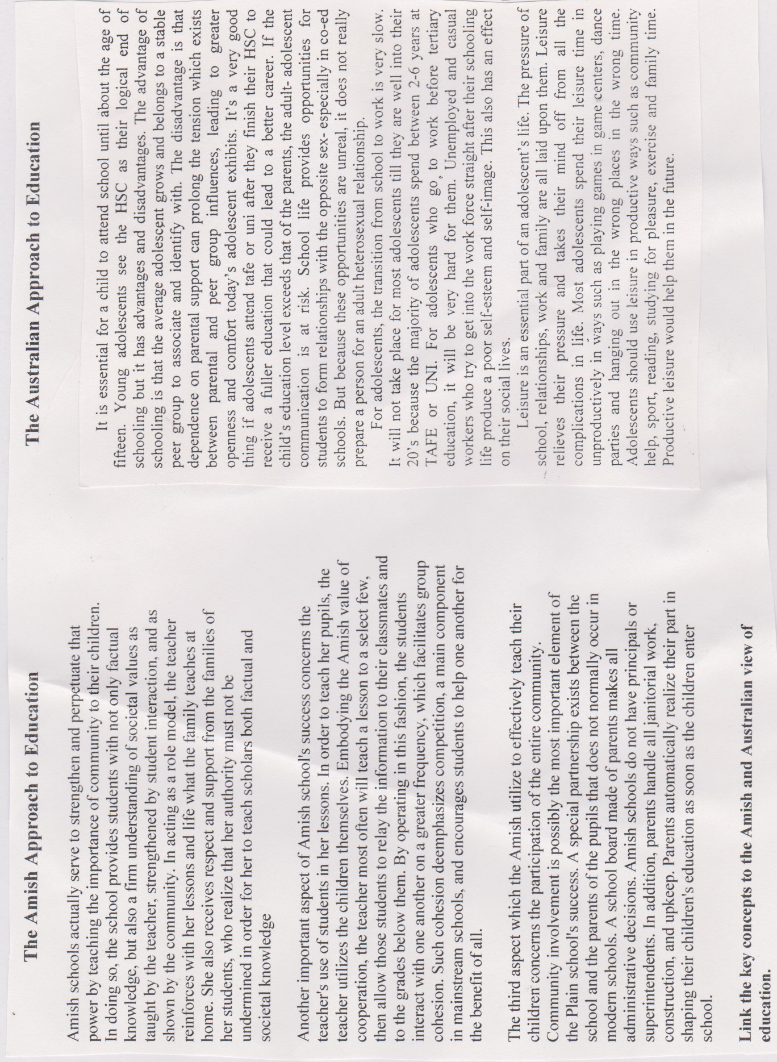

FILM STUDY: WITNESS
- What are your first impressions of the Amish when the film opens?

- Do you think that the scenario that finds the young boy, Samuel, witnessing a murder is realistic? Make sure you explain your answer.

- What examples can you find of the networks that bind the Amish together?

- What aspects of the Amish culture are portrayed in the film?

- Compare your own culture with the Amish – what do you share and what is different? Provide THREE similarities and THREE differences.

FILM STUDY: WITNESS
Make notes from the film about the way the following groups and institutions of society are shaped by individuals
Family
School
Peers
Work
Government
Media
Legal System
Social and cultural research methods
During the study of both the Preliminary and the HSC courses, students are required to develop knowledge and understanding of a variety of the methods used to conduct research. Students will also need to develop skills in:
- planning research tasks, including developing appropriate research methods
- applying research methods ethically
- compiling and organising collected information
- analysing, synthesising and interpreting the findings
- writing up and editing their conclusions in ways appropriate to different audiences.
The term ‘method’ refers to the specific tools of the investigation, or the ways that data can be collected and analysed – for example, a questionnaire.
Two main approaches for research are quantitative and qualitative.
Quantitative methods enable the collection of very specific data from a sample of the relevant population. The findings may then be extrapolated for the whole population under study. With a quantitative method, information is collected by counting, and is able to be collated into percentages and then represented by tables and graphs.
While the ease of collating data gathered through quantitative methods has its advantages for the researcher, it must be remembered that quantitative methods:
- do not allow the researcher to interact closely or personally with those being questioned; the process is impersonal and as objective as possible
- rely heavily on the researcher’s ability to develop a non-biased set of research questions or items in order to record data within the selected sample.

Qualitative methods rely on the researcher’s interpretive skills to understand the often complex and detailed data gathered.
Qualitative research is useful:
- for studies at the individual or small group level
- for finding out, in depth, how and what people are thinking and feeling.
Analysis of qualitative data can be more challenging than analysis of the numbers collected through a quantitative method.
Analysis of qualitative data requires sorting responses to open-ended questions and interviews into broad themes or categories before the researcher is able to draw meaning or conclusions from the data.
Research methods such as questionnaire and interview can produce both quantitative and qualitative information, depending on how the questions are structured.
Closed questions that require only a ‘yes’ or ‘no’ answer, or questions that allow only a limited choice of responses, produce easily quantified and tabulated data.
Open-ended questions, on the other hand, produce descriptive responses that are qualitative in nature and therefore require categorising and analysing before any understanding can be gained.
It is important to remember that research methods exist on a continuum from quantitative to qualitative – that is, from methods that easily measure and quantify data to those that collect detailed and less measurable and, therefore, less quantifiable data. Many methods contain aspects of both – that is, they include quantitative and qualitative elements.
Distinguishing the two broad approaches to social research | Quantitative methods  Researchers collect data that can be measured, counted or quantified, resulting in a statistical report. The focus of quantitative research is WHAT and HOW MANY. | Qualitative methods  Researchers aim to gather an in-depth understanding of an issue by way of open-ended questioning, non-statistical research techniques, or value-based observations. A qualitative investigation focuses on WHY and HOW.
Main features | - Large and randomly selected sample of respondents who represent the particular population of interest  - Structured data collection instrument, with closed-ended or rating-scale questions  - Quantities and trends identified; comparisons can be made  - Researcher is not necessarily known to the participants  - Participant characteristics can be hidden from the research  - Lack of direct contact with the sample assists detachment of the researcher; however, care still needs to be taken in construction of the instrument to ensure that the researcher is aware of potential bias that may be built into the questions  - Quantifies the findings in numerical data, tables, graphs and diagrams | - Usually a small sample and not randomly selected  - Interactive process  - Participants’ characteristics may be known to the researcher  - Narrative report with conceptual description of behaviour, values, attitudes and beliefs  - Contains direct quotations from research participants  - Invaluable for the exploration of subjective experiences  - Relies heavily on the researcher’s interpretive skills to understand the complexities of findings  - Direct quotations from documents and from participants can be utilised
Research methods
Quantitative methods of research | Qualitative methods of research
Questionnaire with closed-ended questions or rating scale questions where the findings can be counted and observed as statistics – the data collected can be quantified.  Content analysis is used in quantitative research to detect and count, and the data collected in this way can be quantified.  Statistical analysis examines statistics to make generalisations and extrapolate trends.  Observation that detects and counts and where the data collected can be quantified. | Questionnaire with open-ended questions gathers opinions and therefore is qualitative in nature.  Content analysis as a qualitative method is used to analyse and interpret themes, words and images from documents, film, art, music and other cultural artefacts and media. After coding the responses, the researcher analyses, interprets and makes qualitative judgements about meanings of the content.  Interview with open-ended questions is qualitative in nature.  Focus group entails the collection of data from an in-depth planned discussion of a defined topic held by a small group of people brought together by a moderator.  Secondary research involves accessing data already produced by other researchers. The researcher makes a subjective judgement about what material is useful and what is not for the purpose of the research process. Summaries and syntheses are made of the research findings.  Personal reflection is the use of, and evaluation of, personal experiences and values to demonstrate analysis and interpretation of data in the context of the research focus.  Participant observation is where the researcher is immersed in the action being observed and his or her role as researcher is not obvious. Non-participant observation is where the researcher observes the interactions taking place without actively engaging in them. The researcher draws meaning from what is being observed, rather than simply counting specific actions as in a quantitative observational study. Both participant and non-participant observation can be covert or overt.  Case study involves the in-depth study of a cultural group, which can be any group of individuals who share a common social experience and/or location. Case study is considered a methodology when it combines two or more research methods, such as ‘observation, interview and documentary evidence’, to gather the data.
RESEARCH METHODOLOGIES
SURVEY
Features:
- Combines observation, interview and/or a written list of questions
- Uses representative samples of specific populations
- Can be done in large numbers
Advantages
- Large sample = less bias
- Easy to calculate
- Able to ensure anonymity = more honest answers
- Quick to answer
- Provides lots of information
Disadvantages
- No assurance of honesty
- No way of knowing if the questions were understood
- Standardised form restrict people

STATISTICAL ANALYSIS
Features:
- Examines the data generated from questionnaires or secondary research
- Enables you to make generalisations and describe trends
- May involve graphs or charts
Advantages
- Complements qualitative research
- May be beneficial
Disadvantages
- The strength of the analysis is linked to the quality of the questionnaire
- Collating information could be difficult

CONTENT ANALYSIS
Features
- Systematic process for examining the subject matter of a source of information to obtain justifiable and reliable information
- Method of summarizing any form of content by counting various aspects of the content
- Interprets hidden meanings and trends in common media types
- Sources if information include textbooks, novels, TV, internet sites etc
Advantages
- Provides quantitative data to supplement research
- Can be used on a wide range of media
Disadvantages
- Difficult to design

QUESTIONNAIRE
Features
- A collection of questions related of questions related to a specific topic that you distribute to a sample of respondents
- Can include open and closed ended questions
- Ensure you:
  - Relate questions to hypothesis
  - Do not use unclear questions
  - Avoid emotions in questions
  - Ensure confidentiality
Advantages
- Investigates a wide range of areas
- Can assess values beliefs, opinions and attitudes
- Minimal cost
- Can be answered quickly
- Allows for a variety of questions
- Quick analysis
Disadvantages
- People may not answer open ended questions
- Little flexibility
- May lead to misinterpretations of questions
- People may not return questionnaire

FOCUS GROUPS
Features
- Involves bringing a group of 3-8 people together to discuss an issue
- Planning and implementation similar to an in-depth interview
Advantages
- Complements quantitative results of a questionnaire
- Helps gauge people’s thoughts etc on an issue
- Can be taped and used for reports
- May provide a broad range of options
Disadvantages
- May be difficult to manage
- Must have a definite framework to stay on task
- Will produce findings which can’t be measured so best to use with quantitative results

INTERVIEW
Features
- Speaking to another person to find out information
- It requires prior knowledge of the topic
- A list of questions you know you’ll ask
- Your technique in gaining information is important
- It requires a recording device (eg I Phone)
Advantages
- Good as a supplement to questionnaires
- Additional info is easily asked for
- The pressure is on the interviewer
- People talk more than they write
- Can be taped and used for reports
- Allows the interviewer to press for more details
Disadvantages
- Lack of anonymity
- Will not give a broad range of opinions
- Difficult to re-administer
- Cannot be quantified or easily collated
- Only as good as the subject chosen

PERSONAL REFLECTION
Features
- Dependent on your experiences, memories and values
- Requires you to respect the people and issues you are going to be reflecting on
Advantages
- As it is about your it requires you to be honest and open about your life and feelings about a specific thing
- It is often used by the person researching and writing to explain how they felt during the process and their reaction to the topic
Disadvantages
- Should be used in conjunction with other information
- Impossible to quantify
- Some topics could cause friction within the family

PARTICIPANT AND NON PARTICIPANT OBSERVATION
Features
- Involves watching and recording in a clearly defined area of human behavior
- Non participant/direct observation does not involve the researcher joining in
- Participant observation involves the researcher joining in
Advantages
- Identity of the persona and social situation is known
- The researcher reflects on the social situation
- Easily gather information about a large number of people fairly easily
- A good source of primary information
- Familiarity
- Can be carried out without interrupting others
- Allows you to study how people really behave rather than how they say they behave
- If carried out in secret, will not alter the subject’s behavior
Disadvantages
- Danger of believing we are better than we really are
- Eyes and ears aren’t reliable
- You must be on the spot when the behavior is taking place
- People’s own prejudice may influence
- Does not allow you to find out reasons for behavior
- People may object to being observed
- If people know they are being observed, they may be self-conscious.

Task
Examine the characteristics of the following methodologies and identify their advantages and disadvantages. Some topics may require research on a laptop.
METHODOLOGY | CHARACTERISTICS | ADVANTAGES/DISADVANTAGES
Survey: uses different instruments such as observation, interview or questionnaire
Case Study: collection of data through observation, interviews and documentary evidence
Participant Observation: Researcher immerses in the action that is being researched. Data is collected by the observer, quantitatively and qualitatively, although researcher needs to be aware of bias
Content analysis: Study and interpretation of written and visual information
Focus Group: A small group discussion of 3-8 participants. Interview questions are asked and recorded
Action Research: an informal qualitative, interpretive, reflective and experimental methodology
Interview: A set of questions closed and/or open- ended questions for quantitative and qualitative results
Questionnaire: An impersonal instrument suitable for a large group of people. Set of closed ended and open ended questions
Observation: Watching and recording behaviors within a defined area.
Ethnographic study: Direct observation and reflection of data from immersion within a group by the researcher. Observation, interview used
Statistical Analysis: Examination of data to interpret meaning, make generalisations and extrapolate trends.

TASK
HSC Examiners are keen to find out how well you know the research methodologies and whether you can distinguish between them. Complete the following as part of your revision.
TERM | DEFINITION | LIST EXAMPLES
QUALITATIVE METHODOLOGIES
QUANTITATIVE METHODOLOGIES
Distinguish between qualitative and quantitative methodologies
PRIMARY RESEARCH
SECONDARY RESEARCH

TASK
Can you tell the difference between these methodologies?

METHODOLOGIES | DISTINGUISHING CHARACTERISTICS  BETWEEN THEM
Survey and questionnaire
Case Study and ethnographic study
Observation and participant observation
Content analysis and statistical analysis
Focus group and interview
Action research and participant observation

Social and cultural literacy
Society and Culture is designed to facilitate the development of a student’s social and cultural literacy. Achieving social and cultural literacy is a developmental process that requires the student to synthesise personal experience and public knowledge at the micro, meso and macro levels of society.
Social and cultural literacy refers to the idea that people should possess a body of knowledge, understanding and skills that allows them to share, communicate effectively, and respect themselves and others. The process of gaining social and cultural literacy is reflected in the diagram below.
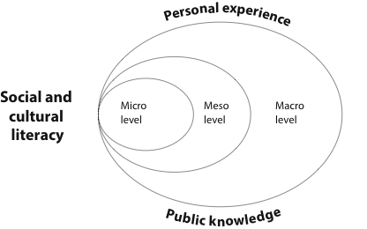

Personal experience refers to the knowledge gained from reflecting on individual experiences.
Public knowledge refers to general knowledge and the knowledge available to everyone. The term also refers to all the knowledge found in the public domain that is the work or research of other people.
Micro-level interactions are personal and occur between individuals and their family, peers and individuals in the community.
Meso-level interactions occur between the micro and the macro levels of society. Meso-level structures are groups in the community, village, school, workplace, local interest club, branch, organisation and state. The meso level is also known as the middle level.
Macro-level interactions are impersonal and relate to large institutions, the media, law and government and are evident at a national and international level.
Interactions exist between micro and meso, micro and macro, and meso and macro levels.
Interactions should be viewed as two-way.
Social and cultural literacy
A socially and culturally literate
person demonstrates the
following characteristics:
- Has a sense of personal, social and cultural identity and understands that culture underpins one’s behaviour, beliefs and values
- Is interested in, observes and asks questions about the micro, meso and macro levels of society
- Empathises with and appreciates the diverse beliefs and values of different societies and cultures
- Researches effectively and ethically, showing critical discernment towards information and the media
- Communicates effectively with individuals and groups and works cooperatively in a cross-cultural setting
- Applies skills to achieve social inclusion and is aware of the issues of discrimination and prejudice
- Avoids making judgements of another culture’s practices using the values of his or her own culture
- Has a sense of social responsibility and displays active citizenship by engaging critically with social issues, and takes considered action for the welfare, dignity, social justice and human rights of others at the local, national and global levels
- Is aware of, and sensitive to, major national and global issues such as poverty, disease and conflict, including armed conflict
- Considers the impact of globalisation, technologies and rapid change, as well as continuity and its implications for the future

Social and cultural research
Students will:
- outline the principles and practices of ethical research that underpin all social and cultural research
- examine the process of research using the steps briefly outlined below as a guide.
- Decide on the topic to be researched
↓
- Develop a focus question or hypothesis
↓
- Gather background information
↓
- Design the research
↓
- Develop the research methods to be used
↓
- Apply the research methods ethically
↓
- Compile and organise the collected information so that it is manageable
↓
- Analyse, synthesise and interpret the findings
↓
- Write up the conclusions in an appropriate format, considering the audience for the final product
↓
- Check the final product for editing or typing mistakes and ensure that all bibliographical information is included and correct

Ethical research
Social and cultural researchers are expected to conduct research in an ethical manner.
Following the principles of ethical research is important because:
- this promotes trust that the information collected will be used responsibly and will be treated with respect and confidentiality
- if the respondents feel comfortable with the ethical research process, they are much more likely to offer replies to questions and therefore genuine knowledge can be gained by the researcher.
In practice, ethical research means that:
- any prospective research participants must be fully informed about the procedures and any possible risks involved in the research, and must give their consent to participate
- participants are not put in awkward situations or asked to talk about sensitive topics that may make them feel uncomfortable
- the ethical researcher is open and honest with participants about the topic and scope of the project and the nature of the participation or information expected from them
- the protection of participants’ rights to confidentiality and privacy is ensured
- the researcher anticipates any negative effects on the research participants (including the researcher), such as personal danger, police intervention, social embarrassment or harassment – the researcher needs to prevent these
- the researcher is mindful of the special needs of any vulnerable groups, such as children
- there is nothing covert associated with the research.
Once data (information) is collected, the researcher begins the process of analysis, synthesis and deduction. At this point, the ethical researcher needs to be aware of any assumptions or biases that may underlie the research. It is critical that the researcher analyses the data without looking for evidence to support any preconceived ideas about what she or he may find.
Ethical research practices apply to both primary and secondary research – for example, in secondary research, the collection and use of information from books, magazines, the internet, communication technologies and so on. The protection of intellectual property in the writing-up process through the acknowledgement of all information used is critical, not only out of respect for the original author of the information but also to protect the researcher from breach of copyright law. With the availability of film clips, information, images and other content from the many sources accessible to researchers, discernment and care need to be taken in order to avoid material that might be inappropriate or potentially offensive for the audience of the final product.
Plagiarising other people’s work is unethical, a breach of copyright law, a misuse of intellectual property, and an untruthful representation of other people’s work as the researcher’s own. Researchers must never plagiarise!

TASK
As part of your study routine, research and complete the following.
Define public knowledge
Define personal experience
Distinguish between public knowledge and personal experience
Define micro world
Define meso world
Define macro world
Explain social and cultural literacy
Explain the characteristics of a socially and culturally literate person

Explain why it is important to be a socially and culturally literate person.

List the advantages in undertaking the steps in social and cultural research
Research and write a definition of ‘Ethical Research’.

Explain why ethical research is important
When conducting research, what does the researcher need to be aware of in terms of ‘Ethical research’?

