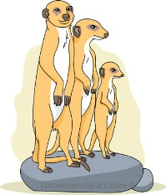
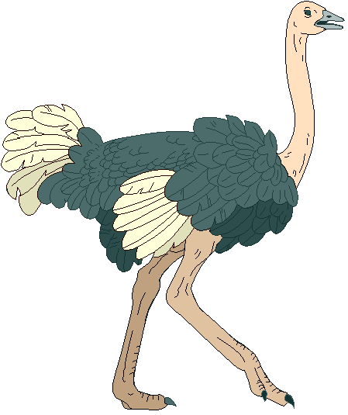
The San of the Kalahari
The Kalahari Desert, in the southern part of the AFRICAN continent, has existed for approximately sixty MILLION years. The desert covers approximately 900,000 square KILOMETRES and covers parts of the African countries of Botswana, NAMIBIA and South Africa.
The Kalahari gets very hot; it can reach temperatures of 40 DEGREES celsius in the summer. In winter the desert has a dry, cold climate where the temperature can reach 0 degrees CELCIUS. The vegetation consists mostly of grasses, scattered trees and SHRUBS including Acacia.
The San people's successful ADAPTATION to the arid Kalahari has earned them the title of ultimate survivors. The San have lived in the Kalahari for around twenty thousand YEARS and are considered to be one of the oldest CULTURES in the world. A small group of these people still follow the traditional NOMADIC lifestyle as hunter gatherers.
The San have survived invasions, first, from other African groups such as the Zulu and BANTU and, later, from EUROPEAN colonists. The arrival of white settlers in the 1600s brought dispossession of land, ENSLAVEMENT and slaughter of the San.
Traditionally, their hunter gather diet consisted of 70 - 80% of plant food, including BERRIES, nuts, roots and melons gathered primarily by the WOMEN. The remaining 20 - 30% was MEAT hunted by the men using poisoned ARROWS and spears on hunts that could last several days. They made their own TEMPORARY homes from wood that they gathered.
The San are not WASTEFUL and every part of the animal is used. The SKINS are used for blankets and the BONES are used for arrows and spears. In the Kalahari water is hard to come by. The San collect moisture by scraping and squeezing the water held in ROOTS and tubers. They also DIG holes in the sand to find water. They also carry water in an OSTRICH eggshell.
adaptation shrubs temporary million Bantu women European African celcius Namibia arrows years nomadic berries enslavement cultures meat ostrich dig roots kilometres bones degrees skins wasteful

Modern Challenges for the San

The San hunting and gathering economy and SOCIAL structure had remained virtually unchanged for tens of thousands of years until recently. European colonialism destroyed the San nomadic way of life, they were no longer allowed to ROAM freely and trophy hunters destroyed the vast herds of GAME that formed their food supply.

The San have been under great pressure to abandon their nomadic lifestyle. Beginning in the 1950's, many San have converted from a nomadic to an agricultural FARMING lifestyle. For example, today in BOTSWANA– the country with the largest San population – out of a population of 50,000 San, only about 3,000 follow the TRADITIONAL way of life. Land that the San used to hunt on is increasingly being used for GRAZING cattle. FENCES are put up to protect the cattle which means that the WILDLIFE the San depend upon for their hunting are changing their migrating patterns.

The last of the hunter gatherers were forcibly evicted from the Central Kalahari Game Reserve in 2002, by the Botswana government to make way for DIAMOND mines. A court case is currently in existence to help the San CLAIM back their land.

Governments have forced the San to relocate to PERMANENT locations usually with the intention of 'civilizing' them and providing schooling, running WATER and other modern amenities. Unfortunately rounding up hunter gatherers and forcing them to live in settlements has been tried in many countries and has not been very SUCCESSFUL.

Sadly, few modern San are able to continue as nomadic HUNTER GATHERERS and most live at the very BOTTOM of the social scale in unacceptable conditions of poverty, leading to alcoholism, disease and DESPAIR.
farming despair roam hunter gatherers claim Botswana
wildlife diamonds water social traditional successful game bottom evicted grazing permanent

