Threats to the Great Barrier Reef
The Great Barrier Reef gained a place on the UNESCO World Heritage List in 1981 as its remarkable natural beauty and diversity was determined to be of 'outstanding universal value'. Gaining a place on the World Heritage List is not the end of the story. Regular monitoring and periodic reporting to UNESCO (United Nations Educational, Scientific and Cultural Organisation) on the condition of the site and steps being taken to protect it are required. The Great Barrier Reef is a particularly fragile environment. If a country does not fulfill its obligations under the convention, there is a real risk that the site will be deleted from the list. Citizens, groups and non-government organisations (NGOs) are encouraged to alert UNESCO if sites are mismanaged. If there is sufficient cause, sites are placed on the ‘World Heritage List in Danger’. There were 54 properties on the danger list in 2017. There is recent speculation that the Great Barrier Reef is at risk of being included on this danger list due to increasing mining and shipping in close proximity to the reef and recent mass bleaching episodes.
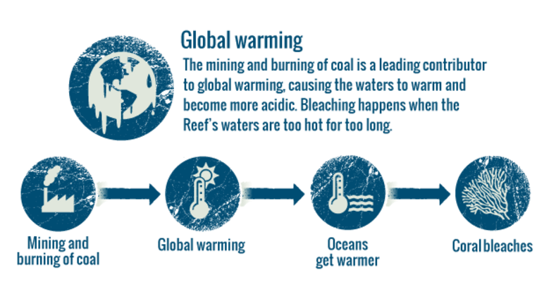

Australian Governments’ Responsibilities
The Commonwealth Government is responsible for implementing international conventions and agreements. This includes UNESCO World Heritage obligations. State governments are the land managers of most sites, however, so the best results are achieved by cooperation between the Commonwealth and the states and territories. World Heritage listings in Australia have highlighted the conflict between conservation and resource development, as well as the conflict between federal and state governments. Laws have been passed to try to solve these disputes.
Answer:

1. What does UNESCO stand for _________________________________________
2. When did the Great Barrier reef gain a place on the World Heritage list? ________
3. Why was it added to the world heritage list? _____________________________
__________________________________________________________________
4. What happens once a site is place on the World Heritage List? _________________
__________________________________________________________________
5. What happens if a country does not fulfil its obligations in managing the site?
__________________________________________________________________
6. Who is encouraged to alert UNESCO if they have concerns about the site’s management? _______________________________________________________
7. How many sites in the world are currently on the danger list? _________________
8. Examine the diagram and answer:
a. What is a leading contributor of global warming? __________________________
b. What causes bleaching of the reef? ____________________________________
9. Who is responsible for implementing international conventions and agreements such as UNESCO World Heritage management obligations? ___________________________
10. How are best results achieved for World Heritage sites? ____________________
__________________________________________________________________
11. What conflict has World Heritage listing highlighted in Australia? ______________
__________________________________________________________________
__________________________________________________________________

