Australian Curriculum Year 8 Geography sample assessment ׀ Assessment resource

Investigating landscapes and their landforms

© The State of Queensland (Queensland Curriculum and Assessment Authority) and its licensors 2014. All web links correct at time of publication.

Geomorphic processes in action
What is geomorphology?

The earth’s surface is like a jigsaw consisting of a series of plates called tectonic plates.

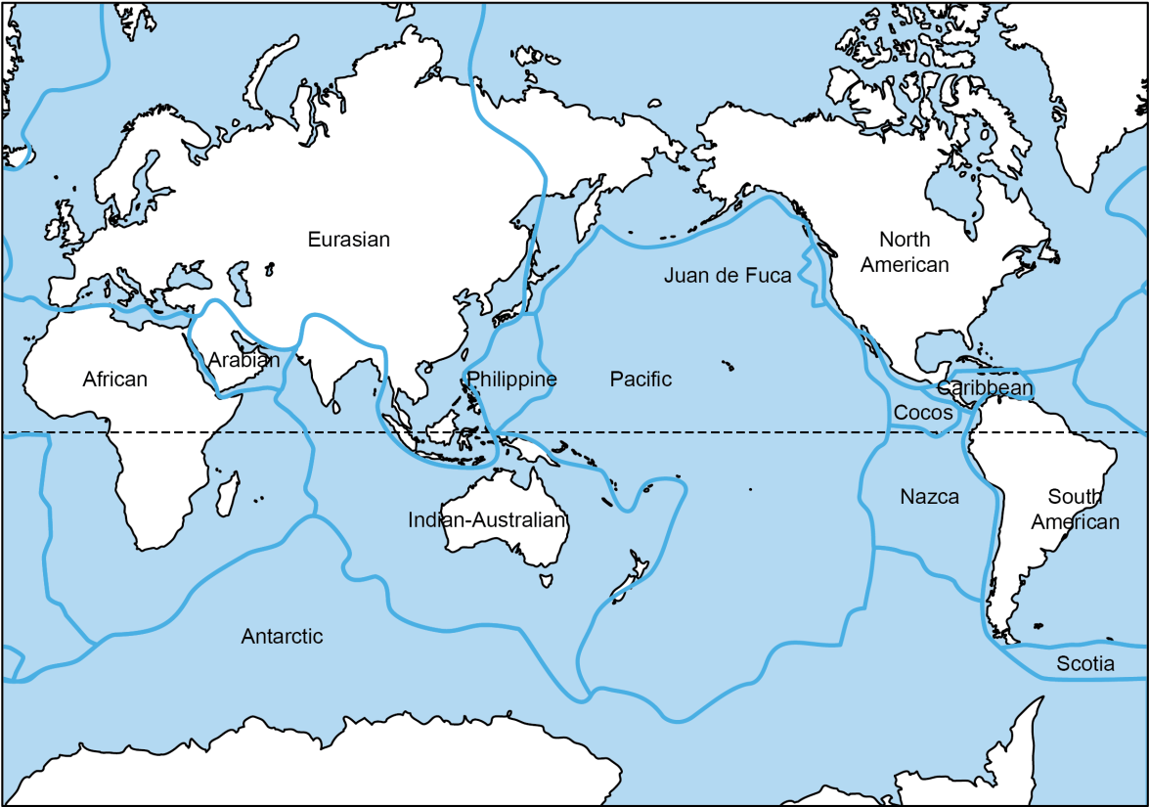

These plates are continually moving and at the boundaries of the plates landforms are created.

Analyse the diagram below to match the type of boundary with the correct description and the landform that is created at each type of boundary. Record this in the table below.

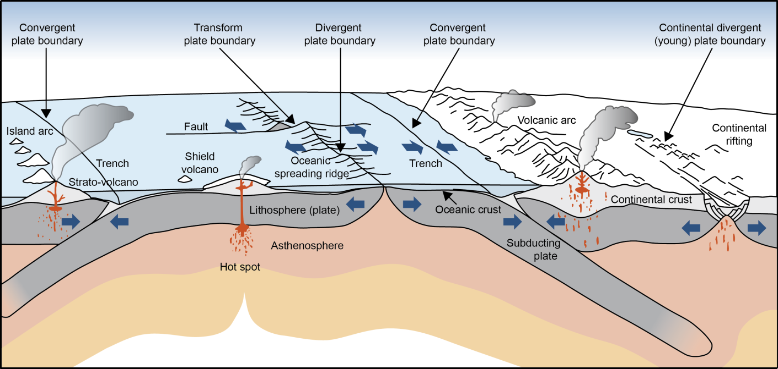

 | Type of boundary | Landform
