Australian Curriculum Year 8 Geography sample assessment ׀ Student booklet

Investigating landscapes and their landforms

© The State of Queensland (Queensland Curriculum and Assessment Authority) and its licensors 2014. All web links correct at time of publication.

Image: Yukon Delta, Alaska. NASA’s Earth Observatory. CC BY 2.0. https://flic.kr/p/azeGX2

Present findings and representations of data and information about landscapes and their landforms in a collection of work using a range of appropriate communication forms.
You will:
- develop a collection of work in class to demonstrate your knowledge, understanding and skills about landforms and landscapes
- use a range of sources to complete a series of learning projects.

Section | Topic | Evidence of learning
1 | Landscapes and their landform features | - Labelled line drawing (from a photograph) of one landscape and specific landforms
2 | Spatial distribution of landscapes and landforms | - Special purpose map showing the spatial distribution of one type of landscape and one related landform within that landscape
3 | Geomorphic processes that produce landforms | - Annotated photograph (or sketch) of a landform model you have created to explain geomorphic processes
4 | Geomorphological hazards | - Annotated map including the spatial distribution of one hazard  - Diagram showing how the hazard occurs  - Summary of the hazard’s effects
5 | Cultural significance of landscapes | - Explanation of an artwork of a landscape or landform by an Aboriginal or Torres Strait Islander artist
6 | Landscape degradation | - Supported explanation and analysis of a selected land degradation issue
7 | Protecting landscapes | - Factsheet with labelled map about one of Australia’s natural World Heritage sites

Section 1. Landscapes and their landform features

Your teacher will provide you with the resource Identifying landscapes and their distinctive landform features.

Choose one image of a landscape:
- create a line drawing or sketch of this landscape in the space below
- label each of the different landforms, and other features, in your drawing.

Section 2. Spatial distribution of landscapes and landforms

Your teacher will provide you with a glossary of geographical terms and cartographic conventions.
- On the map of the world, shade in the spatial distribution of:
  - one type of landscape, e.g. desert, coastal
  - one type of landform found in that landscape, e.g. grassland plain, mountain, wetland, headland
- Label your map with the appropriate cartographic conventions including:
title
legend (key)
border
source
north point.

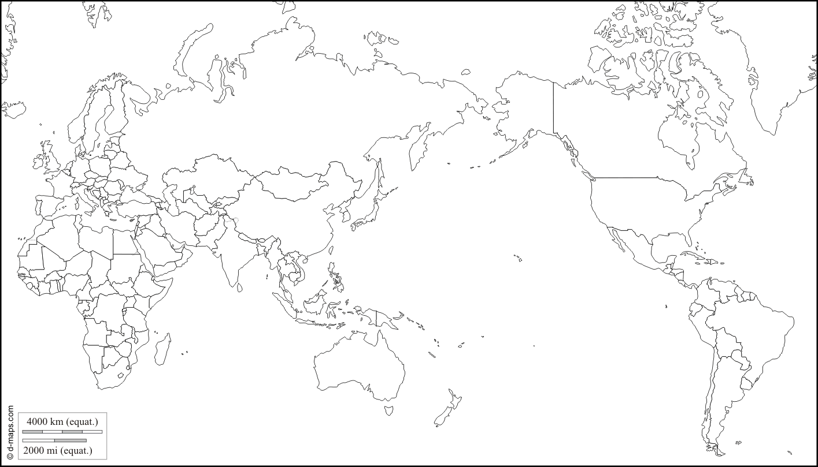

Section 3. Geomorphic processes that produce landforms

Over time landforms take shape through processes of weathering and erosion.

A landform that has been created through the process of erosion is a stack. The stacks are formed in stages over long periods of time.

The Twelve Apostles in Victoria are an example of a stack
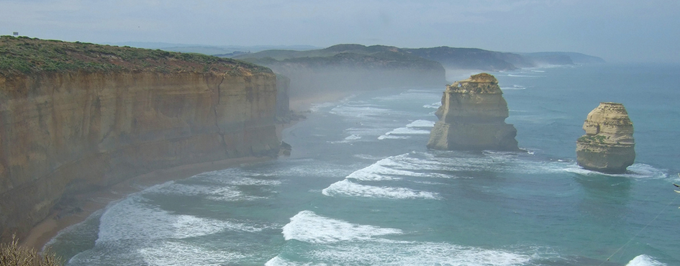
Image: Two of the Twelve Apostles, Martin Coopers photostream, Creative Commons Attribution 2.0. https://flic.kr/p/kaguxZ

- Create a model to show the process of stack formation, ensuring that you have included all of the following features:
crack
cave
arch
headland
stack
stump.

- Take a photograph or make a labelled sketch of your model.

- Annotate your photograph or sketch to explain the process of stack formation.

Section 4. Geomorphological hazards

Select one of the following geomorphological hazards studied in class:
- volcanic eruption
- earthquake
- tsunami.

Create an annotated map to include:
- the spatial distribution of one hazard event
- a diagram showing how the hazard occurs
- a summary of effects of this hazard.

Use cartographic conventions including:
title
legend (key)
border
source
north point.

Check you have:
- positioned your annotations appropriately on your map
- selected relevant ideas and information
- used relevant geographical terminology
- clearly labelled your diagram/s
- represented information clearly.

Section 5. Cultural significance of landscapes

View the video clips:
- Balgo, Maps of the Country, Kiwirrkurra
http://aso.gov.au/titles/documentaries/painting-country
From Painting Country, 2000, Electric Pictures, Robin Eastwood Productions, SBS Independent & NHK.
- Dreamings through Indigenous art
www.australiansatwork.com.au/dreamings/dreamings_ar7-8.php
From Dreamings — the Art of Aboriginal Australia, 1988, Australians At Work, Film Australia, 2005.

While viewing, make notes about:
- who owns the Dreaming stories associated with Country
- the ways these stories are passed on between generations (use examples from the video clips to support your answer).
- how art is used to represent the patterns of the landscape and features of landforms
- how interconnections are made between places and people and their culture in paintings
- how symbols are used to represent ideas in paintings.

Explain the importance of Country to Aboriginal peoples and Torres Strait Islander peoples that is represented in artwork.
Use your notes and examples from the video clips to help you develop the explanation.

Select a piece of Aboriginal art that represents a birds-eye view of a landscape.
- Annotate the photograph of the artwork with relevant descriptors before writing your paragraph. (You may need to re-watch the Painting Country video clips again and research what some of the symbols mean).
- Describe the artist’s representation of the landscape of their Country.
- Explain how the symbols are used to tell the story of the landform/landscape.
Annotated photograph
Describe and explain:

Section 6. Land degradation

Population growth, if not managed, might have a negative impact on the quality of the Earth’s resources and cause land degradation.

Create a line graph
Use the data in Table 1 to create a simple line graph representing the rate of global population growth between1950 and 2050.
Remember to use the appropriate labels.
Table 1
Year | Population in billions
1927 | 2
1950 | 2.55
1960 | 3
1974 | 4.5
1987 | 5
1999 | 6
2011 | 7
2024 (predicted) | 8
2040 (predicted) | 9
2062 (predicted) | 10
Data source: Worldometers.info. www.worldometers.info/world-population

Graph 1

Describe the pattern over time of the world’s population growth (as shown in your graph) and give reasons for this pattern.

Choose an appropriate graph and labels to represent the data in Table 2. (You must choose the type of graph best suited to the type of data). Make sure you use the appropriate conventions.
Table 2
2013 population | % of World Pop. | Density (p/km²)
Asia | 4 298 723 288 | 31 915 446
Africa | 1 110 635 062 | 30 955 880
Europe | 742 452 170 | 23 048 931
Latin America and Caribbean | 616 644 503 | 20 546 598
Northern America | 355 360 791 | 21 775 893
Oceania | 38 303 620 | 8 563 295
WORLD | 7 162 119 434 | 136 806 988
Data source: Worldometers.info. www.worldometers.info/world-population/#top

Graph 2

Describe the patterns of population distribution and density as shown in Graph 2.

What conclusions can you draw from this data about population pressure on the Earth’s resources?

Choose a land degradation issue (e.g. deforestation, salinity, erosion, desertification, toxic pollution) and create:
- a map showing where it is occurring
- data showing its impact on the landscape over time.

Use your map and data to propose:
- an explanation about the impact of your chosen land degradation issue
- action in response to this issue
- predicted outcomes of the action.
Map
Data

Section 7. Protecting landscapes

Create a factsheet which includes:
- the location of one of Australia’s natural World Heritage sites on a labelled map, using spatial technology if appropriate
- a detailed explanation of the importance of this site and why is it listed as a World Heritage site
- a detailed explanation of human use of this site and whether it meets the requirements for sustainable development
- a proposed action to protect this site
- a prediction of the outcome of this proposal.
