Name:

**Landscapes**

**&**

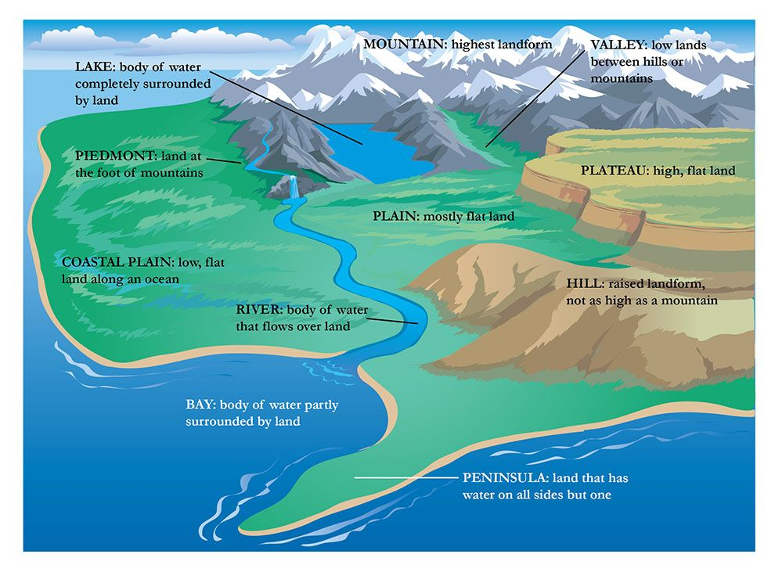**Landforms**

**Learning Intention & Success Criteria**

____________________________________________________________________________________________________________________________________________________________________________________________________________________________________________________________

____________________________________________________________________________________________________________________________________________________________________________________________________________________________________________________________

____________________________________________________________________________________________________________________________________________________________________________________________________________________________________________________________

____________________________________________________________________________________________________________________________________________________________________________________________________________________________________________________________

____________________________________________________________________________________________________________________________________________________________________________________________________________________________________________________________

____________________________________________________________________________________________________________________________________________________________________________________________________________________________________________________________

____________________________________________________________________________________________________________________________________________________________________________________________________________________________________________________________

____________________________________________________________________________________________________________________________________________________________________________________________________________________________________________________________

**Landscapes and Landforms**

**What’s the difference anyway?**

Landscapes are the **___________**, visible features on the surface of the Earth.

Landforms are features on the Earth's surface that are part of the **_____________**. Mountains, hills, **____________**, and plains are the four major types of landforms. Minor landforms include buttes, canyons, **______________,** and basins

**Landscapes**

A landscape is a part of the earth’s _________. It consists of a variety of geographical _________ that are _____________________ to an area.

Landscapes are divided into 2 main categories:

1. _______________ (mountains and deserts), these are mainly ____________ by _______ activity and typical to particular __________ of the world.
2. ____________ (cities and farms) have been created and _______________ by people.

***Types of Landscapes***

Types of Landscapes include:

* ___________elements of landforms (such as mountains, valleys, coastlines) and ___________________ (such as rivers, lakes, seas and oceans)
* _________ elements of land cover (including vegetation and _______________)
* ____________ elements (including different forms of land use, ____________ and structures)
* ________________ elements (such as ____________conditions).

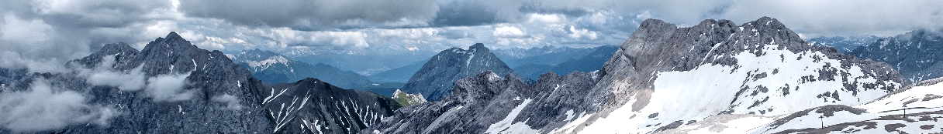**Mountain Landscapes**

_____________ are formed by tectonic __________ on the earth’s surface _________ against each other.

This movement and ________________ causes the shape of the land to change. The land is pushed _____ in a vertical direction and forms _____________overtime.

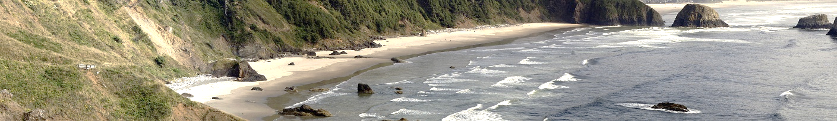**Coastal Landscapes**

This is where _________ mass meets the _______. These are shaped by natural __________ of wind and _________

These geographical forces _______ (wear away) or ______________ (build up) the natural environment.

Features of a coastal environment include beaches, __________ and bays.

**Riverine Landscapes**

This landscape is formed by the natural ______________ of water systems such as _________. A riverine landscape includes the ___________________ (all living things including ____________ and animals) in and around the area of a river.

Riverine landscapes are excellent for _________________uses such as farming because the land is rich and *_______________* for growing food.

**Desert Landscape**

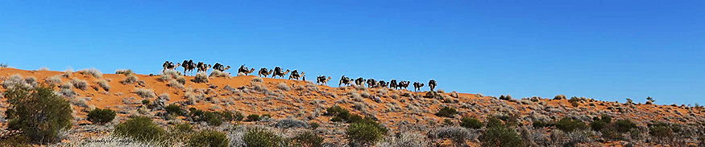

This is a region that receives ______________25 millimetres of **_______** per year. Deserts cover **___________** of the earth’s surface and are the most **______________________________**  regions on earth.

There are 2 types of deserts - **__________** and hot.

**Tropical** **Rainforests**



These are lush **_____________** which can be found along the **_____________**.

Rainforest landscapes receive lots of **____________** – at least 1500mm per **_______**. Rainforests are home to a large variety of **__________** (plants) & fauna (animals)and account for 50 - 70% of all **_____________** on earth.

**Built** **Landscapes**



Built Landscapes are created by **___________**. They provide evidence of human **___________** and occupation. Features include **__________________** such as buildings, roads, **______________**, energy, sewage and telecommunications systems. The **__________________** of built environments usually has **_________________** consequences for our natural environment.

**Glossary**

Match the definitions with the terms in the box below

|  |  |
| --- | --- |
| **Term** | **Definition** |
|  | A community of living creatures (plants, animals (including humans), and microorganisms) in a certain region. |
|  | The natural, visible features on the surface of the Earth. |
|  | The cultivation of land, raising crops and raising livestock; farming. |
|  | Human settlement and occupation. Features include infrastructure such as buildings, roads, transport, energy, sewage and telecommunications |
|  | The plant life present in a particular region. |
|  | Difficult or impossible to support animal and plant life |
|  | Fundamental facilities and systems serving cities and towns such as buildings roads, transport and sewage |
|  | An imaginary line around the centre Earth. It divides Earth into the Northern Hemisphere and the Southern Hemisphere. |
|  | A weathering process where natural forces like water, wind and ice, wear away rocks and soil |
|  | The animal life present in a particular region |
|  | Features on the Earth's surface that are part of the terrain such as mountains, hills, plateaus, and plains |
|  | A raised area of land that is flat on top - also called a tableland |
|  | Lush forests found along the equator that receive high rainfall. |
|  | Major plates floating across the surface of the earth |
|  | The ground cover provided by plants |

Agriculture built environment ecosystem equator erosion fauna fertile flora infrastructure landform landscape plateau…..rainforest tectonic plates uninhabitable vegetation