Biomes - Deserts



What is an Ecosystem?

*Match the key terms with their correct definition:*

Ecosystem

The natural home for a plant or animal, where it is normally found.

An identifiable group formed by people with something in common, usually based on shared space and social organisation.

A system formed by the interactions of the living organisms(plants, animals and humans) and physical elements of an environment.

A large community of plants and animals that occupies a distinct region. Biome are typically defined by their climate and dominant vegetation, include grassland, tundra, desert, tropical rainforest, and deciduous and coniferous forests.

Biomes

Habitats

Community

*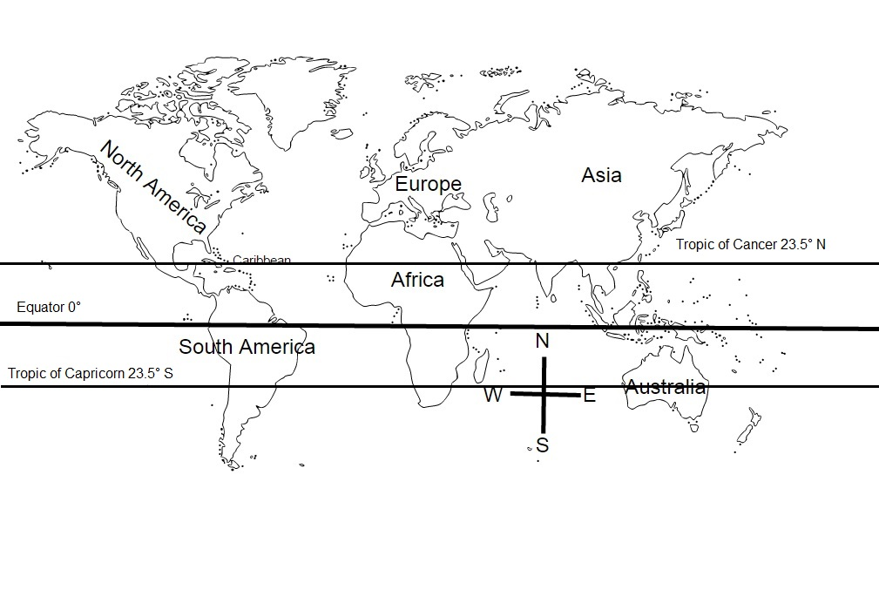Using the colour map on the previous page colour the map below to show where the world’s DESERTS are.*

*Use the map above to answer the following:*

1. Are there any deserts on the equator? ______________

2. How many deserts are found on the Tropic of Cancer? Can you name one? ___________________________________________________________________________

3. How many deserts are found on the Tropic of Capricorn? Can you name one?

­­­­­­­­­­­­­­_______________________________________________________________

4. Are there any continents that do not have desert areas? If so name them _______________________________________________________________

5. Are there any continents where desert extend far into the interior of the continent? If so name them.

_______________________________________________________________

6. Describe the latitudes (degrees North and South of the equator) where deserts are usually found

_______________________________________________________________

**Climate Graphs**

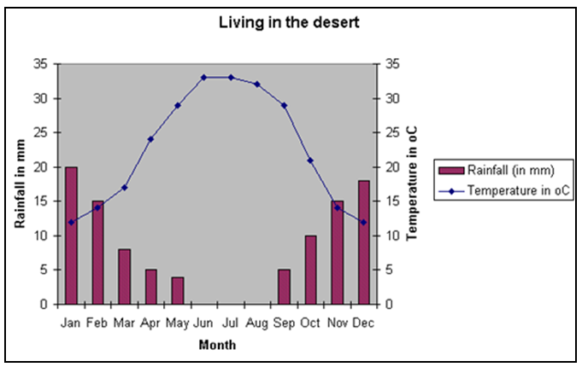The climate graph below shows the average rainfall and temperature of a desert.

Answer the following using the graph above.

What month/s :

was the hottest of the year? _______________________________

was the coolest of the year? _______________________________

had the highest rainfall? _______________________________

had the least rainfall? _______________________________

had temperatures above 30°C ? _______________________________

had temperatured below 15 °C ? _______________________________

Describe the relationship between the rainfall and the temperatures of this desert

______________________________________________________________________________________________________________________________

**Glossary**

**Match the term with the definition**

1. ______________ a plant eater

2. _______________any alteration in the structure or function of an organism by which the organism becomes better fitted to survive and multiply in its environment.

3. ____________________ a member of a group of people who subsist by hunting, fishing, or foraging (gathering) in the wild.

4. ______________ having little rainfall to support vegetation.

5. ______________ plant life.

6. ______________ animals hunted for their flesh.

7. ______________ the fleshy underground stem or root of a plant (like the potato) that is an organ of reproduction and food/water storage

8. ________________ plants that have a very short life cycle after rain

9. ________________ a person who belongs to a group or tribe that moves from place to place depending on the food supply or pastures for animals.

10. _______________ plants with a life cycle of more than two years.

adaptation arid ephemeral herbivore hunter gatherer game nomad perennial tuber vegetation

**A Desert Ecosystem**

Using the information on pages 124 & 125 answer the following:

1. Why is survival a problem for plants and animals in a desert environment?

____________________________________________________________________________________________________________________________________________________________________________________________________________________________________________________________

2. Explain the difference between perennial and ephemeral plants. Provide an example of how each type of plant survives in a desert.

____________________________________________________________________________________________________________________________________________________________________________________________________________________________________________________________

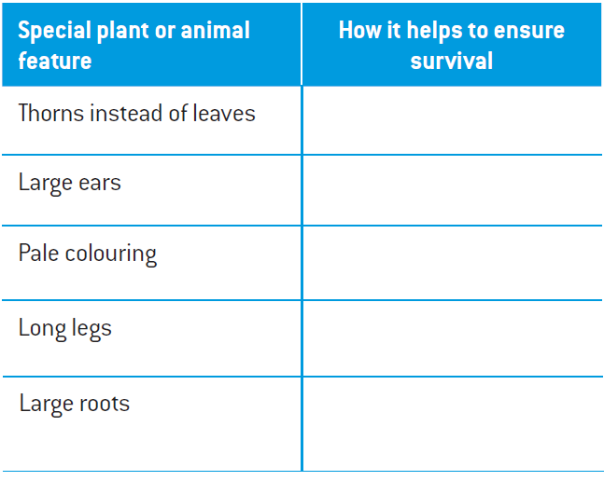3. Complete the following table

**Adapting to the Desert**

Study the camel’s adaptations that have allowed it to survive in harsh desert environments.

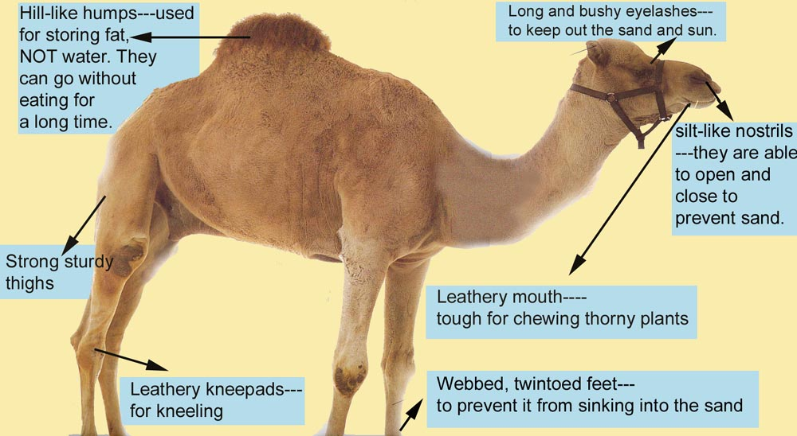

In the space below design the perfect imaginary animal for desert survival and label its adaptive features.

**Life in the Kalahari**

You are now going to look at how people are able to survive in the Kalahari Desert, specifically the San People.

Find the following words in the word search.

|  |  |
| --- | --- |
| Kalahari  Deserts  Camel  Red Sand  South Africa  Fire Drill | Sipwell  San  Nomads  Water  Antelope  Drought |

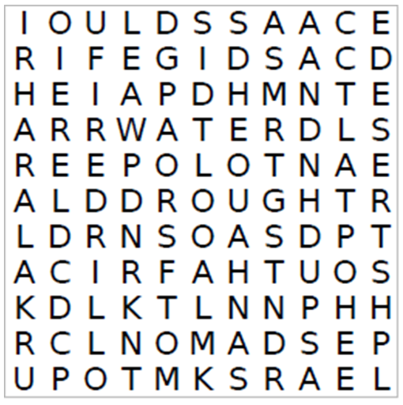

**The San**

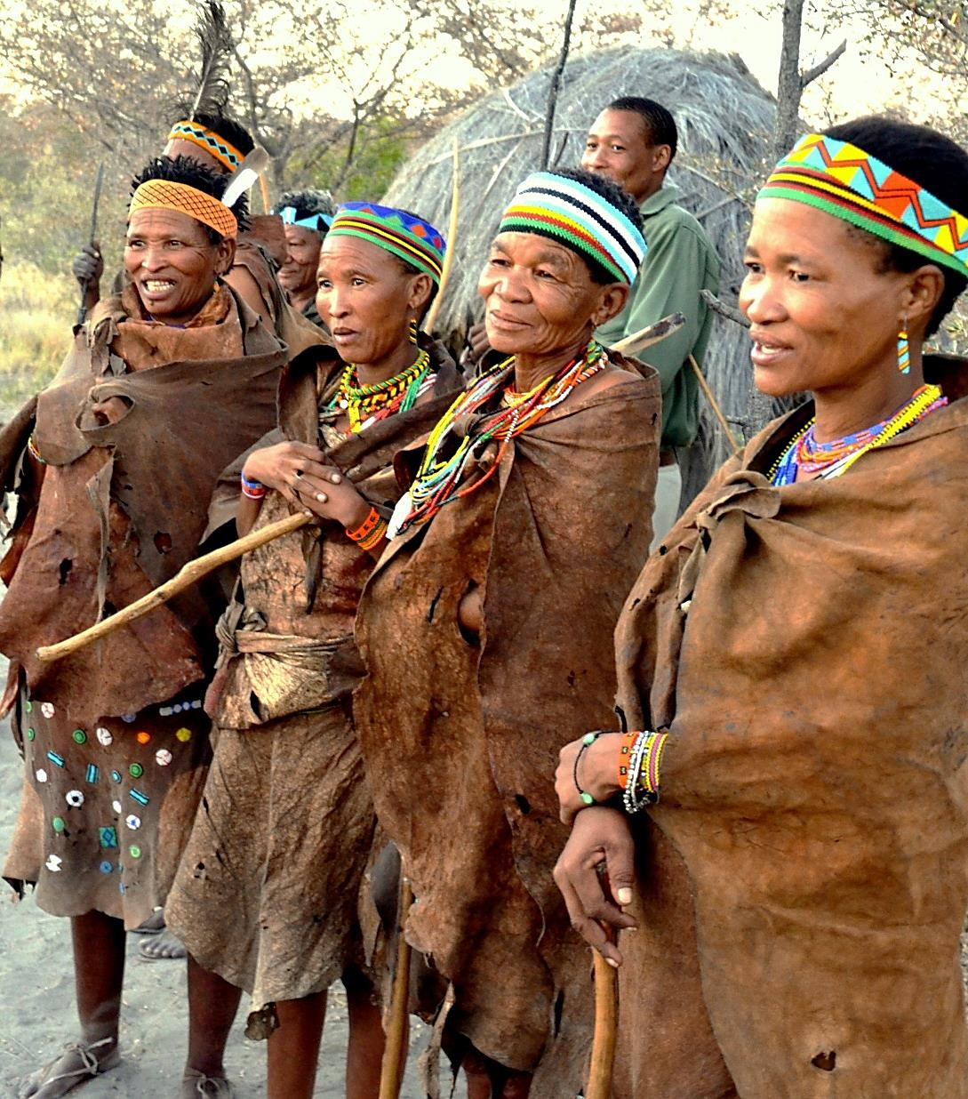

Archaeologists believe that the San people have been living in the Kalahari Desert for 30,000 years. That would make the San people the most ancient race! Some archaeologists think the San have been living in Africa for 80,000 years!

About a thousand years ago, when another African tribe moved south into the Kalahari Desert area, they were surprised to find the San people already living there.

**San Population:** Total 90 000

[Botswana (55,000), Namibia (27,000), South Africa (10,000), Angola (<5,000), Zimbabwe (1,200)]

The Kalahari Desert is a sandy desert of 440,000 square miles. It ranges in altitude from about 900m to 1,200m above sea level. The soil is mostly fine-grained sand – bright red in some areas, and grey in others – and the dune systems are largely fixed and inactive.

The vegetation is mainly thorny shrubs, with acacia trees and spiny shrubs. Large herds of game, such as Springbok, Gemsbok, and Wildebeest, roam the Kalahari, moving long distances in search of fresh vegetation. One of the commonest small mammals is the Meerkat, a highly social Mongoose. The salt pans occasionally flood after heavy rains, attracting large numbers of birds, including both the Greater and Lesser Flamingo. The Kalahari is also home to the San people, about 90,000 people in number.

Answer:

1. How long do archaeologists believe The San have been living in the KALAHARI DESERT? ______________________________

2. How long do archaeologists believe The San have been living in AFRICA? ________________________

3. What is the TOTAL San population today? _________________________

4. What country has the highest population of San people? __________________

5. What country has the LOWEST population of San? ______________________

6. Describe the vegetation of the Kalahari Desert ______________________________________________________________________________________________________________________________

7. Name some of the game that frequent the Kalahari

______________________________________________________________________________________________________________________________

**A Day In The Life Of The San**

Hi, I’m here in the Kalahari, spending the day with the San people. It’s such an honour to be here, I can’t tell you. These are people who really know how to survive in the desert. They’ll certainly be able to teach me a thing or two.

Dawn - It’s time to get up and make a fire, it’s pretty chilly in the desert first thing in the morning. Luckily I brought a blanket. There aren’t any bathrooms in the desert, of course, but a bush makes a good toilet. There’s no water, at least not to waste, the San rub red sand over their bodies. Actually, it works pretty well. Breakfast is a couple of spoonfuls of porridge.

Early Morning - After breakfast, the men set off hunting and the women begin foraging. The women will gatherer everything from ostrich eggs to plants, roots and insects. While the men may not always successfully bring home a hunted animal the women will always have successfully gathered something nutritious for the family. When hunting the men travel very light. All each hunter carries is a bag with his hunting spear, bow and arrows, digging stick (for finding water) and a fire drill for lighting fires. I’m afraid I can’t go with them this time but one of the hunters told me what happens. After walking for miles and miles through the desert, they finally track down an antelope. Finding them is tricky but the San hunters know the desert.

When they track the antelope down, they fire. Their arrows are tipped with poison squeezed from a small but deadly beetle. The antelope doesn’t stand a chance.

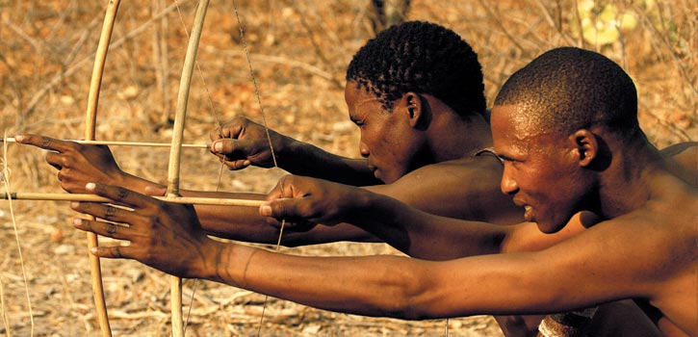

Later That Day - The men carry back the antelope. They have a really ingenious way of cooking it. First the men skin the antelope, then they bury it in a hole in the hot sand. Then they light a fire in the hole and cover the whole thing in sand. When the meat is cooked they cut it into strips. Brilliant! Some of the meat is eaten straight away (and it’s delicious by the way). Some is saved and dried for winter. Because resources are limited The San ensure no part of the antelope is wasted. The antelope’s skin is made into bags and clothes and its bones are used for arrows. The San even eat the gristly bits in the ears. After all, it may be a while before they catch another one.

**Nomadic Lifestyle**

The San live a nomadic life always on the move in search of game and plant foods. The San did not build permanent settlements they preferred using rock shelters as temporary live sites and or open camps; probably weather conditions dictated the choice of sites

The San hunter-gatherers traditionally did not use metals, their weapons being made of wood, stone and bones. No pottery was made; instead they used ostrich egg-shells for storing and holding liquids.

**Finding Water**

The San are very hospitable people, they teach newcomers how to successfully hunt and find water in the desert. Because the San live so simply, some think they have very little understanding of such things, but they are very skilled and clever survivors. The San people know more than 300 different species of plants, many of which have medicinal purposes, whether treating rheumatism or combating hunger. One of the main problems in Africa, however, is drought. About 80% of the San's water comes from the food that they eat. The San find water in plants, the stomachs of the animals they have killed, or where water has collected. They are skilled at finding tubers beneath the ground. One of the tubers best for drinking is called the milk bulb, which soaks up rainfall. Once dug up the San shred it. They then take the shredded pulp into their hands and squeeze it. It emits streams of drinkable (but quite bitter water) water when crushed.

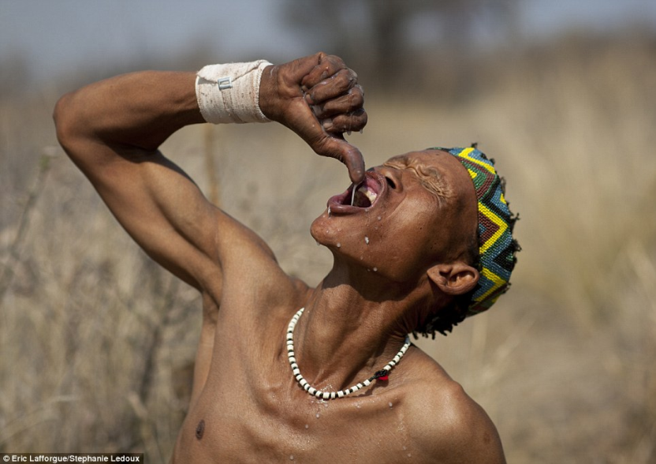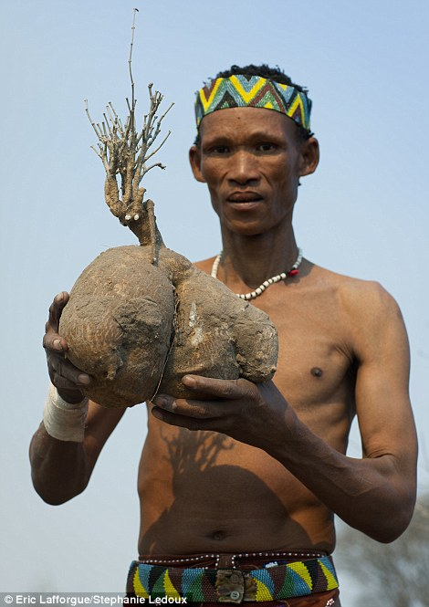

Pictured Left: the Milk Bulb. Right: Squeezing the pulp to drink the water contained in the bulb

**The Sipwell Technique**

A unique way of collecting water is through a ‘sipwell’. to get water this way they scrape a deep hole where the sand damp. Into this hole they put a long hollow grass stem. They then need an empty ostrich egg to collect the water in. By skilful sucking they take the water from the sand, into their mouth and down the straw into the ostrich egg. Some of the eggs are carried. The rest are buried, so they always have water to drink.

Answer:

1. Describe the San’s nomadic lifestyle

___________________________________________________________________________________________________________________

2. Name the foods that the women gather

__________________________________________________________

3. The San ensure no part of the antelope is wasted. What are the uses for the antelope?

____________________________________________________________________________________________________________________

4. Describe one way that The San source their water:

________________________________________________________________________________________________________________________________________________________________________________________________________________________________________

**Social Structure**

The San hunting & gathering economy and social structure has remained virtually unchanged for tens of thousands of years until very recently, a socio-economic culture that has sustained mankind universally during their evolution until the advent of agriculture. The San did not traditionally farm or keep livestock as they have no concept of the ownership of land or animals.

Their social structure is not tribal because they have no main leader and their family ties are fairly relaxed. They are a loosely knit family culture where decisions are made by universal discussion and agreement by consensus. An individual’s opinion is weighed according to their level of skill and experience in the topic of discussion. The San have unique "click" languages. Families within a clan speak a common language but neighbouring clans will usually speak a different dialect, although there would normally be a fair degree of similarity & understanding between them.

The San are generally nomadic within fairly limited boundaries, governed by the proximity of other families and clans. As a very loose guideline, the territory of a family may stretch to a 40 Km circle. Obviously, if there are no other bordering clans or other people these areas may stretch further, as far as is needed to ensure adequate food and water sources.

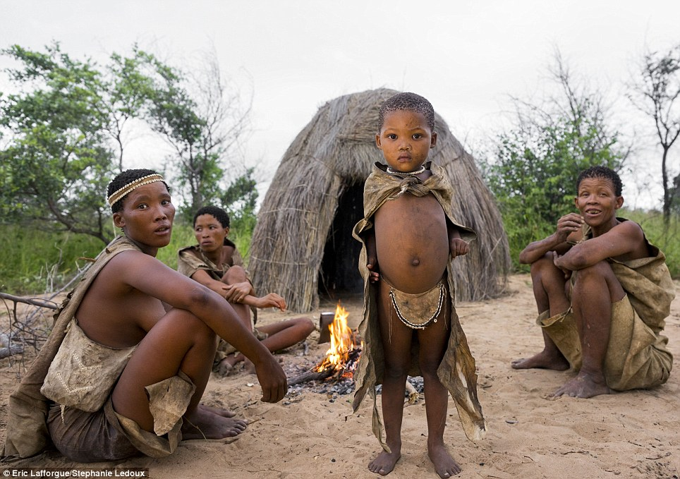

**Gender Roles**

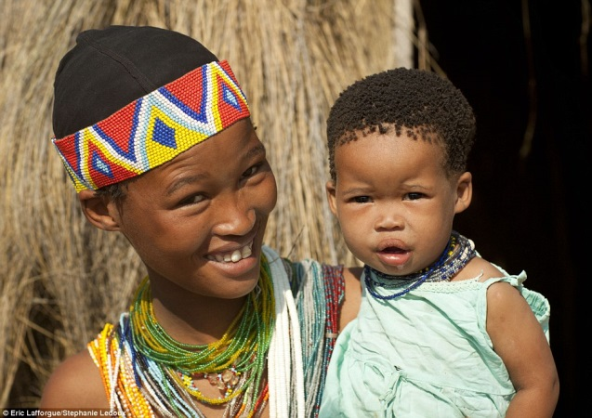The roles of men & women were very distinct and rarely overlapped, which is a characteristic almost universal amongst hunter/gatherers the world over. It based on survival needs encouraging the most efficient utilisation of available skills and resources. Women are expected to gather and cook food and look after the children. Despite this, the importance of women is very high within the group and their opinions often take precedence, particularly where food is concerned.

**Answer:**

1. Why do The San traditionally not farm or keep livestock?

______________________________________________________________________________________________________________________________

2. How are decisions made in San society?

_____________________________________________________________________________________________________________________________________________________________________________________________

3. What roles are women expected to fulfil in San society?

______________________________________________________________________________________________________________________________

4. How well are women regarded in the San community? Why?

_____________________________________________________________________________________________________________________________________________________________________________________________

**What problems do the San face today?**

The San had their homelands invaded by cattle herding Bantu tribes from around 1,500 years ago, and by white European colonists over the last few hundred years. From that time they have faced discrimination, eviction from their ancestral lands, murder and oppression amounting to genocide, which has reduced their population. Today, although all suffer from a perception that their lifestyle is 'primitive' and that they need to be made to live like the majority cattle-herding tribes, specific problems vary according to where they live.

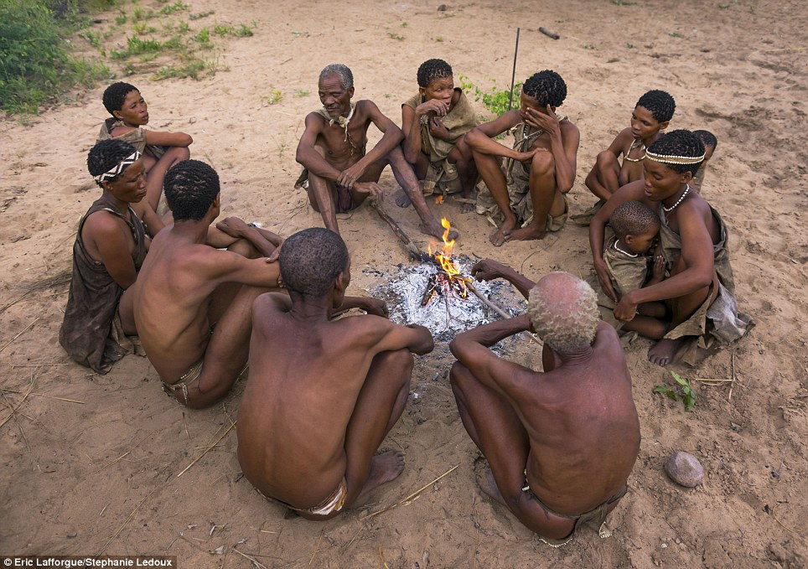

**Evictions in Botswana**

Far from recognising their ownership rights over the land they have lived on for thousands of years, the Botswana government has in fact forced almost all of the San off their land. In the early 1980s, diamonds were discovered in the reserve. Soon after, government ministers went into the reserve to tell the San living there that they would have to leave because of the diamond finds.

Virtually all the San were forced out. Their homes were dismantled, their school and health post were closed, their water supply was destroyed and the people were threatened and trucked away. Almost all were forced out by these tactics, but a large number have since returned, with many more desperate to do so. They now live in resettlement camps outside the reserve. Rarely able to hunt, and arrested and beaten when they do, they are dependent on government handouts. They are now gripped by alcoholism, boredom, depression, and illnesses such as TB and HIV/AIDS.

Although the San won the right in court to go back to their lands in 2006, the government has done everything it can to make their return impossible. Since then the government has arrested more than 50 San for hunting to feed their families, and banned the San from using their water borehole.

**Answer:**

1. Name two groups of people who have invaded The San homelands.

______________________________________________________________________________________________________________________________

2. What unfavourable treatment have the San endured? _____________________________________________________________________________________________________________________________________________________________________________________________

3. Why have the San been forced off their lands in Botswana?

_____________________________________________________________________________________________________________________________________________________________________________________________

4. As a result, what has been some of the unfortunate social issues gripping The San?

___________________________________________________________________________________________________________________________________________________________________________________________________________________________________________________________________________________________________________________________

5. What do you think should be done? How?

__________________________________________________________________________________________________________________________________________________________________________________________________________________________________________________________________________________________________________________________________________________________________________________________