Source A
Great Barrier Reef photos show 'striking' damage to coral after Cyclone Debbie
By Kathy McLeish. Posted 13 Jul 2017, 6:11am
ABC News Online
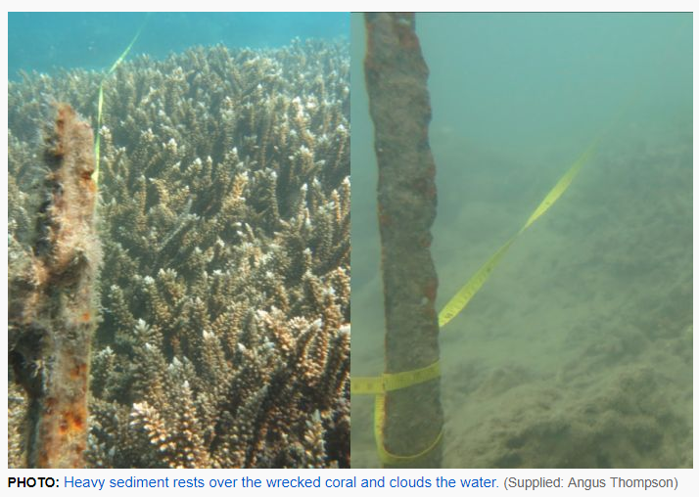
http://www.abc.net.au/news/2017-07-13/comparison-photos-striking-damage-great-barrier-reef-cyclone-qld/8702192

It could be a decade before the southern Great Barrier Reef recovers from the destruction caused by Cyclone Debbie, scientists have said.
Angus Thompson, from the Australian Institute of Marine Science (AIMS), said the damage was striking. "Some of the reefs have had a substantial loss of coral cover — in excess of 95 per cent of the coral gone," he said. Mr Thompson heads the inshore reef monitoring program that feeds into the annual Great Barrier Reef Report Card.
His team has just finished this year's assessment of the Whitsunday Islands region, the first since the area was smashed by Cyclone Debbie in late March 2017. When the category-four system struck the Whitsundays off north Queensland, it was driving 260 kilometre per hour winds that battered the region and the reef from Mackay to Bowen for 48 hours. "We have had big disturbances, but often not at this sort of magnitude from cyclones before," he said. Seven checked reefs had damage to 95pc of coral
Each year, the scientists film and photograph at the same spots. The 2017 photos are in stark contrast to photographs of the same locations taken three years ago. Heavy sediment sits thickly over the wrecked coral and clouds the water, with no sign of the previous healthy reef.
Mr Thompson said his team checked seven reefs and most had damage to more than 95 per cent of the coral.
Only one was not badly impacted with damage to 10 per cent of the coral.

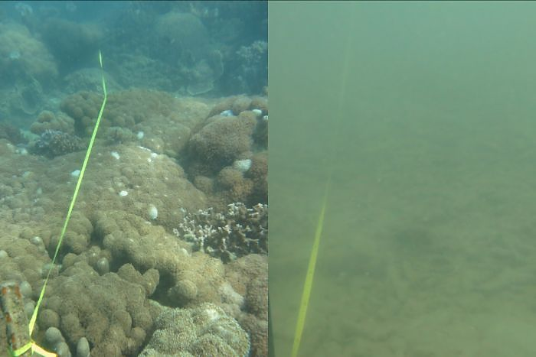
A composite picture showing a healthy Great Barrier Reef on the left in 2014 and a murky muddy reef on the right in 2017.

PHOTO: Difference between reef off Double Cone Island in central Queensland in 2014 and 2017. (Supplied: Angus Thompson)
Not clear how far damage reached
Great Barrier Reef Marine Park Authority (GBRMPA) spokesman Mark Read said it was not clear how far the damage extended. "When we get a tropical cyclone rolling across the reef, we do get extensive damage to live corals and certainly one of the things that is of concern is the capacity of that reef to bounce back after the impact."
"Unfortunately, it came on top of the second consecutive mass bleaching event for the Great Barrier Reef," Mr Read said. He said cyclones and increased sea temperatures were the biggest threat to the reef, which could only be tackled through long-term programs aimed at improving water quality, reducing land run-off, and cutting down greenhouse gases. The GBRMPA will manage the impacts and recovery wok of the reef.
Mr Thompson said coral recovery work began immediately after the cyclone, and included turning coral back over and returning the broken pieces of coral to the coral reefs.
Despite this devastation, there are still beautiful diving spots on the reef that are yet untouched by bleaching events and cyclone damage.

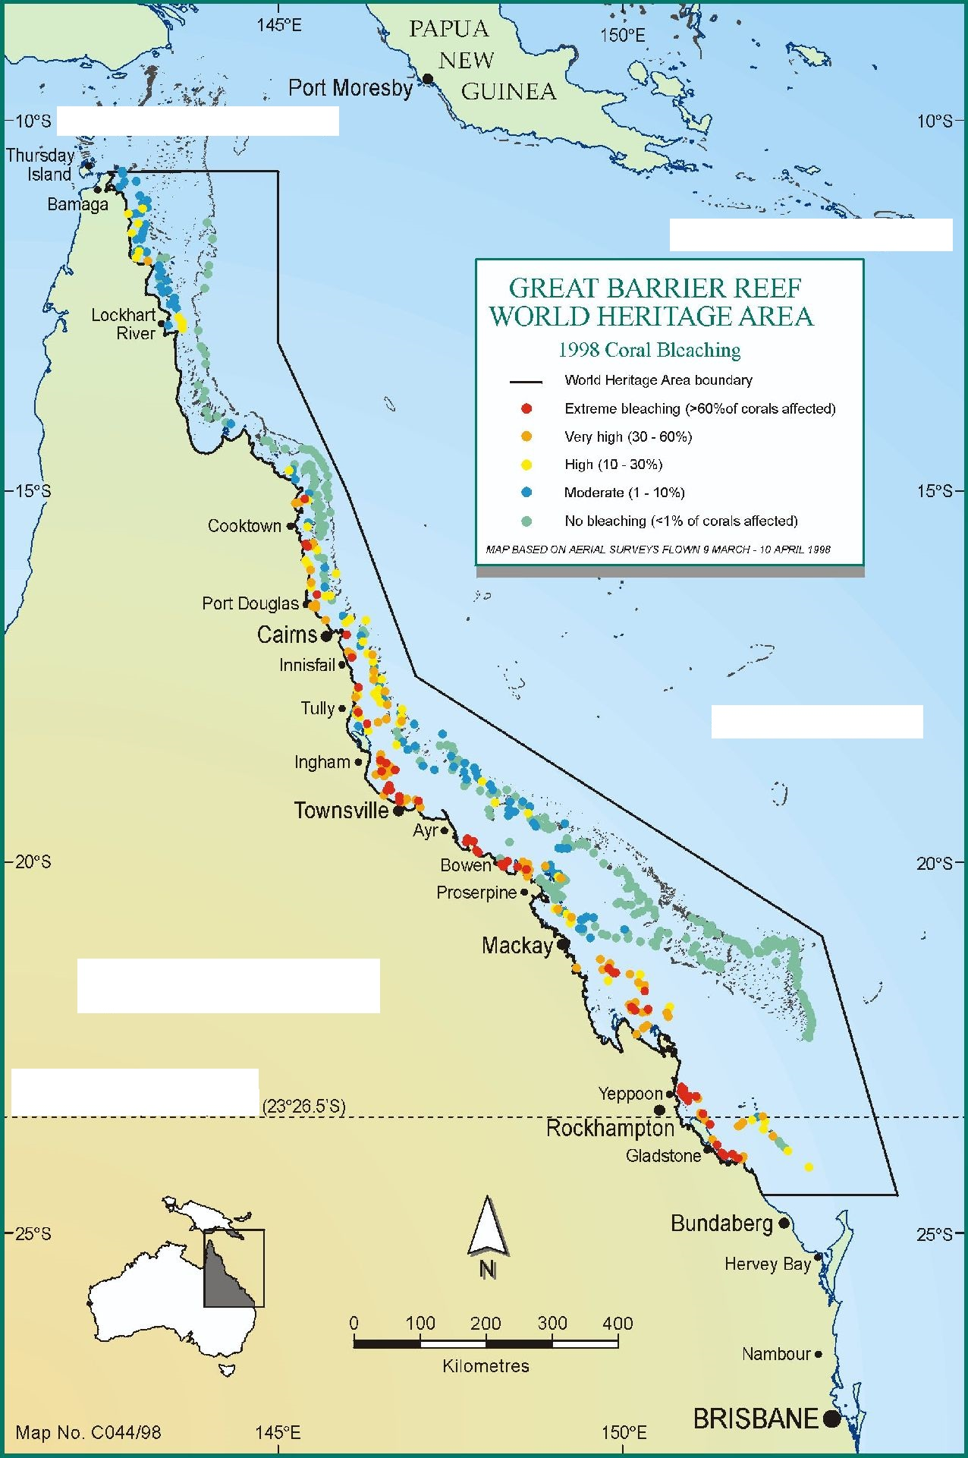
Label the following on the map above:
Tropic of Capricorn, Torres Strait, Pacific Ocean, Coral Sea, Queensland

Answer the following:
1. What was the recent catastrophic event on the Great Barrier Reef?
___________________________________________________________
2. How much coral had some reefs lost?
___________________________________________________________
3. When did this take place?
___________________________________________________________
4. Where did Cyclone Debbie hit?
_____________________________________________________________________________________
5. How fast were the cyclonic winds?
___________________________________________________________
6. Mark with a circle on the map above the regions that were battered over 48 hours.

7. The scientist commenting on the reef works for which institute?
__________________________________________________________________
8. Would you consider this person to be a reliable source? Justify why or why not.
__________________________________________________________________________________________________________________________________________________________________________
9. What do the comparison photos show?
__________________________________________________________________________________________________________________________________________________________________________
10. How long could it be before this part of the reef recovers?
___________________________________________________________
11. What other catastrophic events had earlier occurred on the reef?
_____________________________________________________________________________________

12. What doe GBRMPA stand for?
____________________________________________________________________________________
13. What does the GBRMPA spokesperson say are the two biggest threats to the reef?
_____________________________________________________________________________________
14. Would you consider this spokesperson to be a reliable source of information? Justify why or why not.
__________________________________________________________________________________________________________________________________________________________________________
13. How might these threats be tackled?
__________________________________________________________________________________________________________________________________________________________________________
14. List some ways that we can personally help minimise these threats
______________________________________________________________________________________________________________________________________________________________________________________________________________________________________________________________________________________________________________________________________________________________________________________________________________________________________________________________________________________________________________________________

