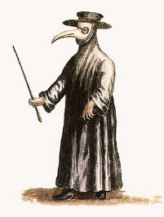
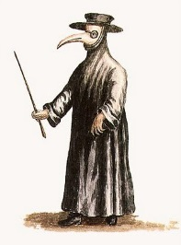
The Black Death

The ____________________ Plague or ‘Black Death, was one of the most disastrous events of the ___________________ period. It is believed that between 25 and 30 ______________ Europeans died over the four years from 1347 to ________.

The disease comes from the _________ of rats. Rats were common in medieval towns. The fleas bit and _____________ the rats. The fleas moved from dead rats to other rats and humans. People bitten by the infected fleas would get the _______________. This link between the fleas, rats and humans was sadly only discovered 500 ____________ after this major outbreak.

The plague firs began in ________________ in the 1320’s. It was spread from east to west Asia overland via traders travelling along the __________ Road. It was also spread via traders and merchants along sea routes to Europe travelling on ___________ . The Mongol siege of the port of ________ on the Black ____ (what is now modern-day Turkey) also played a part in the spread of the disease. The port of Caffa was defended by merchants and ____________ from the Italian town of _________. After the siege the Genoese returned home and brought the plague with them.

Over the next four years, the plague spread inland throughout most of the cities, ___________ and villages of Western Europe. English soldiers returning from the Hundred Years War in France carried the disease with them back to ____________ in 1348.
1351 China infected million Silk years ships fleas Genoa Medieval plague Sea bubonic Caffa England towns sailors

For homework please ensure to complete the Completion of Medieval Europe Asst Survey found at the bottom of the Medieval Assessment task page: http://www.costellohsie.info/medieval-europe-asst-task.html

Black Death – Symptoms and treatments

People at the time describe a range of plague symptoms including ________________ , coughing up ______________ and the growth of large, __________________, itchy, blue-black ____________ (‘buboes’) in the groin and armpits. These tumour-like buboes gradually spread over the entire ________ and emitted blood, ____ and horrible __________. It could also make a person’s ___________ turn black. The victim usually died within three to five _______ of the appearance of the initial symptoms.

Doctors at the time could not cure the plague because they didn’t really understand how ______________ were spread at the time. They used _______________ that they used for most other diseases at the time. Many doctors believed that all disease resulted from bad smells. They prescribed posies of pleasant smelling _________ or flowers that the patient would _______ by means of a nosebag.

Doctors also used the popular medieval treatment of ‘bleeding’ the patient by attaching ___________ to key _______. They also cut into the buboes to _______________ what was thought to be the ‘bad’ blood within them. They then covered the _________ with a herbal ointment. Nothing worked.

Doctors themselves wore beak-like ________ (see images above) that they believed ________________ them from the plague. In the masks would be a nosebag of posies or a cloth soaked in ____________. This was obviously futile against flea bites and many doctors died before their patients.
pus painful days body vomiting sniff tongue blood tumours remove smells veins vinegar diseases leeches cuts treatments herbs protected
Did you know that there were 12 major Bubonic Plague outbreaks in Australia between 1900 and 1925 as ships imported wave after wave of infection?

