**The Formation of Mountains**

**Label the types of Mountains and their features using the words in the text box**

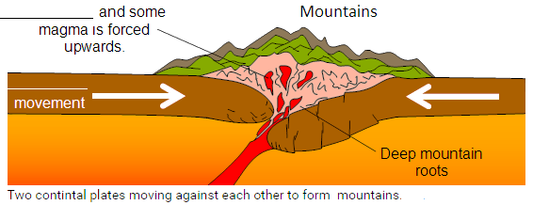______________________ Mountain

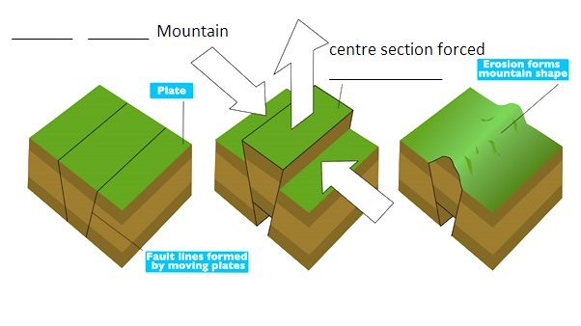

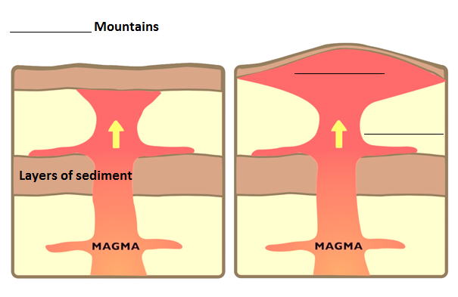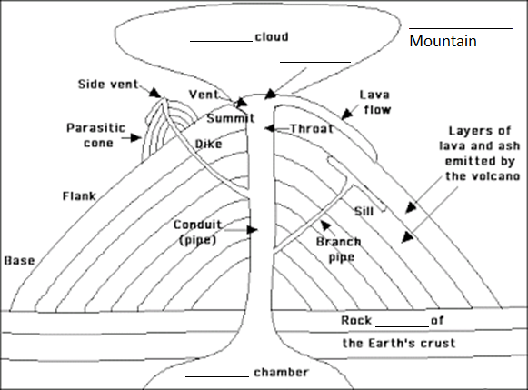

Fold Fault Block Volcanic Dome ash sediment magma plate upwards pressure layers bulge crater