World Inequality

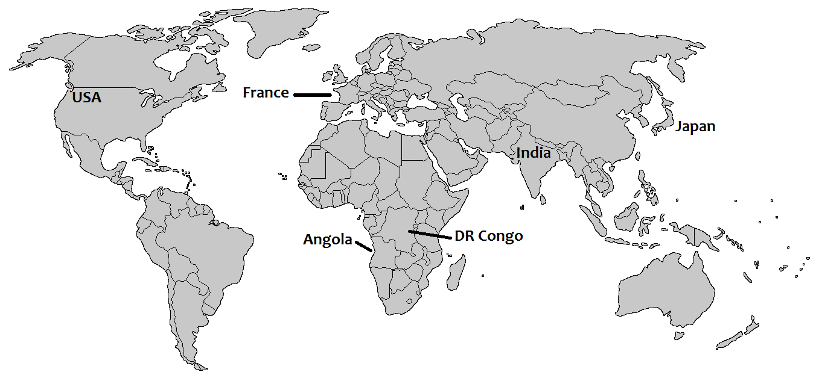
Life Expectancy and Access to Clean Water

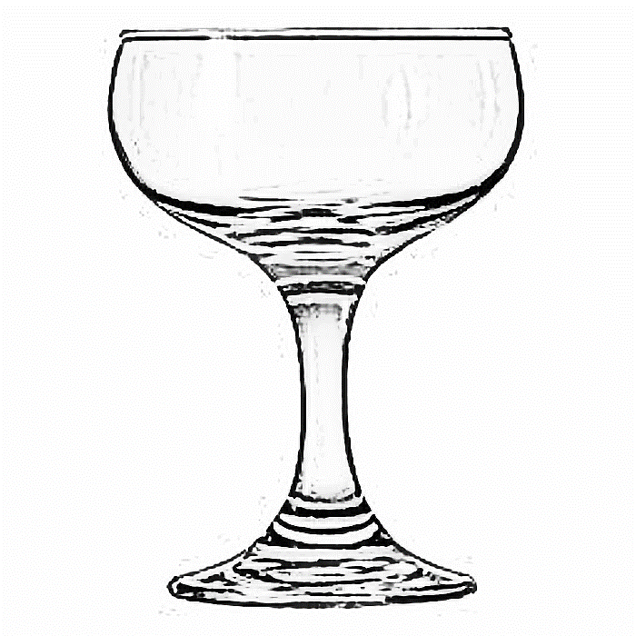
Distribution of Wealth

Health & Maternal Mortality Rate

Absolute Poverty
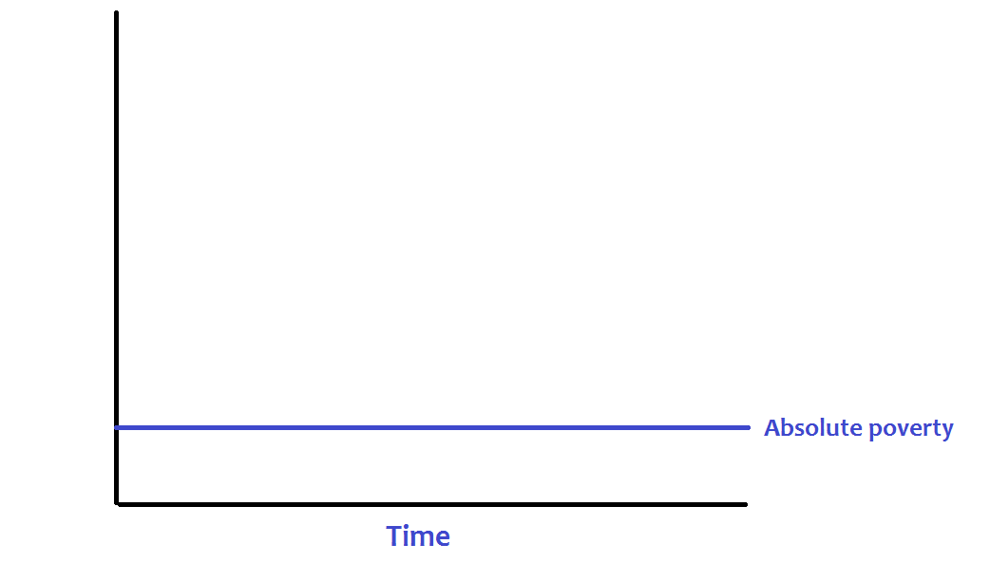
Resources

Relative Poverty
Resources

Social
Inequality

